**Agile Project Management Excellence**

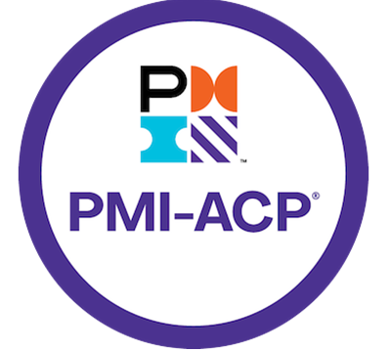

Sriram

# Sriram

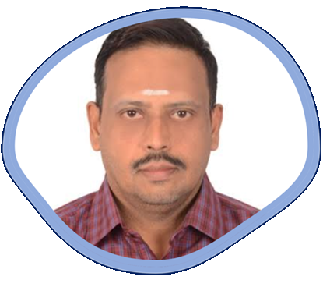

I have been involved in IT Software development since 1997. I have unique combination of process, technical and industrial skills. As a Digital Leader, I have expert level of knowledge in agile and practices with this combination I can help process and technology people, understand the agile world.

The “**Agile Project Management Excellence”** book comprises of Agile Framework. One in All, All in One & Key to Success.

My agile journey started in 2011, when I was a part of Tata Consultancy Services. I practiced scrum and agile methods thoroughly over several years and my teams are highly successful in delivering products using agile techniques.

I am proficient in agile engineering, coaching practices and SAFe consulting practices. I have more than 5 years of experience as a senior architect cum senior manager in development. I religiously follow key agile engineering practices like TDD, Refracting, CI and Collective Ownership. Worked in USA, UK for TCS, AtoS, Cognizant & IBM - Agile customers, which creates a global agile experience.

I moved back to India in 2016 and created agile websites and released books related to Scrum Alliance Professional, Agile Coaching and Implementing SAFe 5.0 practices.

Throughout my agile journey, I have been associated the agile professionals, who have helped and mentored me in the journey where sky is the limit.

Place: Dubai, UAE – Middle East Email: digitalcloudguru@gmail.com

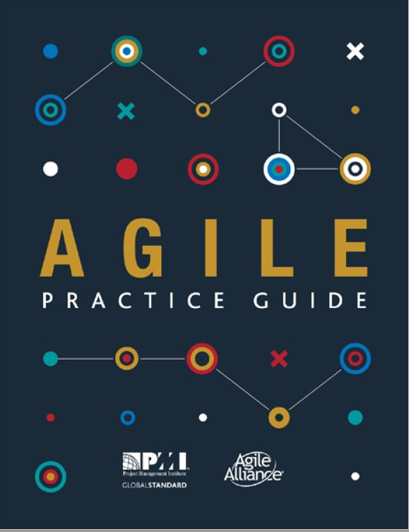

# Table of Contents

Contents

Sriram 2

Table of Contents 4

PMI-ACP Exam Prep 5

Exam Info 5

Eligibility Requirements 5

PMI Audits 5

Exam Objectives 6

Domain 1: Agile Principles and Mindset (9 Tasks) 6

Domain 2: Value-Driven Delivery (14 Tasks) 8

Domain 3: Stakeholders Engagement (10 Tasks) 11

Domain 4: Team Performance (9 Tasks) 13

Domain 5: Adaptive Planning (10 Tasks) 15

Domain 6: Problem Detection and Resolution (5 Tasks) 17

Domain 7: Continuous Improvement (6 Tasks) 18

PMI-ACP Exam Domains, Tools & Techniques, Knowledge & Skills 19

Domain 1. Agile Principles and Mindset 24

Section – 1.1 Creating an Agile Mindset 24

Section – 1.2 Agile Methodologies 38

Scrum 40

XP 108

Lean Kanban 121

Scrumban 129

Feature Driven Development (FDD) 135

Dynamic System Development Method (DSDM) 137

Crystal 138

Agile Framework Comparison 139

Domain 2. Value driven Delivery 143

Domain 3. Stakeholder Engagement 157

Domain 4. Team Performance 174

Domain 5. Adaptive Planning 184

Domain 6. Problem Detection and Resolution 195

Domain 7. Continuous Improvement 202

Agile Project Management Glossary 1 209

Agile Project Management Glossary 2 222

# PMI-ACP Exam Prep

Visit PMI-ACP Website: https://www.pmi.org/certifications/agile-acp

## Exam Info

* No of Questions: 120 multiple choice questions (only 100 will be scored)
* Duration: 3 hours
* Can be taken online or in-person testing center
* Online exams:
* Camera
* Mic
* Speakers

## Eligibility Requirements

* Secondary degree (high school diploma)
* 2,000 hours of general project experience working on teams. A current PMP® or PgMP® will satisfy this requirement but is not required to apply for the PMI-ACP
* 1,500 hours working on agile project teams or with agile methodologies. This requirement is in addition to the 2,000 hours of general project experience
* 21 contact hours of training in agile practices

## PMI Audits

* First complete your application like you are being audited
* About 10% of students are audited by PMI
* Will have to mail them the following: -
* Copy of this PDU certificate
* Signed experience forms

## Exam Objectives

Covers the 7 domains listed in the PMI-ACP exam content outline publish by PMI

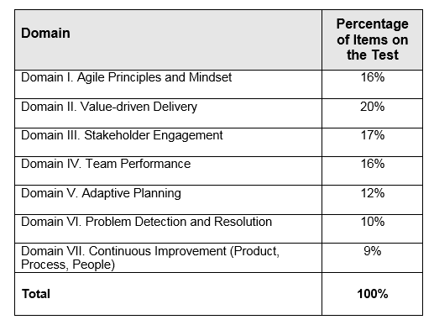

**Domain wise exam objectives**

## Domain 1: Agile Principles and Mindset (9 Tasks)

**Task 1**

Advocate for agile principles by modeling those principles and discussing agile values in order to develop a shared mindset across the team as well as between the customer and the team.

**Task 2**

Help ensure that everyone has a common understanding of the values and principles of agile and a common knowledge around the agile practices and terminology being used in order to work effectively.

**Task 3**

Support change at the system or organization level by educating the organization and influencing processes, behaviors, and people in order to make the organization more effective and efficient.

**Task 4**

Practice visualization by maintaining highly visible information radiators showing real progress and real team performance in order to enhance transparency and trust.

**Task 5**

Contribute to a safe and trustful team environment by allowing everyone to experiment and make mistakes so that each can learn and continuously improve the way he or she works.

**Task 6**

Enhance creativity by experimenting with new techniques and process ideas in order to discover more efficient and effective ways of working.

**Task 7**

Encourage team members to share knowledge by collaborating and working together in order to lower risks around knowledge silos and reduce bottlenecks.

**Task 8**

Encourage emergent leadership within the team by establishing a safe and respectful environment in which new approaches can be tried in order to make improvements and foster self-organization and empowerment.

**Task 9**

Practice servant leadership by supporting and encouraging others in their endeavors so that they can perform at their highest level and continue to improve.

## Domain 2: Value-Driven Delivery (14 Tasks)

**Define Positive Value**

**Task 1**

Define deliverables by identifying units that can be produced incrementally in order to maximize their value to stakeholders while minimizing non-value added work.

**Task 2**

Refine requirements by gaining consensus on the acceptance criteria for features on a just-in-time basis in order to deliver value.

**Task 3**

Select and tailor the team’s process based on project and organizational characteristics as well as team experience in order to optimize value delivery.

**Avoid Potential Downsides**

**Task 4**

Plan for small releasable increments by organizing requirements into minimally marketable features/minimally viable products in order to allow for the early recognition and delivery of value.

**Task 5**

Limit increment size and increase review frequency with appropriate stakeholders in order to identify and respond to risks early on and at minimal cost.

**Task 6**

Solicit customer and user feedback by reviewing increments often in order to confirm and enhance business value.

**Prioritization**

**Task 7**

Prioritize the units of work through collaboration with stakeholders in order to optimize the value of the deliverables.

**Task 8**

Perform frequent review and maintenance of the work results by prioritizing and maintaining internal quality in order to reduce the overall cost of incremental development.

**Task 9**

Continuously identify and prioritize the environmental, operational, and infrastructure factors in order to improve the quality and value of the deliverables.

**Incremental Development**

**Task 10**

Conduct operational reviews and/or periodic checkpoints with stakeholders in order to obtain feedback and corrections to the work in progress and planned work.

**Task 11**

Balance development of deliverable units and risk reduction efforts by incorporating both value producing and risk reducing work into the backlog in order to maximize the total value proposition over time.

**Task 12**

Re-prioritize requirements periodically in order to reflect changes in the environment and stakeholder needs or preferences in order to maximize the value.

**Task 13**

Elicit and prioritize relevant non-functional requirements (such as operations and security) by considering the environment in which the solution will be used in order to minimize the probability of failure.

**Task 14**

Conduct frequent reviews of work products by performing inspections, reviews, and/or testing in order to identify and incorporate improvements into the overall process and product/service.

## Domain 3: Stakeholders Engagement (10 Tasks)

**Understand Stakeholder Needs**

**Task 1**

Identify and engage effective and empowered business stakeholder(s) through periodic reviews in order to ensure that the team is knowledgeable about stakeholders’ interests, needs, and expectations.

**Task 2**

Identify and engage all stakeholders (current and future) by promoting knowledge sharing early and throughout the project to ensure the unimpeded flow of information and value throughout the lifespan of the project.

Ensure Stakeholder Involvement

**Task 3**

Establish stakeholder relationships by forming a working agreement among key stakeholders in order to promote participation and effective collaboration.

**Task 4**

Maintain proper stakeholder involvement by continually assessing changes in the project and organization in order to ensure that new stakeholders are appropriately engaged.

**Task 5**

Establish collaborative behaviors among the members of the organization by fostering group decision making and conflict resolution in order to improve decision quality and reduce the time required to make decisions.

**Understand Stakeholder Needs**

**Task 6**

Identify and engage effective and empowered business stakeholder(s) through periodic reviews in order to ensure that the team is knowledgeable about stakeholders’ interests, needs, and expectations.

**Task 7**

Identify and engage all stakeholders (current and future) by promoting knowledge sharing early and throughout the project to ensure the unimpeded flow of information and value throughout the lifespan of the project.

Ensure Stakeholder Involvement

**Task 8**

Establish stakeholder relationships by forming a working agreement among key stakeholders in order to promote participation and effective collaboration.

**Task 9**

Maintain proper stakeholder involvement by continually assessing changes in the project and organization in order to ensure that new stakeholders are appropriately engaged.

**Task 10**

Establish collaborative behaviors among the members of the organization by fostering group decision making and conflict resolution in order to improve decision quality and reduce the time required to make decisions.

## Domain 4: Team Performance (9 Tasks)

**Team Formation**

**Task 1**

Cooperate with the other team members to devise ground rules and internal processes in order to foster team coherence and strengthen team members’ commitment to shared outcomes.

**Task 2**

Help create a team that has the interpersonal and technical skills needed to achieve all known project objectives in order to create business value with minimal delay.

Team Empowerment

**Task 3**

Encourage team members to become generalizing specialists in order to reduce team size and bottlenecks, and to create a high performing cross-functional team.

**Task 4**

Contribute to self-organizing the work by empowering others and encouraging emerging leadership in order to produce effective solutions and manage complexity.

**Task 5**

Continuously discover team and personal motivators and demotivators in order to ensure that team morale is high and team members are motivated and productive throughout the project.

**Team Collaboration and Commitment**

**Task 6**

Facilitate close communication within the team and with appropriate external stakeholders through co-location or the use of collaboration tools in order to reduce miscommunication and rework.

**Task 7**

Reduce distractions in order to establish a predictable outcome and optimize the value delivered.

**Task 8**

Participate in aligning project and team goals by sharing project vision in order to ensure the team understands how their objectives fit into the overall goals of the project.

**Task 9**

Encourage the team to measure its velocity by tracking and measuring actual performance in previous iterations or releases in order for members to gain a better understanding of their capacity and create more accurate forecasts.

## Domain 5: Adaptive Planning (10 Tasks)

**Levels of Planning**

**Task 1**

Plan at multiple levels (strategic, release, iteration, daily) creating appropriate detail by using rolling wave planning and progressive elaboration to balance predictability of outcomes with ability to exploit opportunities.

**Task 2**

Make planning activities visible and transparent by encouraging participation of key stakeholders and publishing planning results in order to increase commitment level and reduce uncertainty.

**Task 3**

As the project unfolds, set and manage stakeholder expectations by making increasingly specific levels of commitments in order to ensure common understanding of the expected deliverables.

Adaptation

**Task 4**

Adapt the cadence and the planning process based on results of periodic retrospectives about characteristics and/or the size/complexity/criticality of the project deliverables in order to maximize the value.

**Task 5**

Inspect and adapt the project plan to reflect changes in requirements, schedule, budget, and shifting priorities based on team learning, delivery experience, stakeholder feedback, and defects in order to maximize business value delivered.

**Agile Sizing and Estimation**

**Task 6**

Size items by using progressive elaboration techniques in order to determine likely project size independent of team velocity and external variables.

**Task 7**

Adjust capacity by incorporating maintenance and operations demands and other factors in order to create or update the range estimate.

**Task 8**

Create initial scope, schedule, and cost range estimates that reflect current high level understanding of the effort necessary to deliver the project in order to develop a starting point for managing the project.

**Task 9**

Refine scope, schedule, and cost range estimates that reflect the latest understanding of the effort necessary to deliver the project in order to manage the project.

**Task 10**

Continuously use data from changes in resource capacity, project size, and velocity metrics in order to evaluate the estimate to complete.

## Domain 6: Problem Detection and Resolution (5 Tasks)

**Problem Detection and Resolution**

**Task 1**

Create an open and safe environment by encouraging conversation and experimentation, in order to surface problems and impediments that are slowing the team down or preventing its ability to deliver value.

**Task 2**

Identify threats and issues by educating and engaging the team at various points in the project in order to resolve them at the appropriate time and improve processes that caused issues.

**Task 3**

Ensure issues are resolved by appropriate team members and/or reset expectations in light of issues that cannot be resolved in order to maximize the value delivered.

**Task 4**

Maintain a visible, monitored, and prioritized list of threats and issues in order to elevate accountability, encourage action, and track ownership and resolution status.

**Task 5**

Communicate status of threats and issues by maintaining threat list and incorporating activities into backlog of work in order to provide transparency.

## Domain 7: Continuous Improvement (6 Tasks)

**Continuous Improvement (Product, Process, People)**

**Task 1**

Tailor and adapt the project process by periodically reviewing and integrating team practices, organizational culture, and delivery goals in order to ensure team effectiveness within established organizational guidelines and norms.

**Task 2**

Improve team processes by conducting frequent retrospectives and improvement experiments in order to continually enhance the effectiveness of the team, project, and organization.

**Task 3**

Seek feedback on the product by incremental delivery and frequent demonstrations in order to improve the value of the product.

**Task 4**

Create an environment of continued learning by providing opportunities for people to develop their skills in order to develop a more productive team of generalizing specialists.

**Task 5**

Challenge existing process elements by performing a value stream analysis and removing waste in order to increase individual efficiency and team effectiveness.

**Task 6**

Create systemic improvements by disseminating knowledge and practices across projects and organizational boundaries in order to avoid re-occurrence of identified problems and improve the effectiveness of the organization as a whole.

## PMI-ACP Exam Domains, Tools & Techniques, Knowledge & Skills

**Value Driven Delivery**

|  |  |  |
| --- | --- | --- |
| Domain | Tools & Techniques | Knowledge & Skills |
| Value Driven Delivery | ROI, NPV, IRR  Agile Earned Value Management (EVM)  Product Roadmap  Value Stream Mapping  WIP Limits  Relative Prioritization  Risk adjusted backlog  Cumulative flow diagrams  Task| Kanban boards  Chartering  Customer valued prioritization  Risk burndown graphs | Prototypes, Simulations, demonstrations  Incremental delivery  Prioritization  Project and Quality standards  Agile Contracting  Agile Accounting  System Thinking  Variations in Agile Methods  Value based analysis |

**Stakeholder Management**

|  |  |  |
| --- | --- | --- |
| Domain | Tools & Techniques | Knowledge & Skills |
| Stakeholder Management | Wireframes  Servant leadership  User Stories | Backlog  Conflict Resolution  Agile Modeling  Velocity  Information radiators  Distributed teams  Personas  Burn down |up charts  Story Maps  Negotiation | Incorporating stakeholder values  Communication management  Leadership tools and techniques  Stakeholder management  Active listening  Facilitation methods  Globalization, culture and team diversity  Vendor management  Participatory decision models |

**Team Performance**

|  |  |  |
| --- | --- | --- |
| Domain | Tools & Techniques | Knowledge & Skills |
| Team Performance | Daily Standups  Co-located teams  Team Space  Agile Tooling  Adaptive Leadership  Emotional Intelligence | Brainstorming Techniques  Building Empowered Teams  Coaching & Mentoring  Building High Performance Teams  Team Motivation  Colocation & geographically dispersed teams |

**Adaptive Planning**

|  |  |  |
| --- | --- | --- |
| Domain | Tools & Techniques | Knowledge & Skills |
| Adaptive Planning | Process Tailoring  Iteration and release planning  Wideband Delphi and planning Poker  Progressive elaboration  Timeboxing  Minimally Marketable Feature (MMF)  Ideal Time  Affinity Estimating  Relative Sizing | Story Points | Time, budget, and cost estimation  Value-based decomposition and prioritization  Agile charters  Business Case development  Innovation Games |

**Problem Detecting & Resolution**

|  |  |  |
| --- | --- | --- |
| Domain | Tools & Techniques | Knowledge & Skills |
| Problem Detection & Resolution | Cycle Time  Escaped defects  Continuous Integration  Risk based spike  Frequent verification and validation  Test-driven development |Test First Development  Acceptance Test Driven Development | Problem Solving  Control Limits  Failure Modes & Alternatives  Variance and trend analysis |

**Continuous Improvement**

|  |  |  |
| --- | --- | --- |
| Domain | Tools & Techniques | Knowledge & Skills |
| Continuous Improvement | Retrospective | Knowledge Sharing  Process Analysis  Applying new agile practices  PMI's code of Ethics & Professional Conduct  Continuous Improvement  Self-Assessment |

# Domain 1. Agile Principles and Mindset

## Section – 1.1 Creating an Agile Mindset

**What is an Agile?**

Developed for Software projects, but it is a methodology that can be used on all Projects types. Agile” is an umbrella term used to encompass dozens of different techniques and disciplines (e.g., Scrum, XP, KANBAN, etc.), all aimed at the adaptive, iterative, incremental development of software.  The concept of agile has several different implementations, which are called methodologies. The methodologies can either be applied individually to work or together in combination.

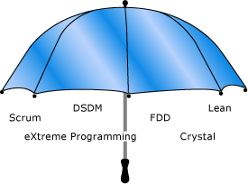

**Prerequisite:**

* Work has high uncertainty in scope
* Work involves knowledge workers

Scrum is the most common method of agile, there are others such as extreme programming (XP), lean development, and Kanban.

**What is Agility?**

Agility is the ability to deliver customer value while dealing with the inherent project unpredictability and dynamism by recognizing and adapting to change.

**Why Agile?**

* Reduce turnaround time for features
* Predictability of market releases – content and timing
* Ability to handle the complex product enhancements
* The main reason for the agile existence due to: -
  + Project priorities change’s frequently
  + Need to respond to customer requirements and market dynamics
  + Promote team work and less reliance on individual heroics
  + Course correction and continuous improvements

**What are the benefits of Agile?**

* Customer involved throughout the life cycle
* Greater Customer Interaction with all stakeholders
* Constant Feedback is required to stay current and successful
* Greater Value up front
* Change is welcomed by all stakeholders
* Integrate early & often
* Fund incrementally –opt to extend, redirect or cancel at a very granular level
* Deliver & realize value steadily
* Validate designs with users & customers
* Continuously adapt to risk and change

**What is Agile Manifesto? What are Agile 4 Values?**

Meeting at Snowbird resort by 17 software pundits and light weight methodologists, February 2001. Created **“Agile Manifesto”**

We are uncovering better ways of developing software by doing it and helping others do it. Through this work we have come to value. i.e., Agile Values

Individuals and interactionsover processes and tools

Working softwareover comprehensive documentation

Customer collaborationover contract negotiation

Responding to changeover following a plan

That is, while there is value in the items on the right, we value the items on the left more.

Author: - Kent Beck, Mike Beedle, Arie Van Bennekum, Alistair Cockburn, Ward Cunningham, Martin Fowler, James Greening, Jim Highsmith, Andrew Hunt, Ron Jerries, Jon Kern, Brian Marick, Robert C. Martin, Steve Mellor, **Ken Schwaber, Jeff Sutherland**, Dave Thomas

**Agile Manifesto: Explanation**

**Individuals and Integrations Over Process & Tools**

* Individuals and interactions are most important
* Processes and tools will be needed on projects
* Projects are completed by people not processes and tools
* Agile projects are people driven

**Working Software over Comprehensive Documentation**

* Agile project needs to deliver value
* Value is about the purpose or business need the project aims to deliver
* Documentation is barely sufficient
* Documentation is done just in time –as the last responsible moment
* Documentation might also be just because
  + Industry requirements
  + Organizational requirements

**Customer Collaboration over Contract Negotiation**

* Agile is flexible, accommodating, and willing to change
* Contracts are often rigid and uncooperative
* Agile contracts must accommodate change
* There’s a difference between being right and doing the right thing

**Responding to Change over a following plan**

* Agile welcomes change
* Predictive projects plan everything in advance
* Agile projects have lots and lots of many changes
* Agile projects have uncertainty up front

**What are Agile Principles? What are 12 principles behind Agile Manifesto?**

|  |  |  |
| --- | --- | --- |
| **No** | **Principle** | **Shortened Version** |
| 1 | Our highest priority is to satisfy the customers through early and  continuous delivery of valuable software | **Customer Satisfaction** |
| 2 | Welcome changing requirements, even late in development. Agile processes harness change for the customer's competitive advantage. | **Welcome Changes** |
| 3 | Deliver working software frequently, from a couple of weeks to a couple of months, with a preference to the shorter timescale. | **Deliver Frequently** |
| 4 | Business people and developers must work together daily throughout the project. | **Work with business** |
| 5 | Build projects around motivated individuals. Give them the environment and support they need, and trust them to get the job done | **Motivated People** |
| 6 | The most efficient and effective method of conveying information to and within a development team is face-to-face conversation. | **Face to Face Communication** |
| 7 | Working software is the primary measure of progress. | **Measure Software Done** |
| 8 | Agile processes promote sustainable development. The sponsors, developers, and users should be able to maintain a constant pace indefinitely. | **Maintain Sustainable Pace** |
| 9 | Continuous attention to technical excellence and good design enhances agility. | **Maintain Design** |
| 10 | Simplicity –the art of maximizing the amount of work not done is essential | **Keep it Simple** |
| 11 | The best architectures, requirements, and designs emerge from self-organizing teams. | **Team creates Architecture** |
| 12 | At regular intervals, the team reflects on how to become more effective, then tunes and adjusts its behavior accordingly. | **Reflect and adjust** |

**What is Declaration of Interdependence?**

Agile and adaptive approaches for linking people, projects and value. We are a community of project leaders that are highly successful at delivering results. To achieve these results:

* We **increase return on investment** by making continuous flow of value our focus
* We **deliver reliable results** by engaging customers infrequent interactions and shared ownership
* We **expect uncertainty** and manage for it to iterations anticipations and adaptation
* We **unleash creativity** and innovation by recognizing that individuals are the ultimate source of value and creating an environment where they can make a difference
* We **boost performance** through group accountability for results and shared responsibility for team effectiveness
* We **improve effectiveness and reliability** through situationally specific strategies processes and practices

**Agile Project Management Vs. Traditional Project Management?**

* Agile builds in increments vs. as a whole
* Agile does planning throughout vs. done all at once
* Agile delivers products over time vs. all at once
* Customers sees value faster vs. at the end
* Agile wants changes vs. discouraging changes

**What is the difference between Being Agile Vs Doing Agile?**

|  |  |
| --- | --- |
| **Being Agile** | **Doing Agile** |
| Possessing an agile mind set  Choose correct practices  Implement correct practices  Tailor agile processes | Doing a job without embracing agile  Forcing agile practice  Command and control  Understand agile |

**Triple Constraint | Inverted Triangle Model**

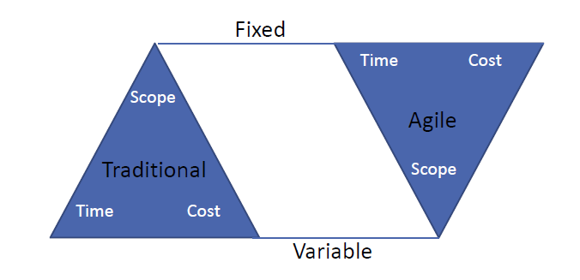

* Triple Constraint which deals with Time, Scope & Cost
* Determine - What is Variable and What is Fixed? – Based on that outcome will change.

**How Agile Development works?**

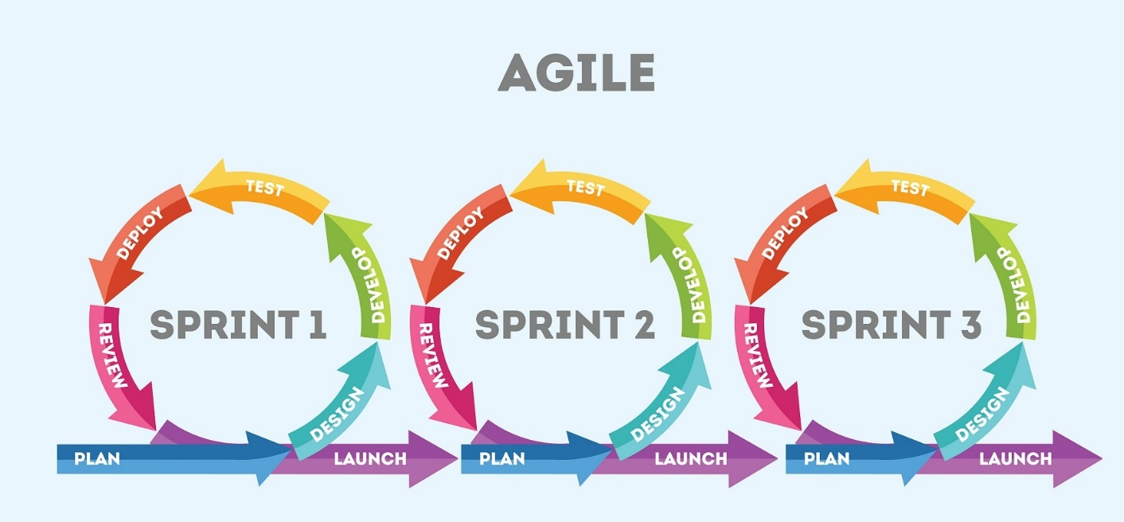

* Development follows a continuous improvement cycle, exposing flaws faster and reducing waste
* Value is achieved faster as releases arrive to the customer more frequently
* Advantages are: - Shorter development cycle, Wider market windows, Early customer feedback & Continuous improvement

**What is an Empirical Process Control?**

Empirical process controls focus on the following: -

Inspection, Transparency & Adaptation

**Inspection**

Inspection in Scrum is depicted through: -

* Use of a common Scrum board and other information radiators
* Collection of feedback from the customer and other stakeholders during the Develop Epic(s), Create Prioritized Product Backlog, and Conduct Release Planning processes.
* Inspection and approval of the Deliverables by the Product Owner and the customer in the Demonstrate and Validate Sprint process.

**Transparency**

Transparency allows all facets of any Scrum process to be observed by anyone. This promotes an easy and transparent flow of information throughout the organization and creates an open work culture. In Scrum, transparency is depicted through: -

|  |  |
| --- | --- |
| **Artifacts**   * Project Vision Statement * Prioritized Product Backlog * Release Planning Schedule   **Meetings**   * Sprint Review Meetings * Daily Standup Meetings | **Information Radiators**   * Burndown Chart * Scrumboard |

**Adaptation**

Adaptation happens as the Scrum Core Team and Stakeholders learn through transparency and inspection and then adapt by making improvements in the work they are doing. Adaptation in Scrum is depicted through: -

* Standup Meetings
* Constant Risk Identification
* Change Requests
* Scrum Guidance Body
* Retrospect Sprint Meeting
* Retrospect Project Meeting

**Why Agile methodology is empirical in nature?**

* Course correction at frequent intervals
* Regular customer feedback
* Failure detected early and hence early adoption of corrective measures
* Status is visible to all stakeholders in a consistent way
* Each iteration follows with Inspect, Transparency & Adaptation

**Sketch the Agile Planning Onion?**

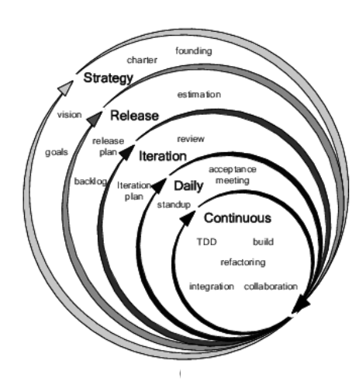

**How Continuous Improvement in Agile?**

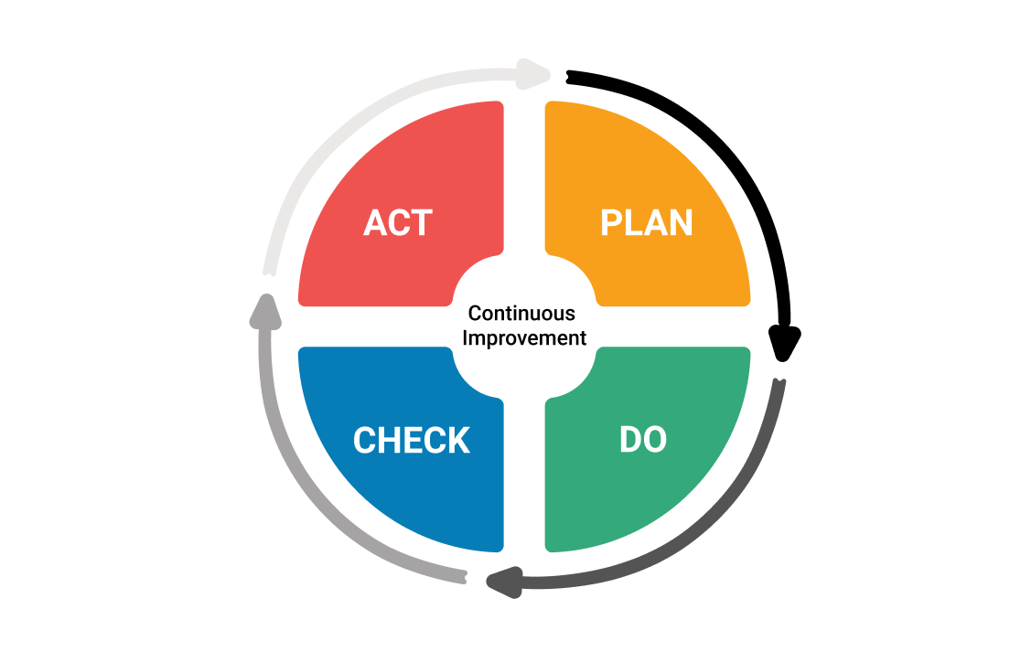

**Traditional Vs Agile Planning?**

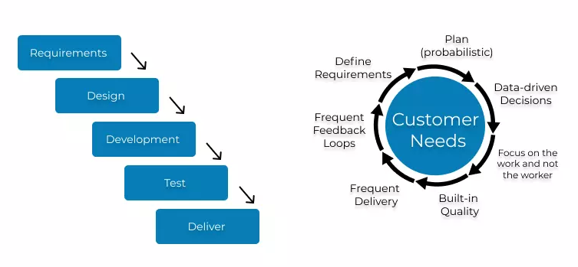

**What is the Agile Mindset?**

The agile mindset is **a thought process that involves understanding, collaborating, learning, and staying flexible to achieve high-performing results**. By combining the agile mindset with processes and tools, teams can adapt to change and deliver incremental value to their customers.

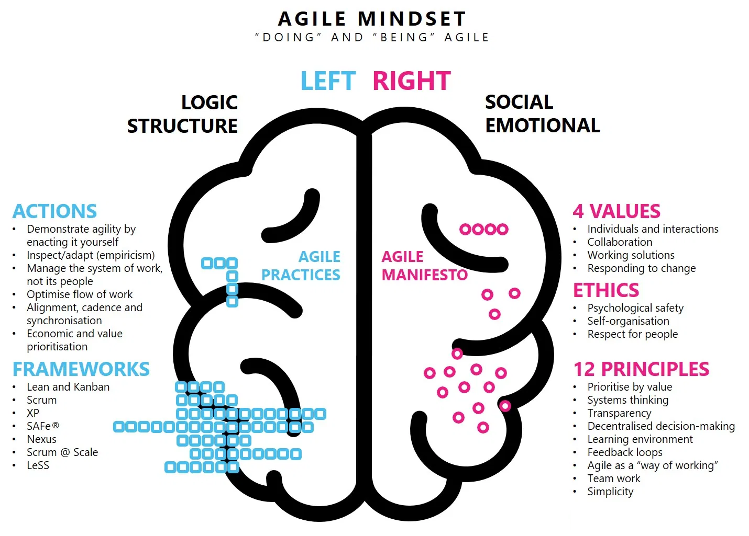

**In Short**

* Welcoming change
* Working in small value increments
* Using build and feedback loops
* Learning through discovery
* Value driven development
* Failing fast with learning
* Continuous delivery & Continuous improvement

**What are the Twelve Principles for Leading Agile Projects?**

1.Learn the team members needs

2.Learn the project requirements

3.Act for the simultaneous welfare of the team and the project

4.Create an environment of functional accountability

5.Have a vision of the completed project

6.Use the project vision to drive your own behavior

7.Serve as the central figure in successful project team development

8.Recognize team conflict as a positive step

9.Manage with an eye toward ethics

10.Remember that ethics is not an afterthought, but an integral part of our thinking

11.Take time to reflect on the project

12.Develop the trick of thinking backwards

**How to Lead the organization effectively?**

* Tap into people’s intrinsic motivations
* Discover why team members want to do something and what motivates and then align that to the project goals
* Management vs Leadership

Management -> Mechanical Focus

Leadership ->Humanistic Focus (on people and purpose)

|  |  |
| --- | --- |
| **Management Focus**   * Task/things * Control * Command | **Leadership Focus**   * People * Empowerment * Communication |

**Servant Leadership**

Leader provides what the team needs: -

* Shield team from interruptions
* Remove impediments to progress
* Re)Communicate project vision
* Carry food and water

**Leadership Tools and Techniques**

* Using these tools still need soft -skills approach
* Modeling Desired Behavior
* Honesty
* Forward-Looking
* Competent
* Inspiring
* Communicating project vision
* Enabling others to act
* Switch from exclusive tools to inclusive tools
* Being willing to change the status quo

**Leadership Task**

* Practice Transparency through Visualization Crate a safe environment for experimentation
* Experiment with new techniques and processes
* Share knowledge through collaboration
* Encourage emergent leadership vis a safe environment

## Section – 1.2 Agile Methodologies

**What are the Agile Methodologies? What are the flavours of Agile?**

|  |  |  |
| --- | --- | --- |
| **Methodologies** |  | **Information** |
| **Scrum** |  | Most popular agile methods  Strongly codified set of ceremonies, roles and artifacts |
| **XP** |  | Foremost of agile methodologies  Strong set of technical practices |
| **Lean Kanban** |  | Lean - Set of principles evolved from manufacturing to eliminate waste  Kanban literally means a “signboard” or “billboard” and it supports the use of visual aids to assist and track production.  Lean Kanban integrates the use of the visualization methods as prescribed by Kanban along with the principles of Lean creating a visual incremental evolutionary process management system. |
| **DSDM** |  | Offshoot of Rapid Application Development Methodology  Cost | Quality/time fixed and requirements prioritized as per MOSCOW |
| **Crystal** |  | Principles are categorized according to criticality and size of the project.  Critical Levels: Comfort ( C )| Discretionary Money | Essential Money ( E ) | Life ( L ) |
| **Feature Driven Development** |  | Plan | Develop and build by feature |
| **Adaptive Software Development (ASD)** | | ASD are constant adaptation of processes to the work at hand, provision of solutions to problems surfacing in large projects, and iterative, incremental development with continuous prototyping. |
| **Agile Unified Process (AUP)** | | AUP combines industry-tried-and-tested Agile techniques such as Test-Driven Development (TDD), Agile Modelling, agile change management, and database refactoring, to deliver a working product of the best quality |
| **Domain-Driven Design (DDD)** | | Domain-driven design is an Agile development approach meant for handling complex designs with implementation linked to an evolving model. |
| **Test Driven Development** | | Test Driven Development is a software development method that involves writing automated test code first and developing the least amount of code necessary to pass that test later. |

## Scrum

##### Introduction to Scrum

**What is Scrum?**

**“A framework within which people can address complex adaptive problems, while productively and creatively delivering products of the highest possible values.”**

* Scrum uses a methodology called the scrum framework & Scrum is a rugby term
* Scrum is light weight, easy to understand, but can be difficult to master, more flexible and allows other agile practices like XP to plug in
* The scrum framework is a set of practices, roles and responsibilities, events, artifacts, and rules

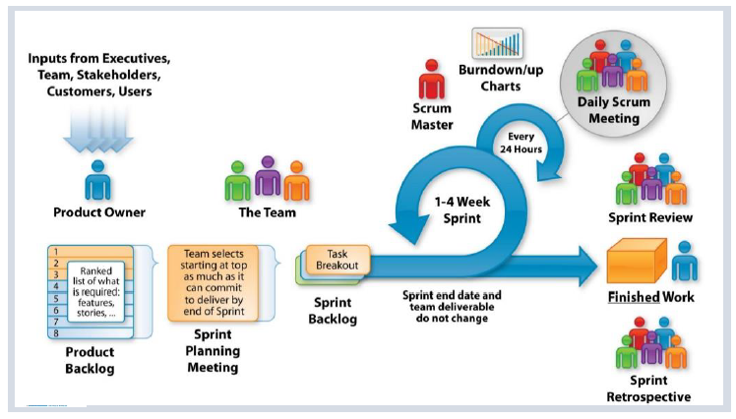

**Tell me Scrum in 100 words?**

* Scrum is an agile process that allows us to focus on delivering the highest business value in the shortest time.
* It allows us too rapidly and repeatedly and repeatedly inspect actual working software in every two weeks.
* The business set the priorities. Team self-organizes to determine the best way to deliver the highest priority features.
* Every two weeks to a month anyone can see the real working software and decide to release it as is or continue to enhance it for another sprint.

**What are the Characteristics of Scrum?**

* The most popular ‘Agile Processes’ in Agile software development & well suited for projects that require Empirical process control
* Focuses on self-organizing teams
* Requirements are captured in a prioritized list (Product Backlog)
* Product progresses in a series of month-long “sprints”
* No specific engineering practices prescribed
* Uses generative rules to create an agile environment for delivering projects

**What is Scrum theory?**

Scrum is based on empirical process control. It is not a set methodology but instead is a framework. Inspection, Transparency & Adaptation are the three pillars of Scrum.

**What are the Principles of Scrum?**

Scrum principles are the core guidelines for applying the Scrum framework and should mandatory be used in all Scrum projects.

The six Scrum principles are: -

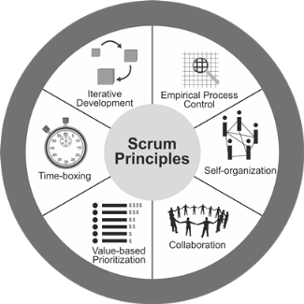

**Empirical Process Control:** This principle emphasizes the core philosophy of Scrum based on the three main ideas of transparency, inspection, and adaptation. Empirical process control aids learning through experimentation, especially when the problem is not well defined or when there are no clear solutions.

**Self-organization**: This principle focuses on today’s workers, who deliver significantly greater value when self-organized, and this results in better team buy-in and shared ownership; and an innovative and creative environment which is more conducive for growth.

**Collaboration:** This principle focuses on the three core dimensions related to collaborative work: awareness, articulation, and appropriation. It also advocates project delivery as a shared value-creation process with teams working and interacting together, as well as with the customer and other business stakeholders, to deliver the greatest value.

**Value Based Prioritization**: This principle highlights the focus of Scrum to deliver maximum business value, from early in the project and continuing throughout.

**Time-boxing**: This principle describes how time is considered a limiting constraint in Scrum and used to help effectively manage project planning and execution. Time-boxed elements in Scrum include Sprints, Daily Standup Meetings, Sprint Planning Meetings, Sprint Review Meetings, and Retrospect Sprint Meetings.

**Iterative Development**: This principle defines iterative development and emphasizes how to better manage changes and build products that satisfy customer needs. It also delineates the Product Owner’s and organization’s responsibilities related to iterative development.

**What are Defined & Empirical Process?**

**Defined Process**

**A Defined process defines all steps in advance, same output is expected every time the process is followed, best suits for “Simple” and “Complicated” problem domains.**

* Follows pre-defined steps to achieve an Output.
* Suitable when the output is well defined.
* Same output is expected every time the process is followed.
* Best suits for problems those fall into “Simple” and “Complicated” problem domains.

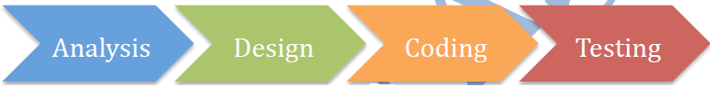

**Empirical Process**

**An Empirical process are interactive, incremental, change often, adapt, and pass through the reviews, Empirical processes are change-driven**

As software products and requirements cannot be 100% confirmed, fixed at the beginning, the best way to build the winning product is to continuously inspect, and adapt at regular intervals, effectively and efficiently. Empirical Process is based on such inspect and adapt cycle.



An Empirical Process is: -

* Built based on the series of experiments
* Experience based decision making
* Suitable when the output can’t be well defined
* Definition of output is refined based on the result of experiments
* Steps in the process are adjusted based on the feedback from the experiments
* Deming Wheel – Plan – DO Inspect -Adapt

In order to build the winning products and deliver value SCRUM has various feedback loops so that product and process are inspected, adapted and transparent.

**How would you say Scrum is based on empiricism?**

Scrum is based in empiricism because: -

* All Artifacts should be transparent to all stakeholders
* All Scrum roles are empowered to do the job right
* All Scrum meetings allow collaboration and opportunities for inspection ad adaptation
* In Scrum, the process is constantly adjusted if needed based on the short and continuous feedback loops at iteration levels

**What are the Pillars of Scrum? What are the three legs of empirical process?**

Three legs of empirical process | pillars of SCRUM – Inspection, Adaptation & Transparency: -



* **Inspection** – Frequent Inspection of artefacts helps stakeholders to make any changes to achieve the goal i.e., Timely checks on how well a project is progressing toward goals & looks for problematic deviations or differences from goals
* **Adaptation** – Continuous improvement by adjusting the process based on the inspection i.e., Adjusting a process to minimize further issues if an inspection shows a problem or undesirable trend
* **Transparency**– All artefacts of the process are visible to all the stakeholders. This helps stakeholders to inspect the current stake and take any required action i.e., Visibility to those responsible for the outcome

**How would you say Scrum is incremental and iterative?**

**Scrum team delivers value incrementally and iteratively**

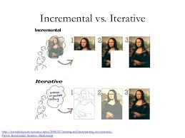

**Iterative Development**

Iterative development is to build something, to get some feedback, then refine it to make better, keep doing that until the product is good enough.

**Benefits**

* Focus on high value and good Return on Investment (ROI)
* Reduce rarely used features, maximize frequently used features
* Usable product at any time
* Quality Focus
* Effective and efficient
* Usable product at any time
* Sustainable pace of development

**Incremental Development**

Incremental development is to build small increment of a full fledges product. Each increment adds more software value – like Adding package to a Software Product. After lot of increments, you have got a big Software Product.

**Benefits**

* Reduce risk during development
* Early discovery and mitigation of risks
* Accommodates changes early
* Manageable Complexity
* Higher confidence and satisfaction from early repeated successful delivery
* Early and continuously visibility of product increment
* Better predictability and progress
* Higher quality and lower defects
* Final product close to customer’s desire
* Early and regular process improvement
* Continuous collaboration ad engagement with customers
* Effective and efficient
* Usable product at any time
* Sustainable pace of development

**Coin a Scrum Word from the Scrum values?**

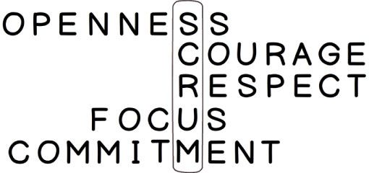

**What is the Project noise level in Agile? What is Ralph-Stacy Complex Model?**

Ralph-Stacy complexity model shows the different problem domains and their nature. The model has four problem domains namely Simple, Complicated, Complex & Anarchy | Chaotic.

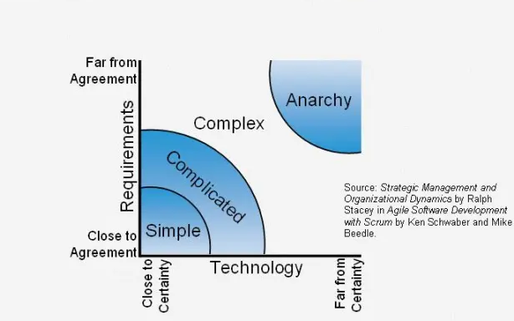

X- axis captures how something is being done. This represents the technology or implementation method. Y-axis shows what is being done. This represents requirements of the work being done.

**Problem Domains**

**Simple:** These problems are those we know what to do and how to do.

**Complicated:** These Problems require a specialized skill. Once you have an expert, they know how to do this.

**Complex:** There is no way to reduce uncertainty on what to do or how to do other than working iteratively. Scrum works best in this problem domain. i.e., Software Development

**Chaotic | Anarchy:** Problems in this region

**What are the Scrum Values?**

All work performed in SCRUM needs a set of values as the foundation for the team’s processes and interactions. And by embracing these five values, the team makes them more instrumental to its health and success.

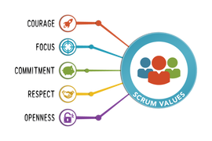

**Focus:** Because we focus on only a few things at a time, we work well together and produce excellent work. We deliver valuable items sooner.

**Courage:** Because we work as a team, we feel supported and have more resources at our disposal. This gives us the courage to undertake greater challenges.

**Openness:** As we work together, we express how we’re doing, what’s in our way, and our concerns so they can be addressed.

**Commitment:** Because we have great control over our own destiny, we are more committed to success.

**Respect:** As we work together, sharing successes and failures, we come to respect each other and to help each other become worthy of respect.

As an organization applies Scrum it discovers its benefits. At the same time, it sees how these values inherently contribute to the success of Scrum and understands why they are both needed, and bolstered, by Scrum.

**Scrum DOGMA | Rule**

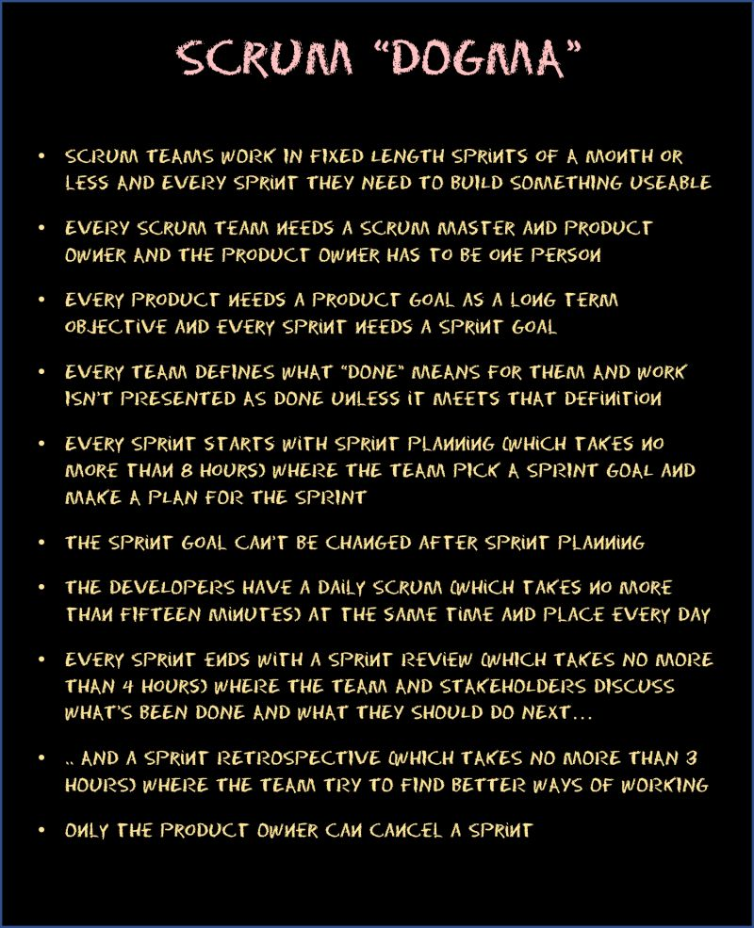

**Tell me about Scrum Framework in short?**

Already we have seen the Agile has 4 Values & 12 Principles.

SCRUM is a simple process framework. SCRUM has

**3 Legs**      : Inspect, Adapt, Transparent (Pillars of Scrum)

**3 Roles**      : Product Owner | Scrum Master | Development Team (The Scrum Team)

**3 Artifacts**  : Product Backlog | Sprint Backlog | Product Increment

**4 Meetings**  : Sprint Planning | Daily SCRUM | Sprint Review | Sprint Retrospective

**1 Activity**  : Product Backlog Refinement

**5 Values**     : Focus | Courage | Openness | Commitment | Respect

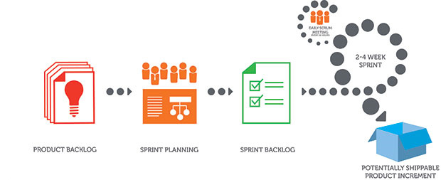

**Product Backlog -** Ordered list of items to be worked on for the product

**Sprint Backlog -** Product backlog items selected to work in the Sprint and the work plan to complete those items

**Product Increment -** Completed product backlog items in a sprint, which are ready to be delivered to the customer

**Product Backlog Refinement -**A meeting to get the product backlog items ready for the next few sprints

**Sprint Planning -** A meeting to create the sprint goal and plan the work for the sprint

**Daily Scrum -**A daily 15-minute time boxed event for the Development Team to synchronize activities and create a plan for the next 24 hours

**Sprint Review -**A meeting to inspect the product increment and adapt the product backlog if needed

**Sprint Retrospective -**A meeting for the scrum team to inspect and adapt the process, people and tools

##### The Scrum Team

**Who are all the Scrum team member & What are the Roles & responsibilities?**

* **Scrum Master** –Responsible for communicating the scrum methodology and ensuring the methodology is used effectively
* **Product owner** –Prioritizes the product backlog to ensure value from each sprint
* **Development team** –The software developers who create the product through the sprint

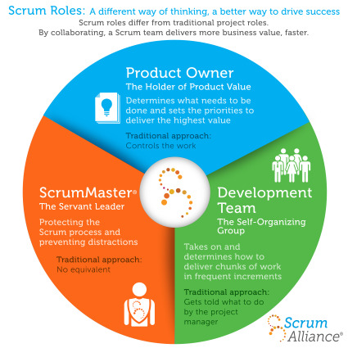

|  |  |  |  |
| --- | --- | --- | --- |
| **Item** | **Development Team** | **Product Owner** | **Scrum Master** |
| **Estimates** | * DT |  |  |
| **Backlog Priorities** |  | * PO |  |
| **Agile Coaching** |  |  | * SM |
| **Velocity Predictions** | * DT |  |  |
| **Definition of Done | Sprint Planning** | * DT | * PO | * SM |
| **Process Adherence** |  |  | * SM |
| **Technical Decision** | * DT |  |  |

**Product Owner**

* Product Owner owns the Product vision
* Defines features, decides on release date and content
* Responsible for market success
* Be responsible for the profitability of the product (ROI)
* Prioritize features according to the market value
* Adjust features and priority every iteration, as needed
* Accept or reject work results
* Maintains and grooms the Product Backlog
* An effective product owner is Committed, Responsible, Authorized, Collaborative, and Knowledgeable (CRACK)

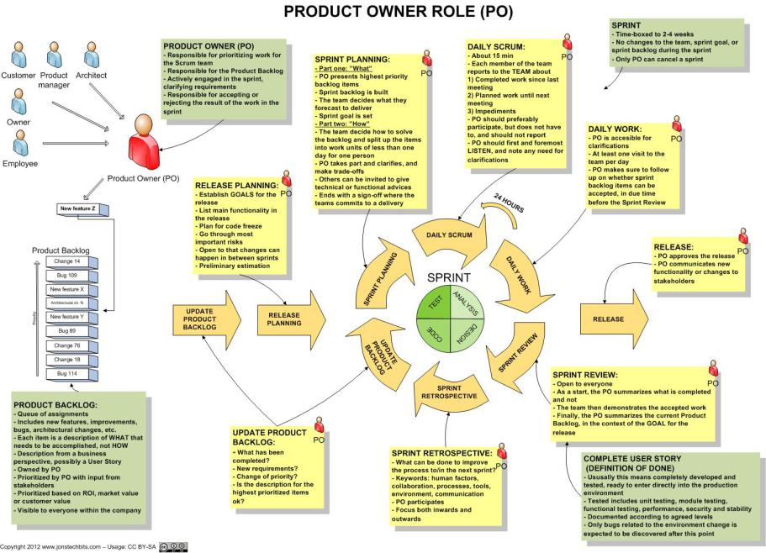

**Product Owner’s responsibility to Stakeholders**

Product owner collaborates with stakeholders of the product to understand their vision and market conditions and regularly update them on the progress of the product development. Product Owner

* Creates the Product vision if it does not exist
* Creates and manages Product Backlog to fulfil the Product vision
* Reviews the product with stakeholders in Sprint Review meetings to solicit feedback
* Updates stakeholders about progress of the product development typically every sprint
* Represents single voice of customers
* Prioritizes product backlog items based on business needs with the consensus of all stakeholders
* Orders the product backlog items to maximize the delivery value

**Product Owner responsibility to the team**

* Establishes the shared vision between stakeholders and the team
* Details out the product backlog items as appropriate. Make sure that high value items are ready for implementation in upcoming sprints
* Helps team estimate by clarifying any questions
* Available to the team to answer any questions regarding the product domain during the sprint
* Optimizes the value of the work the development team performs
* Keeps the product backlog transparent, clear and visible to all
* Attend Scrum Meetings
  + Sprint Planning: Helps the team plan to sprint
  + Sprint Review: Reviews the product increment with stakeholders
  + Sprint Retrospective: Contributes to come up with improvement ideas

**Other responsibilities of a Product Owner**

* Responsible for deciding whether to release the product increment at the end of the sprint
* Creates and manages the release plans
* Tracks the release progress

**Scrum Master**

* Responsible for facilitating process & represents management to the project
* Responsible for enacting Scrum rules, values and practices and censure team members and stakeholders not adhering to these rule’s ad norms
* Removes impediments
* Looks for ways to enhance productivity
* Assists Product Owner in leveraging Scrum
* Ensure that the team is fully functional and productive
* Enable close co-operation across all roles and functions
* Focuses Team, shield the team from external interferences
* Practices “Servant Leadership” – Facilitator and enabler rather than a manager

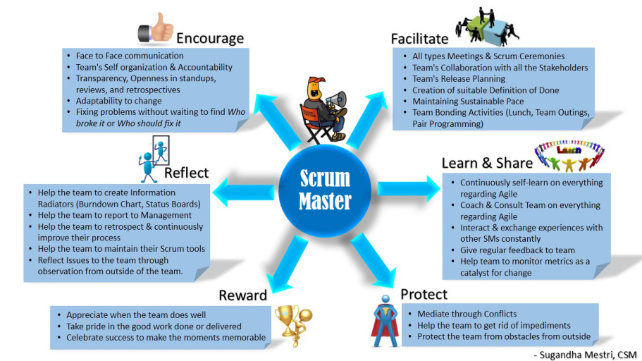

**General Responsibilities of Scrum Master**

* Teaches Scrum to the team and the rest of the organization
* Ensures that scrum is understood and enacted
* Facilitate all scrum meetings as needed and requested. Makes sure that meetings are happening the scrum team. Coaches the team on how to complete the tasks on time within the timebox for that meeting
* Responsible for building the product fast by eliminating the waste
* A Servant – Leader for the Scrum Team
* Act as a change agent that increases the productivity of the Scrum team

**Scrum Master Service to the Product Owner**

The Scrum Master serves the Product Owner in several ways, including: -

* Helps Product Owner to prioritize the work. Teaches PO and Stakeholders value- based prioritization
* Finding techniques for effective Product Backlog management;
* Helping the Scrum Team understand the need for clear and concise Product Backlog items;
* Understanding product planning in an empirical environment;
* Ensuring the Product Owner knows how to arrange the Product Backlog to maximize value;
* Understanding and practicing agility; and,
* Facilitating Scrum events as requested or needed.

**Scrum Master Service to the Development Team**

The Scrum Master serves the Development Team in several ways, including: -

* Identifies the impediments those are blocking the team to progress and help resolve them as quickly as possible. Scrum Master goal is to make sure the team is highly productive
* Coaching the Development Team in self-organization and cross-functionality;
* Helping the Development Team to create high-value products;
* Removing impediments to the Development Team’s progress;
* Facilitating Scrum events as requested or needed; and,
* Coaching the Development Team in organizational environments in which Scrum is not yet fully adopted and understood.

**Scrum Master Service to the Organization**

The Scrum Master serves the organization in several ways, including: -

* Assess the readiness of the organization to implement the team
* Leading and coaching the organization in its Scrum adoption;
* Planning Scrum implementations within the organization;
* Helping employees and stakeholders understand and enact Scrum and empirical product development;
* Causing change that increases the productivity of the Scrum Team; and,
* Working with other Scrum Masters to increase the effectiveness of the application of Scrum in the organization.

**What are the qualities of an effective Scrum Master?**

The Scrum Master to be effective, there various important skills to acquire. Here some of those skills are: - Facilitation | Coaching | Servant Leadership

**I - Facilitation**

Facilitation is the process of designing and conducting a successful meeting or event that has a particular objective. Facilitation serves the needs of any group, who are meeting with a common purpose. The person who facilitates the meeting is called a “Facilitator”



**Characteristics of Facilitator**

* Facilitator does not stand in front of the group and lecture
* Facilitator is an active unbiased member of the learning process
* Facilitator has to skillfully assist the group to understand their common objectives, and to help them to achieve these objectives without taking sides in any arguments
* Facilitator guides and helps to achieve consensus

**Basic Skills of a Facilitator**

* Follows a good meeting practice
* Time keeping
* Run the meeting on agenda
* Assisting the group to brainstorm and problem solve
* Ability to intervene in a way that adds creativity to a discussion rather than leading the discussion
* Ability to understand the group dynamics include:
* Who is dominating the group? How to stop him/her
* Who is withdrawn? How to involve him/her
* Who looks bored? How to get their attention

**Good Facilitation techniques should: -**

* Help the participants to be comfortable with each other
* Create a fun and interesting learning development
* Boost the energy levels of workshop participants
* Organize interesting and productive group work activities
* Use participatory activities which enable dynamic reviews of what has been learnt?
* Increase group activity so that workshop participants can expand on the new

**II - Coaching**

According to Tim Gallwey “Coaching is unlocking a person’s potential to maximize their own performance. It’s helping them to learn rather than teaching them”



Coaching is a useful way of developing people’s skills and abilities, and of boosting performance. It can also help deal with issues and challenges before they become major problems.

A coaching session will typically take place as a conversation between the coach and coachee (person being coached), and it focusses on helping the coachee discover answers for themselves

Occasionally, coaching may mean an informal relationship between two people, of whom one has more experience and expertise than the other and offers advice and guidance as latter learns.

**Qualities of a Coach**

* Coaches help to find solutions
* Coaching helps the organizations to change for the better
* Coaching is long term and sustainable results
* Coaching gives progressive elaboration
* Coaching helps you to review and refine your own solution to make it work

**Coaching is different from Consulting; the key differences are: -**

* Consultants usually identify and correct the problems. Coaches helps to find solutions
* Consulting is treated like a silver bullet whereas Coaching helps the organizations to change for the better
* Consulting is often short term based and Coaching is long term and produce sustainable results
* Consulting may give sudden spike in improvement and Coaching gives progress elaboration
* Consulting is more of implanting some other’s solution but coaching helps you to review and refine your own solution to make it work

**How Scrum Master can become a good coach?**

* Develop positive attitude and patience
* Lead by example
* Keep up the balance
* Set the realistic pace
* Be cautious about your language
* Open to learn
* Accept feedback

**Compare Teaching Vs Mentoring Vs Coaching?**

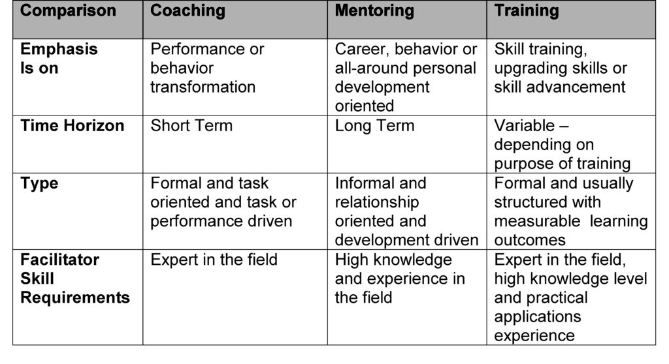

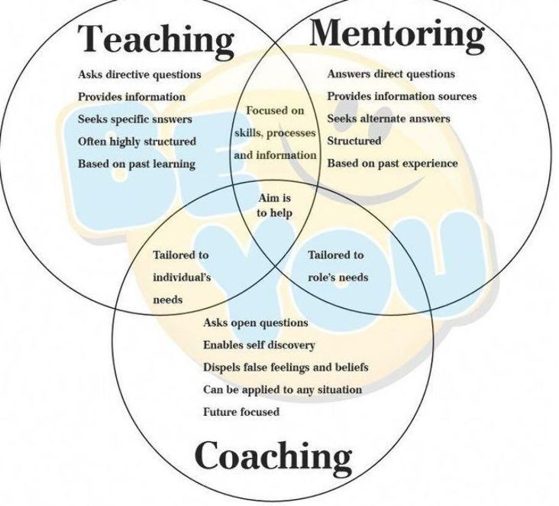

**III - Servant Leadership**

You must be the change you wish to see in the world. You are the change agent for your organization.

According to Robert K Greenleaf. The Servant-leader is servant first… it begins with the natural feeling that one wants to serve, to serve first. The conscious choice brings one to aspire to lead. That person is sharply different from one who is leader first, perhaps because of the need to assuage an unusual power drive or to acquire material possessions. The leader-first and servant-first are two extreme types. Between them there are shadings and blends that are part of the infinite variety of human nature.



On character and Servant Leadership

* Listening
* Empathy
* Healing
* Awareness
* Persuasion
* Conceptualization
* Foresight
* Stewardship
* Commitment to the growth of people
* Building community

**The Development Team**

* Small group containing all necessary project skills
* Typically, 4 – 9 people. Ideally 7+/- 2 (Note: Scrum Master & Product Owner Excluded)
* **Cross functional** – Programmers, testers, Architects user experience designers, etc.,
* Members should be full-time – May be exceptions for DBA’s
* Teams are **self-organizing** (No titles), Manages own work within Sprints
* Membership should change only between sprints
* Focuses on steady delivery of high-quality features
* Generates options for delivery
* Team has **common goal**. Individual Development Team members may have specialized skills and areas of focus, but accountability belongs to the Development Team as a whole.

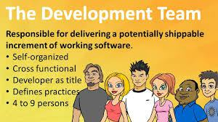

Team’s responsibilities include but not limited to:-

* Quality of the product increment
* Create the product increment
* Participate in all scrum meetings
* Implement good engineering practices like Continuous Integration, Continuous Delivery, Automation, Collective Ownership, Clean code, Simple design & effectively run the Test-Driven Development & Behavior Driven Development
* Create and manage the product backlog
* Identify and eliminate the “Technical Debt”
* Track progress of the sprint
* Helps the product owner in backlog management by explaining technical constraints
* Estimates Product Backlog items

##### Scrum Artifacts

**What are Scrum Artifacts?**

Scrum’s artifacts represent work or value to provide transparency and opportunities for inspection and adaptation. Artifacts defined by Scrum are specifically designed to maximize transparency of key information so that everybody has the same understanding of the artifact.

The core Scrum Artifacts are: -

* Product Backlog
* Sprint Backlog

**Product Vision**

A product vision is created by the product owner. The product must be in alignment with the company’s strategy that describes the business vision. It gives a view to all involved about why the work is being undertaken and what to expect from it.

**Product Roadmap**

Product Roadmap is a pictorial representation of which product features would be delivered in which release. It is created during the strategy meeting. The product roadmap equates to the product division as a whole. This is done and owned by the product owner.



**Product Backlog**

* An ordered list of all items that might be needed in the product
* Single source of requirements for any changes to be made to the product
* The Product Owner is responsible for the Product Backlog, including its content, availability and ordering. Items in the Product Backlog are called “Product Backlog Items (PBI)”
* Each product backlog item would have:
  + Description – Details of the item
  + Value – What business value this item would provide
  + Estimate – Effort estimates to build this item
  + Order – The order in which the items should be worked in

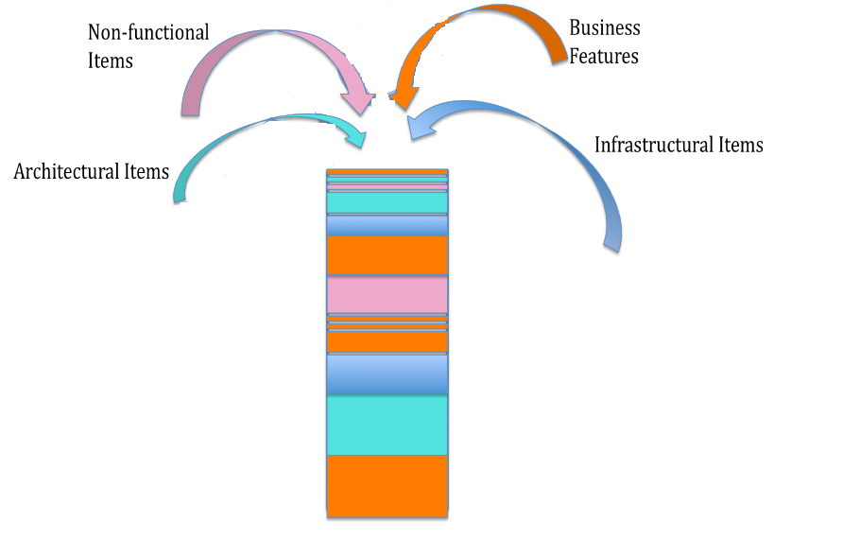

* The product owner sorts and prioritizes the backlog items
* The development team always works on the most important items based on the prioritized items in the product backlog
* The backlog is always prioritized before the current sprint
* Backlog refinement is done by both the product owner and the development team working in harmony is called grooming or refinement of backlog
* The team estimates their capacity to attack the items in the product backlog
* A Product Backlog is best described as **DEEP**
  + **D**etailed Appropriately: Higher order items are more detailed and well understood compared to lower order items
  + **Estimated:** Product backlog items are estimated i relative size by the development team. Product owner orders the items based on the value and the cost
  + **Emergent:** Product Backlog is a living artifact. It is always updated for details, estimates and order. The life of the product backlog is same as life of the product itself
  + **Prioritized:** Product backlog items are ordered based on the priority. The order is force ranking (1,2,3) so that there are no completing priorities
* To determine the **Priority**

Customervalue prioritization is concerned with working on the items that yield the highest value to the customer as soon as possible.

**MoSCoW** is a technique used to prioritize stories into four distinct categories:

* **M – MUST** have this  
  Requirements that are fundamental to the system; without which system will not work and have no value and have to be included in the current delivery time box
* **S – SHOULD** have this  
  Requirements that is important for project success; Important as MUST have but not as time-critical or have a work around. In other words, not necessary for delivery in the current delivery time box
* **C – COULD** have this  
  Requirements not necessary; can include if it increases customer satisfaction for little development cost
* **W – WON’T** have this time, but WOULD like in the future  
  Alternatively WANT – No to this release

**Release Backlog**

It is created during the Release Planning Meeting and includes only those user stories that are to be delivered in that release, it is a subset of the Product Backlog.

**Sprint Backlog**

It is a subset of Release backlog and contains only those user stories that are targeted to be delivered in the particular sprint. It is also accomplished by a plan for the sprint. This is created during Sprint Planning Meeting.

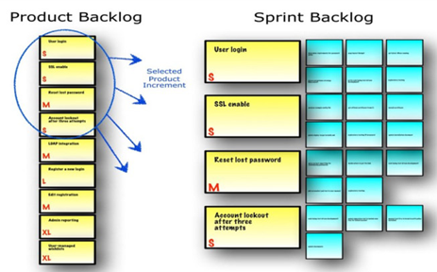

* Highest priority items take into the sprint for implementation and the plan to deliver those items is sprint backlog
* Sprint backlog is created during sprint planning
* Helps team see the total work involved in achieving the sprint goal
* Development team creates and manages the sprint backlog, this includes updating the time left of each task, create any forgotten tasks, update the status of each task etc.
* Team should keep the status of the items up to date so that the sprint progress is transparent
* All items should be updated at least once a day
* Team uses Daily Scrum meeting to inspect and adapt the Sprint backlog

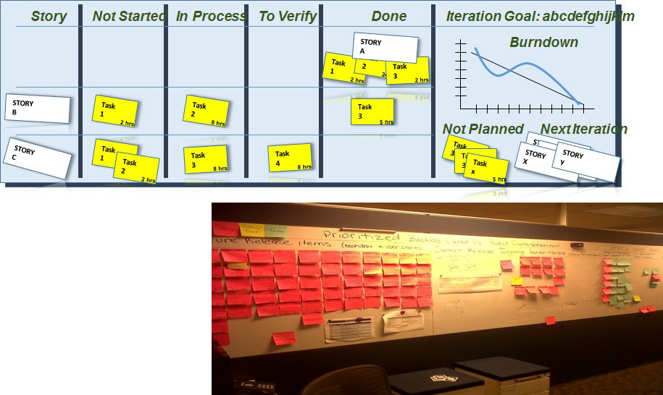

**Product Backlog Refinement**

Product backlog refinement is the process through which product backlog items are reviewed by the Scrum team and revised, providing more detail and ensuring that there is greater clarity in the requirements for that item.

When product backlog is initially created it would have items of various sizes, clarity and value. But a scrum team needs clarity on few most important to get started. Backlog could be depicted as the following picture. Items at the top are important right now and should be smaller in size and more details so that team could start implementing them in upcoming sprints. As you go lower the product backlog, the items are less important ad less detailed. Product owner elaborates them as they become important.

Scrum has an activity called “Product Backlog Refinement” to progressively elaborate the product backlog.

* Primary goal of product backlog refinement is to get ready with few items for upcoming one or two sprints
* Product Backlog items that are refined are deemed “Ready” for selection in a Sprint Planning
* Product Backlog Refinement is the act of adding detail, estimates and order to items in the Product Backlog
* Product Backlog Refinement is an ongoing activity throughout a Scrum project
* Team and PO decide the frequency and duration of backlog refinement meeting. However, it is time boxed at 10% of total available time.

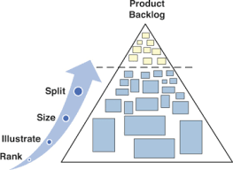

**Product Increment**

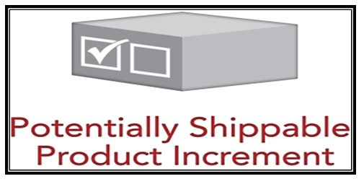

**Input:** Product Backlog Item | Output: Updated Product Backlog

**Should the team always release the Product Increment?**

At the end of each sprint, the team must produce a potentially shippable product increment with the following features

* + High Quality
  + Tested
  + Completed
  + Ready to Use
  + As per Definition of Done
* It depends. If the product increment that is produced is usable and adds the value to the business, product owner may choose to release it right away.
* Though the product increment is working, it may not be the feature complete and product owner may not want to release it
* Some business doesn’t want to surprise their customers too often by frequent release
* Whether the product increment is shipped or not, building working software every sprint eliminates the technical uncertainty

##### Scrum Events | Meetings

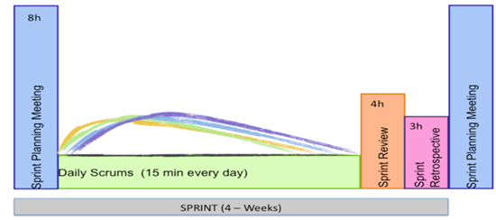

Prescribed events are used in Scrum to create regularity and to minimize the need for meetings not defined in Scrum. All events are time-boxed events, such that every event has a maximum duration. Once a Sprint begins, its duration is fixed and cannot be shortened or lengthened. The remaining events may end whenever the purpose of the event is achieved, ensuring an appropriate amount of time is spent without allowing waste in the process.

Other than the Sprint itself, which is a container for all other events, each event in Scrum is a formal opportunity to inspect and adapt something. These events are specifically designed to enable critical transparency and inspection. Failure to include any of these events results in reduced transparency and is a lost opportunity to inspect and adapt. Scrum activities are also known as events or ceremonies

The major scrum events or ceremonies:

* + Sprint planning
  + The Sprint
  + Daily scrum
  + Sprint reviews
  + Sprint retrospective

**Timeboxing**

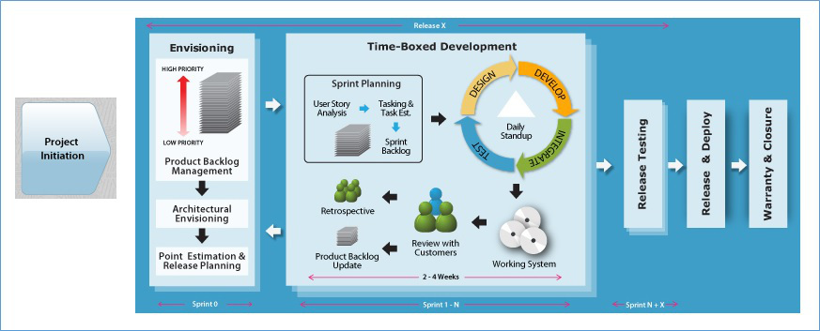

* + Time boxing is the maximum time allowed for an event
  + Time boxing makes tams focus on most important things first
  + All Scrum events are time boxed. Sprints are time boxed @ 1 to 4 weeks
  + Other Scrum events are time boxed based on the sprint duration
  + All official Scrum Events use the agile concept of Timeboxing.
  + The SM ensures the events are kept within the timebox.
  + Timeboxing helps the members of the Scrum Team™ stay focused on the same objective.
* As a result, the members who work on a problem are encouraged to come up with the best solution in the time allotted
  + Timeboxing limits the work in progress.

**Extending a Sprint for a few more days to achieve the Sprint Goal is not allowed**

**Sprint Planning**

The purpose of sprint planning meeting is to determine what the work will be done in that sprint and how the work will be achieved.

|  |  |
| --- | --- |
| **Who Attend?** | Dev Team, Product Owner and Scrum Master |
| **When?** | First day of the Sprint |
| **Time box** | 4 hours for 2 weeks Sprint | 8 hours for 4 weeks Sprint |
| **What?** | * Discuss Sprint Backlog * What to do? – Product Owner * How to do? – Development Team |
| **Input** | * Refined Product Backlog * Latest product increment * Projected team’s capacity * Team’s prior performance |
| **Outcome** | Sprint Backlog & Sprint Goal |

**How the Sprint Planning meeting gets executed?**

* Product Owner and Project team needs to discuss the goals of the upcoming sprint
* Product Owner and team negotiates stories to select in current sprint from prioritized product backlog for the upcoming sprint
* Selected stories are estimated with agreed acceptance criteria
* Team identifies and estimates Task, discusses how the work will be accomplished
* Scrum Master, Product Owner and team can attend the meeting
* Product Backlog has to be groomed by PO prior to sprint planning meeting, Product owner reviews with the team items in the updated backlog
* Self-organized Development team defines how the work will be done in the goals of the sprint will be achieved
* Normally split into 2 sets of 4 hours each Timebox: Max 8 hours per sprint
* First half for choosing the product backlog items with PO
* Second half for splitting into tasks and assignment (Product Owner is optional for the second half)
* The development team predicts what can be delivered based on estimates, projected capacity, and past performance to define the sprint goal.
* The development team then determines how this functionality will be built and how the team will organize to deliver the sprint goal.
* Output of this will be the sprint backlog. The work to get done in the next sprint.
* Artifacts – Sprint Goal, Sprint Backlog (Output of Sprint Planning)

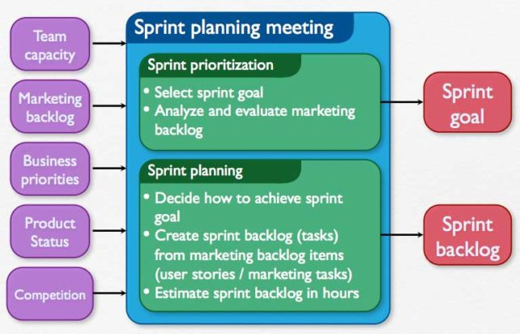

**Input:** Refined Product Backlog | Latest Product Increment | Team Capacity

**Outcome:** Sprint Goal | Sprint Backlog

**Sprint Goal**

The Sprint Goal is an objective set for the Sprint that can be met through the implementation of Product Backlog.

It provides guidance to the Development Team on why it is building the Increment. It is created during the Sprint Planning meeting. The Sprint Goal gives the Development Team some flexibility regarding the functionality implemented within the Sprint. The selected Product Backlog items deliver one coherent function, which can be the Sprint Goal. The Sprint Goal can be any other coherence that causes the Development Team to work together rather than on separate initiatives.

As the Development Team works, it keeps the Sprint Goal in mind. In order to satisfy the Sprint Goal, it implements the functionality and technology. If the work turns out to be different than the Development Team expected, they collaborate with the Product Owner to negotiate the scope of Sprint Backlog within the Sprint.

**Sprint Cancellation**



A Sprint can be cancelled before the Sprint time-box is over. Only the Product Owner has the authority to cancel the Sprint, although he or she may do so under influence from the stakeholders, the Development Team, or the Scrum Master.

A Sprint would be cancelled if the Sprint Goal becomes obsolete.

This might occur if the company changes direction or if market or technology conditions change. In general, a Sprint should be cancelled if it no longer makes sense given the circumstances. But, due to the short duration of Sprints, cancellation rarely makes sense.

When a Sprint is cancelled, any completed and “Done” Product Backlog items are reviewed. If part of the work is potentially releasable, the Product Owner typically accepts it. All incomplete Product Backlog Items are re-estimated and put back on the Product Backlog.

The work done on them depreciates quickly and must be frequently re-estimated. Sprint cancellations consume resources, since everyone has to regroup in another Sprint Planning to start another Sprint. Sprint cancellations are often traumatic to the Scrum Team, and are very uncommon.

**The Sprint**

The heart of the Scrum is Sprint. A sprint is a timeboxed(time-limited) iteration of 1 - 4 weeks to build a potentially releasable product.

Each sprints contain and consists of the following: -

* Sprint Planning
* Daily Scrums
* Development work
* Sprint Review
* Sprint Retrospective

Sprints best have consistent durations throughout a development effort. A new Sprint starts immediately after the conclusion of the previous Sprint.

During the sprint, no changes are made that would affect the sprint. The development team members are kept the same throughout the sprint

The development team works on one item at a time to completely build it such that each item could be usable and releasable. Team does all the functions required to complete each item.

**Sprint is protected**

During the Sprint: -

* No changes are made that would endanger the Sprint Goal;
* Quality goals do not decrease; and,
* Scope may be clarified and re-negotiated between the Product Owner and Development Team as more is learned.

Each Sprint may be considered a project with no more than a one-month horizon. Like projects, Sprints are used to accomplish something. Each Sprint has a definition of what is to be built, a design and flexible plan that will guide building it, the work, and the resultant product.

Sprints are limited to one calendar month. When a Sprint’s horizon is too long the definition of what is being built may change, complexity may rise, and risk may increase. Sprints enable predictability by ensuring inspection and adaptation of progress toward a Sprint Goal at least every calendar month. Sprints also limit risk to one calendar month of cost.

**Architecture is built incrementally**

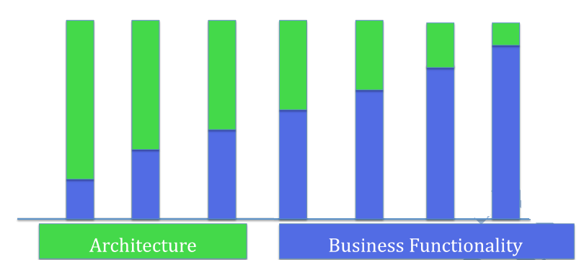

**Test small test often**

* Testers are involved right from the beginning
* Developers check in code in smaller testable chunks
* Testers try the functionality to see its working
* Testers and developers collaborate throughout the sprint
* The goal is to deliver usable product increment at the end of every sprint

**What else happens in a Sprint?**

* DBA’s, sysadmin, Technical Writers and any other supporting members are involved ASAP. Data models and database design done incrementally
* Documentation evolves as the stories are implemented
* Executable test document the test cases

**Sprint | Iteration**

* Sprint and iteration are essentially the same things. The standard duration for each is two weeks.
* Iteration is a small amount of time (1 to 4 weeks) used to build a small part of the product
* Iteration planning meetings have two parts that are time-boxed

**Part 1 – What**

* Product Owner explains the items at the upper part of the Product Backlog
* Team estimates how much they can take on in an iteration
* Team makes a preliminary commitment

**Part 2 – How**

* Team Plans how they are going to implement their commitment
* Team starts with design, and this leads to a list of tasks (Iteration Backlog)
* Team confirms their commitment (or adjust it)

**Sprint | Iteration 0**

Iteration 0 is conducted at the start of every release to: -

* (Re) Validate the core and extended team members
* Identify all dependent group signoff need
* Identify the development and test environment
* Identify the dependencies on other projects, teams & resource that may influence the release schedule
* Identify the deliverables and signoff needed
* Identify number of iterations for the release using team velocity (if any)
* Identify the schedule for release testing and release iteration | sprint. As a guideline, have release iteration after every three-time boxed developed iterations
* Identify any assumptions made
* Identify the risks involved in the project
* Detail the project | release schedule
* Create a release plan

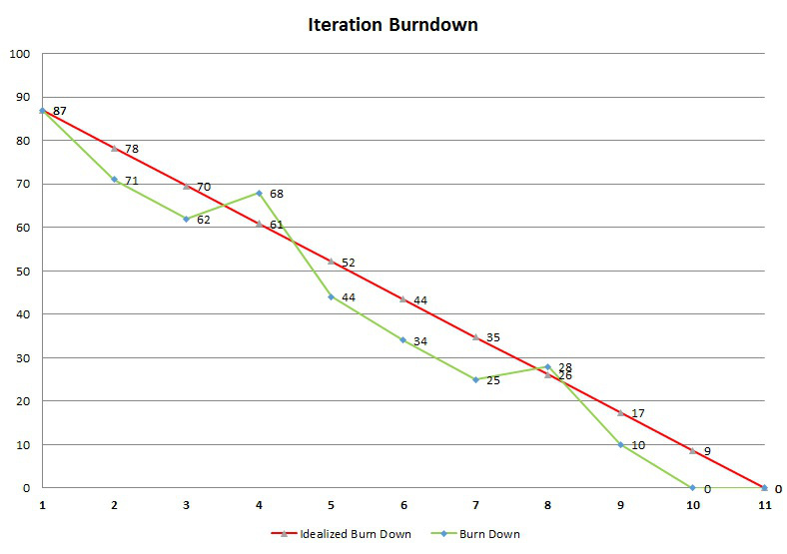

**Daily Scrum**

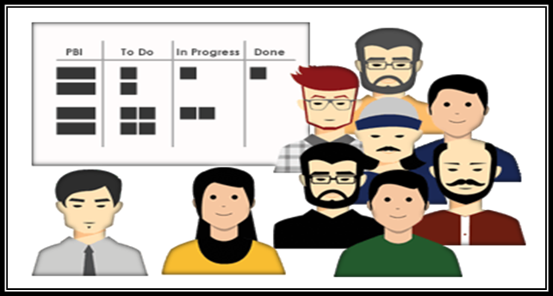

|  |  |
| --- | --- |
| **Who Attend?** | Dev Team and Scrum Master |
| **When?** | Entire Sprint duration |
| **Time box** | Max 15 Mins |
| **What?** | * What did you do yesterday? * What will you do today? * Are there any impediments in your way? |
| **Input** | Sprint Backlog & Sprint Goal |
| **Outcome** | * Plan for next 24 hours * List of impediments if any |

* The purpose of the daily scrum meeting is for development team to sync up, team will inspect and adapt the sprint backlog.
* A 15-minute time-boxed activity for the Development Team to synchronize activities and create a plan for the next 24 hours
* Should be held at the same time and place each day
* Scrum master makes teaches the team how to stick to the time box, make sure that the meeting is happening and facilitates if needed
* Development team member gets together and answer 3 questions:
* What did you do yesterday?
* What will you do today?
* Are there any impediments in your way?

**Sprint Review**

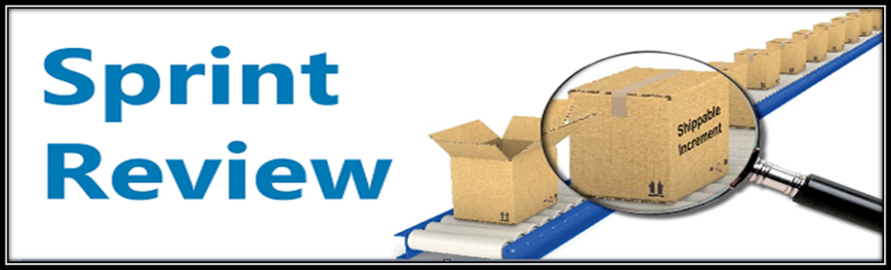

|  |  |
| --- | --- |
| **Who Attend?** | Product Owner, Dev Team and Scrum Master |
| **When?** | Last day of the Sprint |
| **Time box** | 2 hours for 2 weeks sprint | 4 hours for 4 weeks sprint |
| **What?** | Review Product Increment & give feedback. Feedback goes to the Product Backlog |
| **Input** | Product Increment, Product Backlog & Market Conditions |
| **Outcome** | * Feedback on Product * Updated Product Backlog * Direction for the Product Backlog |

* The purpose of the Sprint Review meeting is to inspect and adapt the product itself.
* Should be time boxed to no more than an hour per week of Sprint
* Product Owner invites few key stakeholders, Scrum Master make sure that the meeting is happening and teaches the team on how to complete it with in the time box
* Takes place at the end of the Sprint
* Development Team demonstrates the product increment built during the sprint
* Development Team talks about any impediments they have to work through while building the product
* Designed to gather feedback from stakeholders on what the Team has completed in the sprint, Stakeholders talks about the market conditions, future direction etc.,
* Product Owner presents the product backlog as it is and discusses what is done and what is not
* To create a conversation between the Team and the stakeholders about how to make the product better
* Product Owner updates Product Backlog based on the new learning

**Sprint Retrospective**

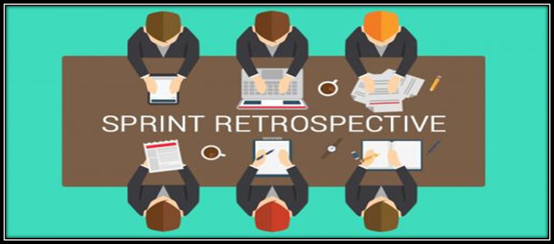

|  |  |
| --- | --- |
| **Who Attend?** | Product Owner, Dev Team and Scrum Master |
| **When?** | Last day of the Sprint |
| **Time box** | 3 hours for 4 weeks sprint |
| **What?** | * What went well? * What did not went well? * Any improvement – Identify the improvement list |
| **Input** | * Feedback |Experiences in the sprint * Current Practices |
| **Outcome** | Prioritized list improvements |

* The purpose of the sprint retrospective meeting is to inspect and adapt the process, practices, tools and behaviors of Scrum team members.
* Scrum master attends the accountability standpoint as well as helps the team complete the meeting within the time box
* Opportunity for the Team to inspect and create a plan for improvements to be done during the next Sprint.
* Team discusses: -
* What went well?
* What went wrong?
* What are the improvements? | What to do more of?

**The Definition of Done**

* Definition of Done is a list of attractive activities agreed by the Product Owner and the Development Team to call a backlog item is done during the sprint.
* Definition of Done consist of activities needed for functional and quality requirements
* Team comes up with the DOD and adheres to it while creating the product increment
* Different teams may have different DOD but all teams should follow minimal DOD that includes all critical activities required
* If there are standards at organizational level, a common DOD can capture those and the teams should have separate DOD in addition to one at the organizational level

A stronger DOD leads to higher quality product: -

* Code Complete
* Unit tests Written
* Code Review
* Manual Functional Testing
* Automation
* Updated Documents
* User Acceptance Testing
* Successful Deployment
* Suppose if the DOD is missing essential activities, it is called a Weak DOD. For E.g. Load testing may not be done for every sprint and is deferred to later time.
* A weak DOD causes unfinished work in every sprint. The unfinished work is added back to product backlog. This increased the risk. If a major bug is found during the load testing, that could risk the release
* Weak DOD also increases the Technical Debt. This might include the automation or code reviews

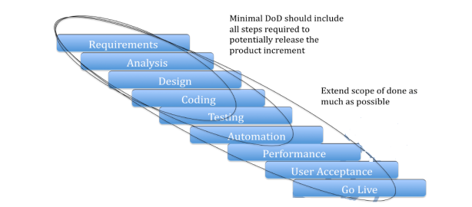

**Scrum Meetings Comparison**

|  |  |  |  |
| --- | --- | --- | --- |
| 1. Sprint Planning | | 2. Daily Scrum | |
| Who | Product Owner, Dev Team | Who | Dev Team |
| When | First day of Sprint | **When** | Entire Sprint duration |
| Time box | Max 8 hours | **Time box** | Max 15 Mins |
| What | * Sprint Back log  * What to do? – Product Owner  * How to do? – Team | **What** | * What did you do yesterday?  * What will you do today?  * Are there any impediments in your way? |
| Input | Prioritize Product Backlog | **Input** | Sprint Backlog |
| Outcome | Sprint Goal, Sprint Backlog | **Outcome** | Updated Sprint Backlog |
|  |  |  |  |
| 3. Sprint Review | | **4. Sprint Retrospective** | |
| Who | Stakeholders, Product Owner, Scrum Master | Who | Scrum Master, Product Owner, Team |
| When | Last day of Sprint | **When** | End of Sprint |
| Time box | Max 4 hours for 4 weeks | **Time box** | Max 3 hours |
| What | Review Product Increment & give feedback, feedback goes to product backlog | **What** | * What went well  * What did not went well  * Any Improvements  * Identify the improvements list |
| Input | Product Increment | **Input** | Feedback / Experience of team members |
| Outcome | Product Backlog (Revised) | **Outcome** | List of Improvements |

##### User Stories & Estimation

**User Stories**

**What is User Story?**

User stories are well suited as product backlog items. User story is not a concept from Scrum but commonly used in Scrum projects to manage requirements.

User Story is as any user, I want to create my account: -

* Token for the feature
* Usually written on a small index card
* Captures intent of the failure
* Captures conditions of satisfaction or acceptance test criteria

**User story is written in which format?**

As a <who> I want to <what> So that < why>

Who: User of the product

What: Activity user wants to perform using the feature

Why: Purpose the feature is going to serve.

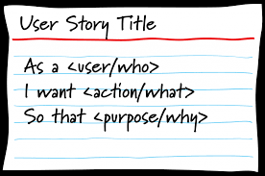

**What 3C’s of User story?**

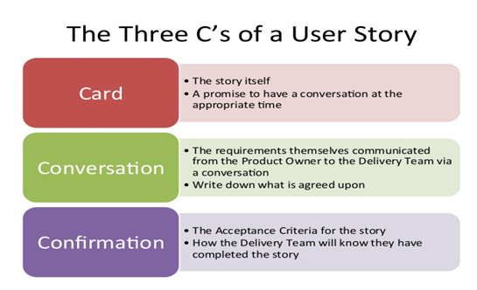

**Acceptance Criteria of User Story?**

Acceptance Criteria is the criteria if the product satisfies the user story is considered done. Acceptance Criteria is basis for high level test cases.

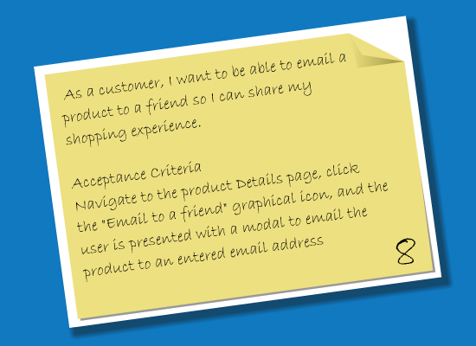

**How to write good user stories?**

It is essential to write user stories, which are small and independent enough to be worked on in each sprint. For a good product backlog, the team should INVEST in good user stories:

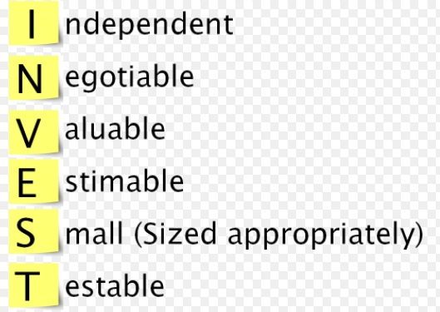

**Independent:** Stories should be independent enough so that the team does not have to pull in many other stories along with that story.

**Negotiable:** Team should be able to negotiate stories in and out of a sprint. This way the team can maximize the value.

**Valuable:** Valuable to the customer directly or indirectly. A technical story may not add a direct value to the customer.

**Estimable:** Team should be able to estimate the stories. This requires clarity on detail and the stories are independent.

**Sized Appropriately:** Higher order stories are smaller in size such that they could be completed in a sprint

**Testable:** A story should cover one piece of functionality that could be tested in isolation

**How to split the User Story?**

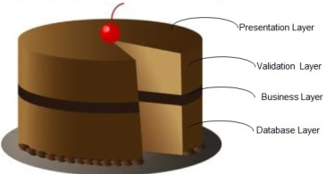

We can split the user story into the different layers such as:-

* Presentation Layer
* Validation Layer
* Business Layer
* Database Layer

**Estimation: Planning Poker Game**

During Agile estimation, use poker card to raise the points as per the baseline.

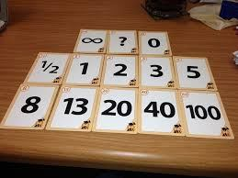

Planning Poker® is a consensus-based estimating technique. Agile teams around the world use Planning Poker to estimate their product backlogs. Planning Poker can be used with story points, ideal days, or any other estimating unit.

Planning Poker is an agile estimating and planning technique that is consensus based. To start a poker planning session, the product owner or customer reads an agile user story or describes a feature to the estimators.

Each estimator is holding a deck of Planning Poker cards with values like 0, 1, 2, 3, 5, 8, 13, 20, 40 and 100, which is the sequence we recommend. The values represent the number of story points, ideal days, or other units in which the team estimates.

The estimators discuss the feature, asking questions of the product owner as needed. When the feature has been fully discussed, each estimator privately selects one card to represent his or her estimate. All cards are then revealed at the same time.

If all estimators selected the same value, that becomes the estimate. If not, the estimators discuss their estimates. The high and low estimators should especially share their reasons. After further discussion, each estimator reselects an estimate card, and all cards are again revealed at the same time.

The poker planning process is repeated until consensus is achieved or until the estimators decide that agile estimating and planning of a particular item needs to be deferred until additional information can be acquired.

**Estimate the Painting Project**

|  |  |
| --- | --- |
| Master Bedroom 20 Ft * 16 Ft – Walk in Close (1/8) | 20 |
| Store Room – 4 Ft * 6 Ft | 2 |
| Kid’s Bedroom – 12 Ft * 12 Ft | 13 |
| Guest Bedroom – 10 Ft * 10 Ft | 8 |
| Study Room – 10 Ft * 10 Ft – Book Shelves | 8 |
| Living Room – 14 Ft * 14 Ft | 13 |
| Family Room – 20 Ft * 18 Ft – High Ceiling | 40 |
| Foyer – 6 Ft * 12 Ft | 5 |
| Servant Room – With Bathroom | 8 |
| Exterior Painting | 40 |

**Agile Estimation**

Product backlog items are estimated so that the product owner can make trade off decisions in prioritizing the items. Estimates are also required for release or long-term planning. In scrum, the product backlog items are progressively elaborated, so estimating them in hours is very difficult.

|  |  |  |
| --- | --- | --- |
|  | Problem | Solution |
|  | (Product Backlog Items) | (Tasks) |
| Who | Development Team | Development Team |
| When | Product Backlog Refinement | Sprint Planning |
| Unit of Measure | Story Points, Function Points, Use Case Point, Ideal Days, etc., | Hours |
| How | Planning Poker, Delphi, PERT, COCOMO, Expert Judgement, etc., | Expert Judgement |

**How estimation different in Scrum? Why do we need estimates?**

**Estimates are relative sizes**

* Humans are good at estimating by comparison
* Backlog items are estimated in relative sizes
  + Size 4 item is roughly two times bigger than size 2 item
* Size represents the relative effort it takes to complete the item
  + Size 4 item takes two time longer than size 2 item
* Estimates are influenced by
  + How much is there?
  + How hard is it?
* Estimates are at the right granularity
  + Estimates should be roughly accurate than precisely wrong

**Common units of estimation using Story Points**

Indicates how big is an item?

A 4-point item is two times bigger than 2-point item

Unit less

**How long it will take in days (Ideal days) if?**

It’s all you worked on

No interruptions

No impediments

**Advantages of Story Points**

Story points are additive, time-based estimates may not be

Story points avoids unit confusion

|  |  |
| --- | --- |
| **Estimate the cement plastering / painting project**  First baseline one area and arrive other area | |
| **Area** | **Story Points** |
| Master Bed Room 20 ft * 16 ft – Walk in closet (1/8) | **20** |
| Store Room – 4 ft * 6 ft – (**Baselined**) | **2** |
| Kid’s Bed Room – 12 ft * 12 ft | **13** |
| Guest Bed Room – 10 ft * 10 ft | **8** |
| Study Room – 10 ft * 10 ft with Book Shelves | **8** |
| Living Room – 14 ft * 14 ft | **13** |
| Family Room – 20 ft * 18 ft with High Ceiling | **40** |
| Foyer – 6 ft * 12 ft | **5** |
| Servant Room along with bathroom | **8** |
| Pet Dog Room –  4 ft * 6 ft | **2** |
| Exterior Painting | **40** |

**Exercise – Derive the story points for below house**

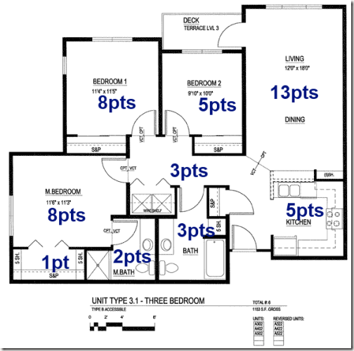

**Agile Capacity Planning**

**Capacity planning** is the process of determining the production **capacity** needed by an organization to meet changing demands for its products. In Scrum **Capacity planning**, the maximum amount of work that an organization is capable of completing in a given period to build the product.

* A successful sprint starts with the **planning session**.
* Taking the time to plan allows the team to review the work about to be undertaken, **estimate the effort required to complete that work**, and then **commit to a prioritized list of stories and tasks that are within the team’s calculated capacity**.
* Agile planning session is to present a **collection of user stories**to the team and allow them to be estimated. This is where team **effort gets aligned with business direction**
* At the **end of the session**, the team should feel committed to completing the work required to implement the agreed-upon list of user stories during the **next sprint**
* A well-formed agile team has a **product owner**who is prepared for the planning session and is ready to present sprint goals and a prioritized list of stories for estimation by the team
* The **product owner**should review the product backlog frequently so that stories are staged and ready-to-go for planning sessions based on the latest business priorities product owner who can clearly state the Vision (why the agile team exists) and can formulate clearly the goals for each Sprint.
* This clearly stated vision and sprint goals should be used to begin the sprint planning session, so that guiding principles can be applied to each story considered for estimating. New stories are typically unfolded as the team asks questions of the product manager during the planning session.
* **Two best practices**for determining team capacity are: -
* **The total capacity of the team should be based on the following equation:**
* **# of team members × # of days in the iteration × (no more than) six hours**
* **Suppose a five-member, well-formed agile team is planning a ten-day sprint.**
* The capacity of the team is quickly established to be
* **5 members × 10 days × 6 hours per day = 300 hours capacity.**
* The ideal daily burn down is, therefore, thirty hours (300 hours of capacity ÷ 10 day sprint).

**Capacity Planning Hours spent in Ceremonies**

|  |  |  |  |  |
| --- | --- | --- | --- | --- |
| S. No | Action Items | Formula | Sample | Actual |
| A | Sprint Planning | =           4   Hours     *   4 Developers | 16 Hours |  |
| B | Daily Scrum | =           5  Mins       *    5 Days | 1.25 Hours |  |
| C | Sprint Review | =            2 Hours     *     1 Developers | 2 Hours |  |
| D | Sprint Retrospective | =            2 Hours     *     1 Developers | 2 Hours |  |
| E | Product Backlog Refinement | =            4 Hours     *     1 Developers | 4 Hours |  |
| F | Others |  | 10 Hours |  |
|  |  | Total | 35 Hours |  |

##### Release Planning

The release planning is a tentative plan for the whole release that covers several sprints

The **Input** for release plans is: –

* Release strategy, Priority
* Estimated Product backlog that gives the total size of the release
* Velocity of the team which represents the productivity
* Assumptions, constraints and risks

**Total size of the backlog**

* Development team estimates items in the backlog. Since all items won’t be clear. the team makes their best guess.
* Any estimation technique like planning poker or affinity estimation could be used
* Team can iterate over estimates until they feel that the overall estimate is roughly accurate

**Velocity**

* A long-term measure that indicates how much work is “done” per sprint
* Velocity is number of points completed per sprint
* Particularly finished stories don’t count
* Velocity varies in every sprint

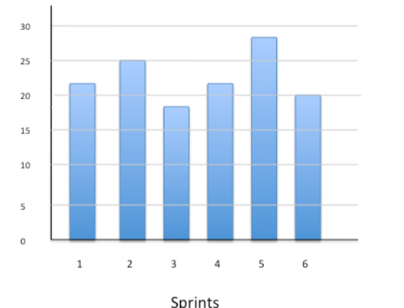

**How do we know the team’s velocity?**

* If the team is in place for some time, look at the history of the team’s velocity
* If the team is new, run couple of sprints to establish the initial velocity
* Use the average velocity over several sprints to predict the completion date

**Let’s plan a release**

Let’s say the release backlog of size 100 points. The team ran 4 sprints and had velocities of 8, 11, 9, 10

Average velocity for 4 sprints: 38/4 = 9.5

Best Velocity:11    |   Worst Velocity: 8

Remaining points after 4 sprints: 62 | Required sprints to complete 62 points (Round up value)

@ Average velocity: 62/9.5 = 7 sprints | @Best Velocity: 62/11 = 6 sprints | @ Worst Velocity: 62/8 = 8 sprints

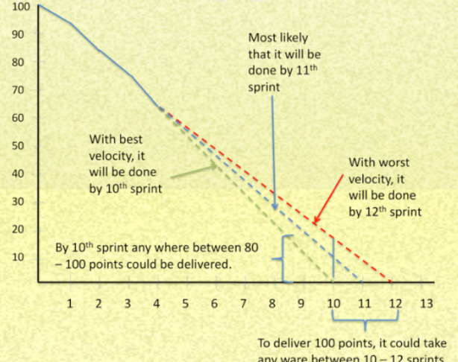

The **output** for release plans is: –

* Release scope/date
* Prioritized backlog
* Ordered estimated in size and forecasted in sprint, Release burnt chart

## XP

**What is XP?**

* Extreme programming is also known as XP
* XP is all about software development best practices, while scrum at the project management level focuses on prioritizing work and getting feedback

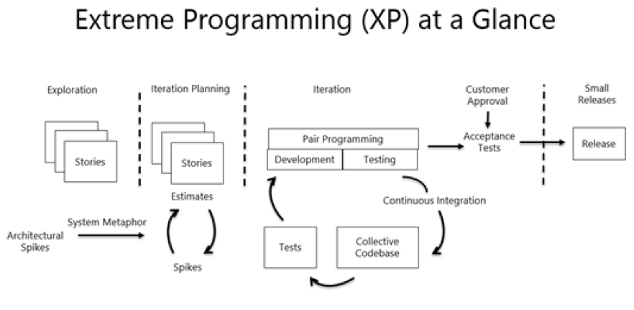

XP recognizes that:

* All requirements will not be known at the beginning
* Requirements will change
* Use tools to accommodate, change as a natural process
* Do the simplest thing that possibly work and refactor
* Emphasis values and principles rather than process

**Share XP Life Cycle or overall flow of XP?**

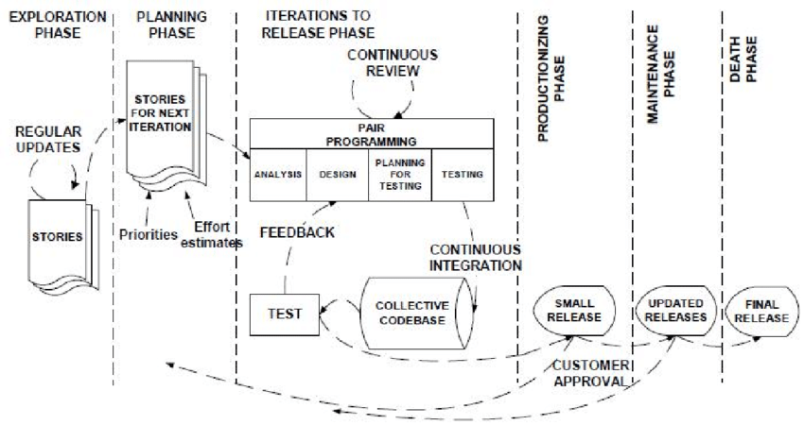

**What are XP Values?**

XP has simple rules that are based on 5 values to guide the teamwork, The XP Values are Simplicity, Communication, Feedback, Courage & Respect.

1. **Communication.** Everyone on a team works jointly at every stage of the project.
2. **Simplicity.** Developers strive to write simple code bringing more value to a product, as it saves time and effort.
3. **Feedback.** Team members deliver software frequently, get feedback about it, and improve a product according to the new requirements.
4. **Respect.** Every person assigned to a project contributes to a common goal.
5. **Courage.** Programmers objectively evaluate their own results without making excuses and are always ready to respond to changes.

These values represent a specific mindset of motivated team players who do their best on the way to achieving a common goal. XP principles derive from these values and reflect them in more concrete ways.

**Simplicity**

Reducing complexity, extra features, and waste. Find the simplest thing that could possibly work

**Communication**

* Ensuring that the project team knows what is expected of them
* Ensuring the project team knows what other people are working on
* The daily standup meeting is an excellent communication tool

**Feedback**

* The development team needs feedback early in the project
* Failing fast is a way to get feedback early
* Feedback gives the team an opportunity to improve the project

**Courage**

* Developers’ work is entirely visible to others on the project team
* Team members share code and correct each other’s code
* XP uses pair programming

**Respect**

* Team members must respect one another
* Everyone is responsible for the success and or failure of the project
* Everyone works differently but must work together

**What are the 5 XP Principles?**

1. **Rapid feedback.** Team members understand the given feedback and react to it right away.
2. **Assumed simplicity.** Developers need to focus on the job that is important at the moment and follow YAGNI (You Ain’t Gonna Need It) and DRY (Don’t Repeat Yourself) principles.
3. **Incremental changes.** Small changes made to a product step by step work better than big ones made at once.
4. **Embracing change.** If a client thinks a product needs to be changed, programmers should support this decision and plan how to implement new requirements.
5. **Quality work.** A team that works well, makes a valuable product and feels proud of it.

**Whate are the XP Concepts?**

The XP Concepts are: -

**Technical Debt:** Design and Coding imperfections that needed for correction. It is the cost of shortcuts that are accumulating over time, leading to: -

* Increased Risk
* Slower Time to Market
* Greater Maintenance & Enhancement Costs

Note: Unmanaged Technical Debt leads to systems too un-widely to use, and too expensive to fix, so team needs more attention to handle it on time.

**Stories:** Self-contained elements taken up for implementation

**Timeboxing:** Allocate time and wrap up by that time

**Last Responsible Moment:** Delay till when it is absolutely needed

**Iterations:** Design/Code/test/release within a specific duration

**Refactoring:** Improve Code quality without changing the behavior

**What are the XP Practices?**

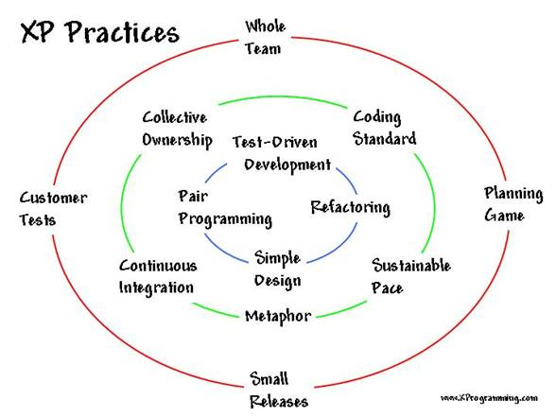

**Whole Team**

* XP team members are collocated
* Generalizing specialist not role specialist
* Efficient and sharing of information

**Planning games**

* Planning games are just planning activities
* Release planning is the release of new functionality
  + No more than one or two releases per year
  + The customer outlines the functionality required in the release
  + Developers estimate the difficulty to build the functionality
* Iteration planning is similar to sprint planning
  + Iteration planning happens at the start of every iteration
  + The customer defines what functionality they want to see by the end of the iteration
  + The development team estimates the difficulty to build the functionality

**Small Releases**

* Small releases to a test environment are part of the XP practices
* Increases visibility to the customer
* Helps to deploy working software to the end users

**Customer Tests**

* Definition of the required functionality
* Description of one or more test criteria for the software to be working

**Collective Ownership**

* Any pair of developers can improve or amend the code
* Multiple people will work on all the code
* Improve defect resolution in discovery
* Knowledge is shared not isolated

**Coding Standard**

* A coding standard is defined
* The team adheres to the standard
* Provides for consistency in writing the code

**Sustainable Pace**

* Productivity is optimized through a sustainable pace
* Consistent overtime and long hours are not sustainable

**Metaphor**

* Metaphors and similes are used to explain designs
* Metaphors help communicate the software to the customer

**Continuous Integration**

* Compiling the code frequently throughout the day
* Programmer’s check-in code to the code repository
* Integration test run automatically for immediate feedback

**Test Driven Development**

* Acceptance test are written prior to developing new code
* Initial tests will fail because the code has not been fully developed yet
* When the code has been written correctly it will pass the test

**Refactoring**

* Cleaning up the code
* Removing duplicated code
* Lowering coupling
* Increasing cohesion

**Simple Design**

* What is the simplest thing that could work?
* Simple does not mean easy
* Simple design is a risk mitigation approach

**Pair Programming**

* One person writes the code while the second person reviews the code
* The two people change roles frequently
* The pair will catch mistakes and speed up productivity

**What are the XP Team Roles?**

* **Coach** –Mentor/guide/facilitator/communicator similar to the Scrum Master
* **Customer** –the individual who provides requirements priorities and direction for the project similar to the product owner
* **Programmer** –the developers who write the code
* **Testers** –Define and write the acceptability test

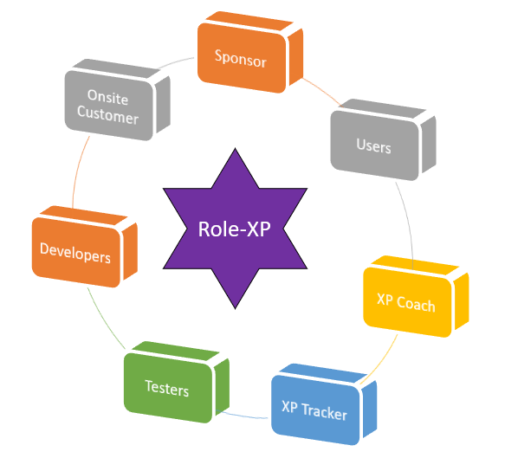

**XP Roles with On-Site Customers**

|  |  |
| --- | --- |
| **What they do** | **Who** |
| * Release Planning * Provide requirement details and answer queries * Prioritize stories * Reviewing work in progress * Leading iteration demos * Stay one step ahead of developers – Crunching, user stories and grooming the backlog train for future iterations | * Product managers * Domain Experts * Interaction Designers * Business Analysts |

**XP Roles with Programmers**

|  |  |
| --- | --- |
| **What they do** | **Who** |
| * Pair Programming * Incrementally Design & Architect * Pare down technical debt * Configuration Management: Single Code base and automated builds * Implement code and refactor * Adhere to coding standards | * Programmers * Designers and Architects * Technical Specialist |

**XP Roles with Testers**

|  |  |
| --- | --- |
| **What they do** | **Who** |
| * Automate regression tests * Test for functional and non-functional requirements * Exploring testing * Automated tests in nighty builds | * Manual testers * Automation Engineers |

**XP Roles with Coach**

|  |  |
| --- | --- |
| **What they do** | **Who** |
| * Process Coaching * Technical Coaching * Access to resources * Impediment removal * Guidance an support | * Coaches * Project Managers * Quality Analysts * Executive Sponsors |

**XP Feedback Loops**

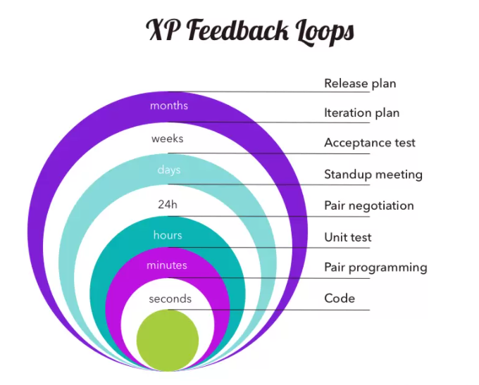

**Comparison of XP with other Frameworks?**

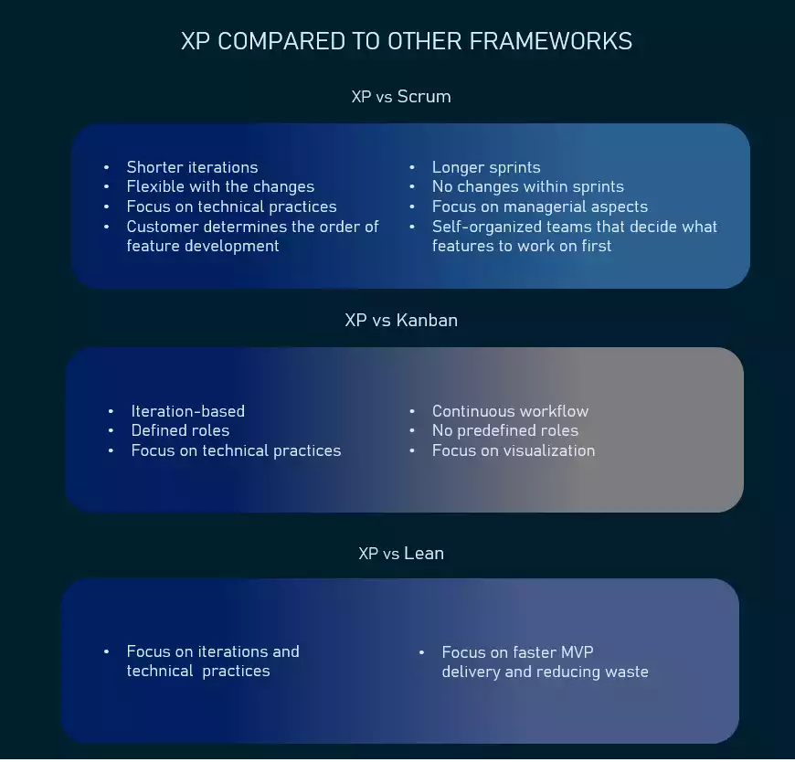

**When to use XP?**

It’s important to make sure a company’s size, structure, and expertise, as well as the staff’s knowledge base allow for applying XP practices. These are the factors to consider.

**Highly-adaptive development.** Some systems don’t have constant functionality features and implies frequent changes. XP was designed to help development teams adapt to fast-changing requirements.

**Risky projects.** Teams applying XP practices are more likely to avoid problems connected with working on a new system, especially when a customer sets strict deadlines for a project. Additionally, a high level of customer engagement reduces the risk of their not accepting the end product.

**Small teams.** XP practices are efficient for teams that don’t exceed 12 people. Managing such groups is usually easier, communication is more efficient, and it takes less time to conduct meetings and brainstorming sessions.

**Automated testing.** Another factor that can influence the choice of XP is the developers’ ability to create and run unit tests, as well as availability of the necessary testing tools.

**Readiness to accept new culture and knowledge.** XP is different from traditional approaches to software development, and the way some of its practices should be implemented might not be obvious. So, it’s important that your organization and team members are ready to embrace change. It’s also worth inviting an experienced coach if you don’t have previous involvement with XP.

**Customer participation.** As XP requires customers, developers and managers to work side-by-side, make sure your client is always available to provide input until a project ends.

Agility principles are becoming increasingly popular as they prove their effectiveness. Even though extreme programming is not the most widespread methodology, it offers a lot of sensible practices that can benefit software development and are worth considering for implementation in your projects.

**What are the Pros and Cons of XP?**

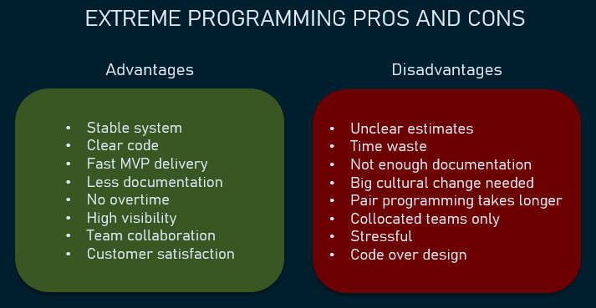

## Lean Kanban

**Lean**

**What is Lean Software Development?**

* Lean is a set of principles that have been taken from lean manufacturing approaches and applied to software development
* Lean is not an agile methodology but agile values are closely aligned.
* Toyota production system
* Visual management tools
* Customer to find value
* Learning and continuous Improvement



**Lean Principles & Practices**

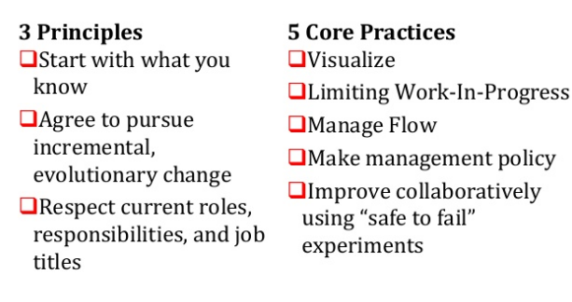

**What are the Seven Lean Core Concepts?**

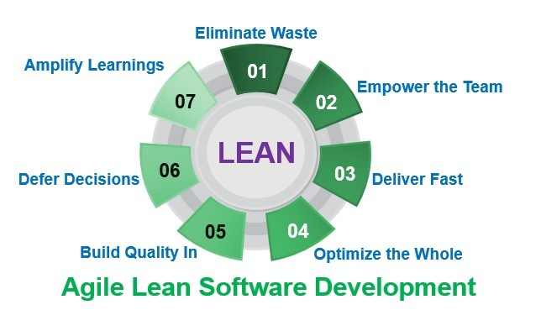

**What are the Seven Wastes of Lean?**

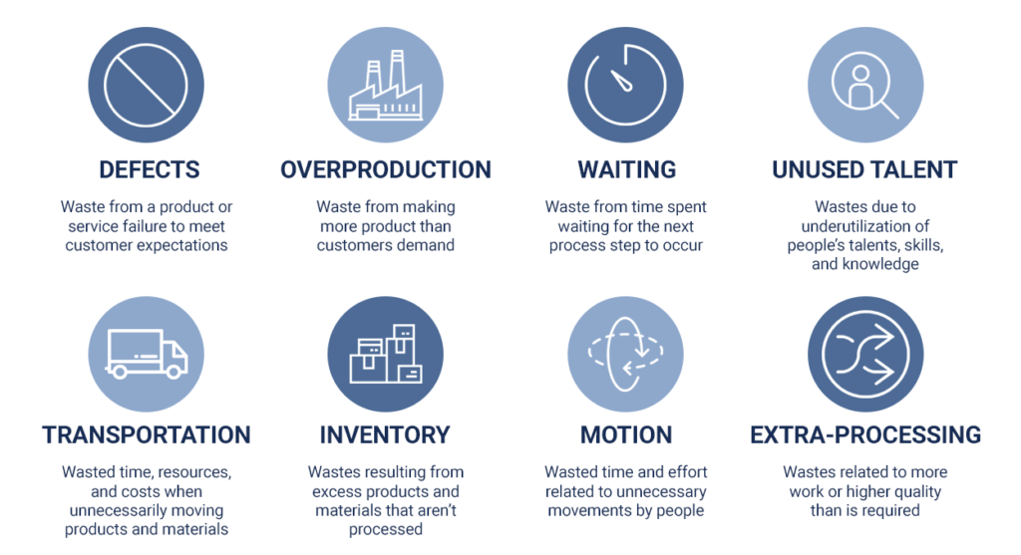

**Match the Agile Practices to Lean Development?**

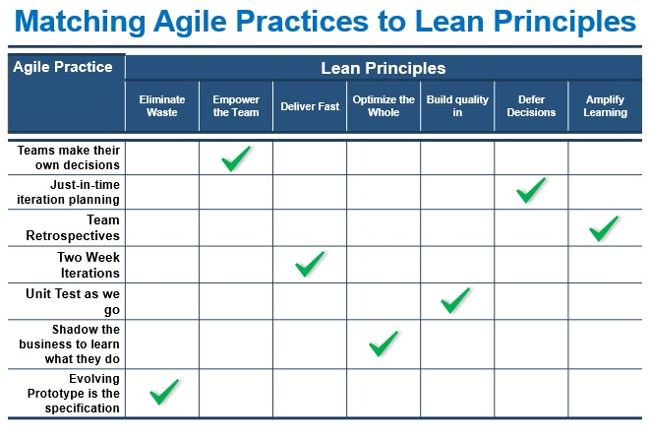

**What are the Value Stream Mapping Terms?**

**Value Stream Mapping** is a lean management method for analysing the current state and designing a future state for the series of events that take a product or service from its beginning through to the customer

**Lead time** is the time taken from when an issue is logged until work is completed on that issue. Lead time is what customer sees

**Cycle Time** is a measure of the time a work item takes to complete. The time a user story takes to get from the backlog to the done

**W I P (Work In Progress):**Number of work units in progress.

**Throughput**: The amount of material, data, work units that enters into a system and passes to generate output. Velocity, in Agile terms, can be the similar to this

**Little’s Law**: Cycle Time = W I P / A C R* Where *ACR = Average Completion Rate

**Total Cycle Time**= Value Added Time + Non Value-Added Time

**Cycle Time Efficiency**: (Value Added Time / Total Cycle Time) * 100

**What is 5S Framework?**

5 S is a methodology that had come out of the techniques within Total Productive Maintenance (TPM) and from the Toyota Production Systems (TPS).

5 S method uses a list of five Japanese Words: Seiri (Sort), Seiton (Straighten), Seiso (Shine), Seikketsu (Standardize), and Shitsuke (Sustain)

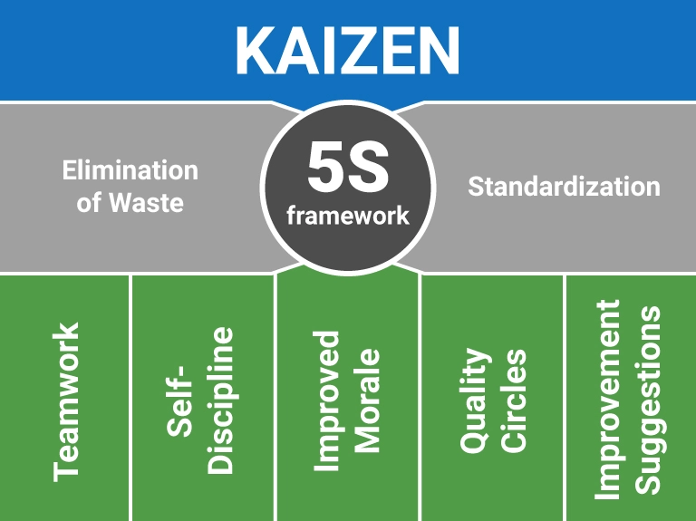

**What is 5 Why’s?**

* The 5 Whys is an interactive question-asking technique used to explore the cause-and effect relationships underlying a problem.
* By asking why 5 times and answering it each time we can get the real cause of the problem.
* It is a brainstorming technique

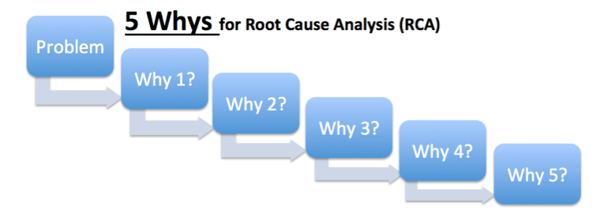

**Fishbone Diagram**

A fishbone diagram is a cause-and-effect discovery tool that helps figure out the reason(s) for defects, variations or failures within a process. In other words, it helps break down, in successive layers, root causes that potentially contribute to an effect.  Sometimes called an Ishikawa diagram or cause-and-effect analysis, a fishbone diagram is one of the main tools used in a root cause analysis.

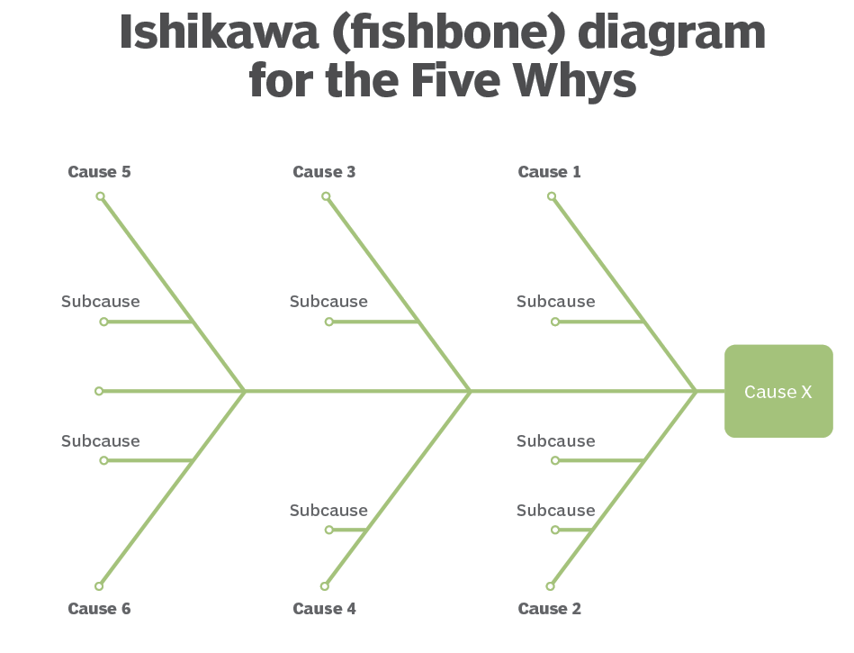

**What is Kaizen?**

* Japanese term for continuous improvement | Relentless
* Philosophy involving everyone in the organization to make never ending efforts for improvement

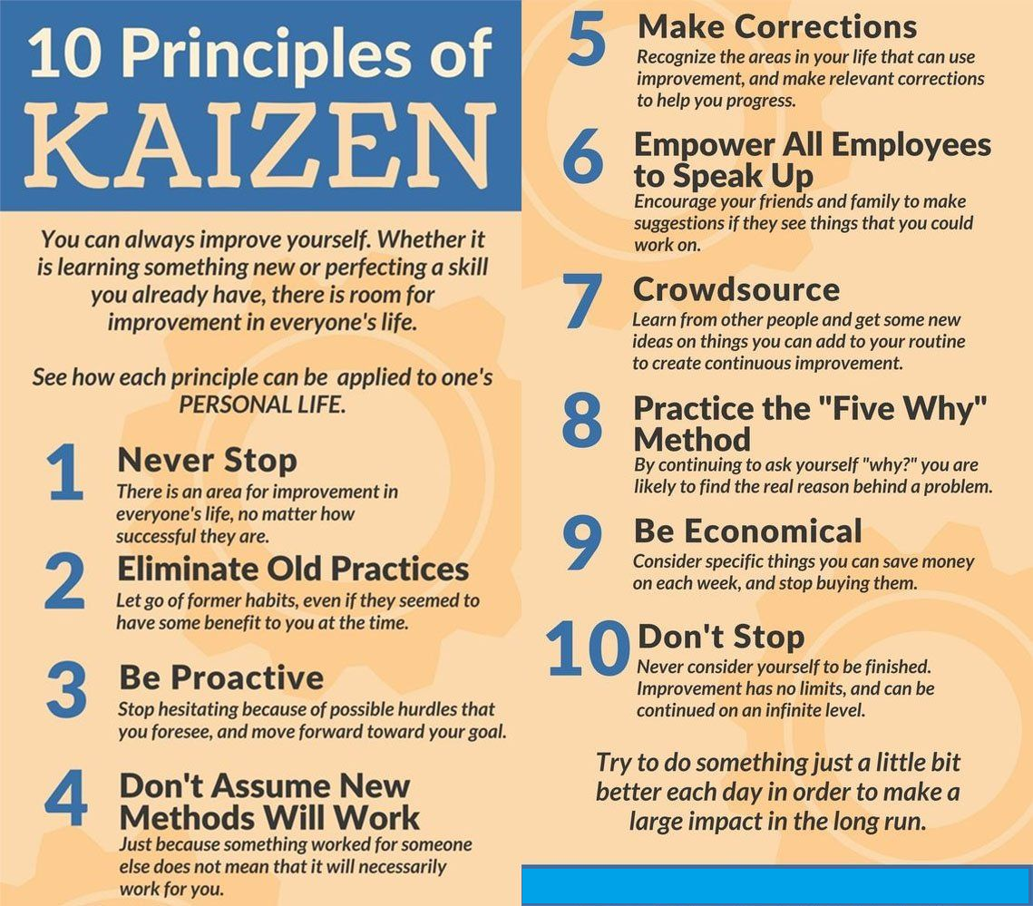

**Kanban**

**What is Kanban?**

* Japanese word that means sign board
* The signboard has categories of work for each stage of the production process



**What are the 5 Principles of Kanban?**

* Visualize the workflow
* Limit work in progress
* Manage flow
* Make process policies explicit
* Improve collaboratively

**What is Kanban Pull system?**

* A pull system moves work through development
* The development team completes an item; the next item in queue is pulled into the next stage of the process
* Kanban does not use timeboxed iterations
* Only so many items can be in each stage of the project
* Work moves from left to right

**Kanban Board**

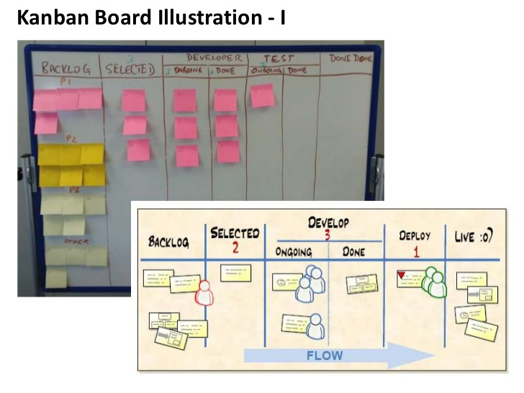

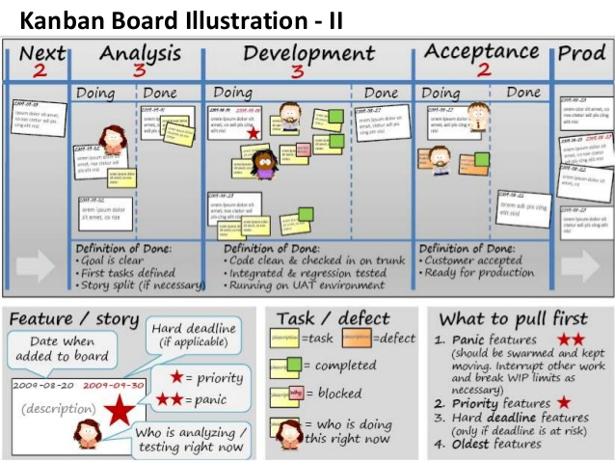

## Scrumban

**What is Scrumban?**

**Scrumban is an Agile framework that helps teams manage projects more efficiently.**

Scrumban was created by mixing two other popular Agile frameworks Scrum and Kanban. Initially, it was used as a stepping stone when switching from one of the parent frameworks to the other. However, in time teams started seeing value in Scrumban and it became a standalone practice.

**Why Scrumban?**

* Easier to adopt than Scrum: Scrumban has a less constrained process, more similar to Kanban. Thus, the teams can learn and pick it up faster
* Great for R&D teams and product development: The quick paced process allows to test out ideas quickly and without much loss
* Focused on throughput and continuous improvement: Scrumban ensures the team produces at a steady pace and keeps improving their process

**What are the key aspects of Scrumban?**

**1. Planning & planning trigger**

The team plans only for next Sprint and only when needed

In Scrumban the team plans for the next Sprint only. This is done based on previous performance and estimation.

To know when to plan for the next iteration Scrumban teams use a planning trigger. This is a number that defines how many tasks should be left in the backlog when the team holds a planning session.

For example, a team of 5 people have an average cycle time of 1 day and it takes 2 days for them to hold a planning session. To make sure there are no interruptions in the process, they have to hold the planning session at a time where the team still has 2 days of work left in the backlog. So their planning trigger is 10.

**2. Kanban board**

For visualizing and tracking work items throughout the process

To monitor the work that is being done, Scrumban teams use a Kanban board. This allows them to track all the work that is planned, being done and completed. Kanban boards vary from team to team, but usually are composed out of Backlog, Process section (divided into columns based on your process –Design, Manufacturing, etc.) and Done column.

It is important to note, that the team members pull tasks from the backlog on their own. Once a team member is done with a task, they review the backlog and pick the highest priority task based on their skillset. This is why it is important to review the board daily and reprioritize if needed.

**3. WIP Limit**

Limits the number of tasks the team can work on at a time

To ensure constant value delivery, Scrumban teams limit the amount of work items the team can work on at any given time. This is called a Work In Progress (WIP) limit.

It helps deliver each individual work item faster and allows to more easily estimate the delivery dates of all work items.

Usually, the teams set this limit based on the amount of people in the team. For example, if there are 5 people in the team the WIP limit is 5. Thus, each team member can work on one task at a time.

**4. Work freeze and Triage**

Helps identify and execute the most important work items at the end.

To control the work scope at the end of the project, Scrumban teams use Work freeze and Triage.

First a Work freeze is used, meaning the team cannot add any new tasks to the backlog. Then, the project manager or the team implements the Triage. Which means they look through the backlog and decide which of the tasks they are going to complete and which will be left undone in this cycle.

These measures help ensure the team delivers a minimum viable product at the end of each sprint throughout the project.

**5. Planning buckets**

Aids the Scrumban team in long-term planning efforts.

Planning buckets are the long-term planning technique that Scrumban teams use.

It works by specifying 3 buckets (this can be lists or simply additional columns in a Kanban board) where the team lists out their roadmap.

* The first bucket holds the largest ideas and goals that the team wants to realize within a year.
* The second bucket holds clearer plans that the team wants to realize within 6 months.
* And the third bucket holds specific plans for the next 3 months.

As the team decides to move forth with their plans, they are moved to the backlog and executed in the next iteration.

**What are the Team roles in Scrumban?**

Scrumban does not specify any roles for the teams to use. Instead, the teams are encouraged to keep the roles they used previously and change them up only if necessary.

One thing to note when assembling a Scrumban team is to make sure they are self-managing. As many processes are left for the team to handle without having a project manager.

**Scrumban cycle**

The Scrumban cycle usually follows these 6 steps that are repeated during every Sprint throughout the project.

* Planning
* Daily Standup
* Work freeze, Triage & Stabilization
* Release
* Retrospective
* Work Item Refinement

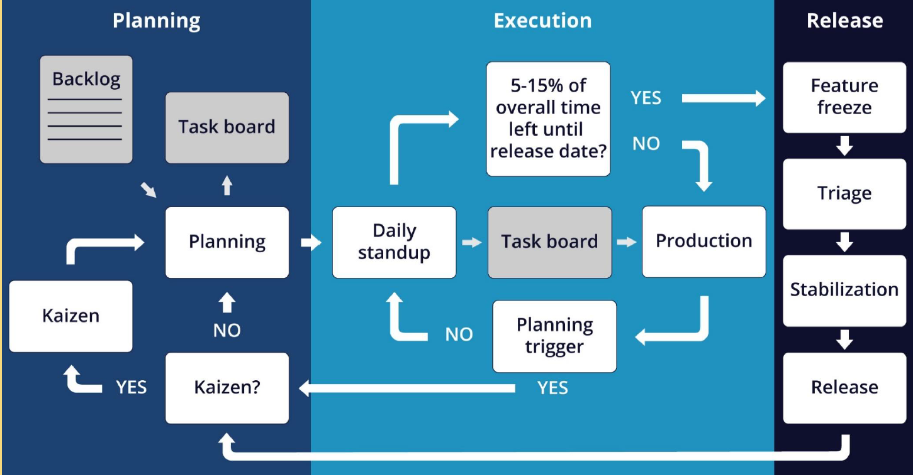

**In-detail**

**1. Work Item Refinement**

Work item refinement takes place before every Sprint and is aimed to identify which of the work items should be considered for the next iteration.

This meeting is attended by the project manager and the stakeholders, and it helps set the direction in which the team will be going next. It is important to consider which of the suggested work items are the most important and why.

Once you have a prioritized list, you also have to define what has to be done for each of those items. So that once the team gathers for a planning session, they can pick up the work item.

**2. Planning**

Once the project begins and then each time after the planning trigger goes off, the Scrumban team meets to plan tasks for their next Sprint.

The team takes the most important work items from the refined product backlog, specify what has to be done for each and estimate how much time that is going to take. The team only takes so many tasks that they can complete in one Sprint.

**3. Daily Standup**

The team then starts working on the planned tasks. Each team member pulling tasks from the backlog based on their priority.

To make sure tasks are completed quickly, no team member can work on more than one task at a time. And to track the progress and identify issues, the team gathers each day to review their progress in a short standup meeting.

**4. Work freeze, Triage & Stabilization**

If the team is working with time boxed Sprints or the project is coming to an end, the project manager might use a Work freeze. This means that the team can no longer take on new tasks from the backlog.

Then the project manager holds a Triage and decides which of the backlog items the team is going to complete in the current Sprint or project, and which of them will be left unfinished.

Work freeze and triage mean that the amount of work completed by the team will stop growing and stabilize.

**5. Release**

Once the team reaches the deadline or completes all the planned tasks, the Sprint ends. The goal of the team is to make an incremental change to the end

product during the Sprint and then present it to the stakeholders during the Release.

Here, the project manager or the team representative explains what has been done and gathers feedback from the client. This way checking if they like where the team is going and gather any new requirements. This allows the Scrumban team to adjust course and present the best result for the clients

**6. Retrospective**

The final step of the Scrumban process is the Retrospective.

After every release, the team gathers to review their work processes and to identify what went well and what needs improvements for the next cycle. This is a good place to implement process changes and to commit to 1 or 2 concrete improvements for the next Sprint. Once the Retrospective is done, the cycle begins again from the first step.

## Feature Driven Development (FDD)

**What is FDD?**

* The development team creates a model for the product
* They will build a feature list and a plan for the work
* The team moves through the design and build the directions for the product features
* The team designs by features and builds by features



**What are its Features?**

* Domain object modeling
* Developing by feature
* Individual class code ownership
* Feature teams
* Inspections
* Configuration management
* Regular builds
* Visibility of progress and results

## Dynamic System Development Method (DSDM)

**What is DSDM?**

* Focus on the business need
* Deliver on time
* Collaborate
* Never compromise quality
* Build incrementally from foundations
* Develop iteratively
* Communicate continuously and clearly
* Demonstrate control



## Crystal

**What is Crystal?**

* Customized methodologies coded by color names
* Methodologies are appropriate for different criticalities and team sizes
* Criticality is about the impact of a product defect design

**What are the Professional Responsibility and Ethics?**

**Responsibility**

* + Make decisions based on the interests of the company
  + Protect proprietary information

**Respect**

* + Maintain the attitude of mutual co-operation
  + Respect cultural differences
  + Negotiate in good faith
  + Deal with conflict directly
  + Don’t use your position to influence others

**Fairness**

* + Look for and disclose conflict of interest
  + Don’t discriminate

**Honesty**

* + Understand the truth
  + Be truthful of all communications

## Agile Framework Comparison

**Comparison of Scrum Vs XP**

|  |  |  |
| --- | --- | --- |
| **Definition** | **Scrum** | **Extreme Programming** |
| **Time Boxing**  (Fixed Length period of time) | Sprint | Iteration |
| **Release to Production** | Release | Small Release |
| **Agile Planning Meetings** | Sprint | Release Planning | Planning Game |
| **Business representative to Project** | Product Owner | Customer |
| **Lessons Learned style** | Retrospective | Reflection |
| **Agile Project Manager** | Scrum Master | Coach |
| **Empowered cross Functional team** | Development Team | Team |
| **Brief daily status meeting** | Daily Scrum | Daily Standup |

**Scrum Vs XP Vs Kanban**

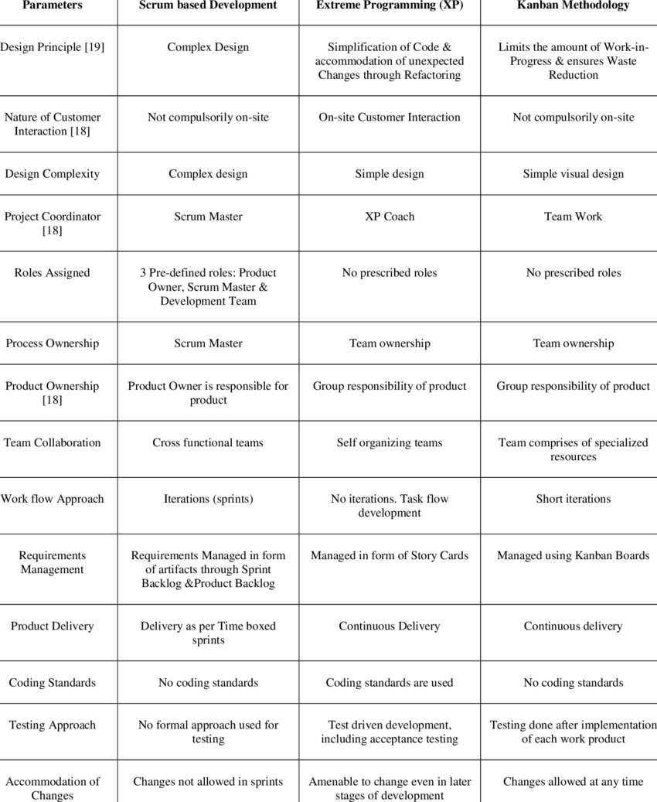

**Scrum Positive Challenges**

|  |  |
| --- | --- |
| **Scrum Positive** | **Scrum Challenges** |
| * Inspect | Adapt | Transparency * Fail fast | Faster feedback * Collective ownership * Continuous Improvement * Self-Organized team * Collaboration * Engagement * Self-Delivery Teams * Well defined roles / ceremonies * Early Feedback * Accountability * Shared risk * High Quality * Excellent Productivity | * Skill set for co-locations * Delivery commitment of every two weeks * Not having deliverable after every Sprint * Larger Team * Mind-set Change * Ad-hoc requirements within the Sprint * Resource Criticality * Inefficient resource utilization (Testers are free at the beginning and over busy at the end) * Adaptability & Sustainability * Time-box collaboration * Team level limit (Only for smaller teams) * Cross functional team structure * Framing Agile centric metrics * Some-times story point estimation |

**Kanban Positive Challenges**

|  |  |
| --- | --- |
| **Kanban Positive** | **Kanban Challenges** |
| * Supports dynamic requirements prioritization * No time-box value * Lead & cycle time delivery can be calculated * Visualize blockage through the cumulative flow diagram | workflow * Limit Work In Progress * Manage Workflow, Pull * Faster Throughput * No Team Limit, Allows Specialist * Well defined Roles * Improves [Kaizen] Process * Expose Bottleneck | * Knowledge work industry (Green –New Brown-Existing project) * Arriving optimum WIP limit * Lesser Collaboration * No Control limit on changes * Higher degree of variation * Starvation * New Product Development * Limited Estimation / Commitment |

**Scrum Vs Kanban**

|  |  |
| --- | --- |
| **Scrum** | **Kanban** |
| * Quicker Value Realization * Empower & Motivated Teams * Customer Satisfaction * Good Quality | * Better Visualization * Faster Throughput, Higher Cyclic Team * No Team limit, Allows Specialist Roles |

**Scrum Vs Kanban Vs Scrumban**

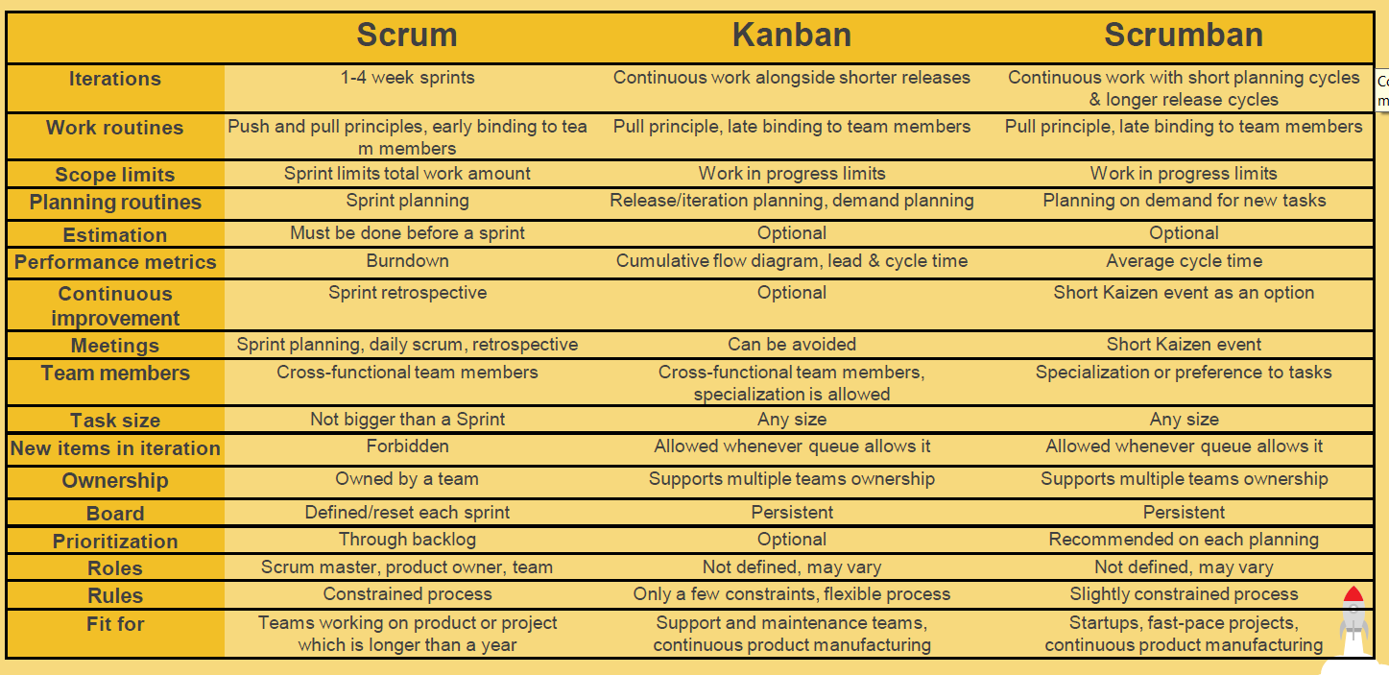

# Domain 2. Value driven Delivery

**What is Value-Driven Delivery?**

* Projects undertaken to generate business value
* Produce Benefit
* Improve Service
* Market Demand
* Safety Compliance
* Regulatory Compliance
* The project manager’s goal is to increase value and reduce risk as early as possible

**Early Value Delivery**

* Agile promote early and often delivery
* Aim to deliver highest value early in project
* Deliver as many high-value components as soon as possible
  + Reduces risk
  + Stakeholder satisfaction -> Project success
* Shows understanding of stakeholders’ needs
* Stakeholders are engaged
* Builds confidence of stakeholders in team

**Benefits**

* The longer a project lasts the more opportunity for risk, by delivering high value items early, the team demonstrates an understanding of the customer’s needs
* Early value help stakeholders maintain synergy an interest in the project

**Reduce Waste**

* Minimize Waste | Waste reduces value
* Poppendieck’s Seven Areas of Waste:For E.g.:
* Partially done work
* Extra processes
* Extra features
* Waiting
* Defects

**Assessing Value – Agile Metrics (Financial)**

**Return on investment (ROI)**

* The ratio of the benefits received from an investment to the money invested. Usually, a percentage.
* Return on investment is the profitability in a project
* Return on investment is the value of the project minus the investment in the project
* A higher return on investment means you are getting a better return than a lower return bigger is better
* Return on investment is not the best approach to discovering business value in a project

**Internal rate of return (IRR)**

* Interest rate you will need to get in today’s money to receive a certain amount of money in the future.
* Calculates the NPV of the cost of the project and when the NPV of the project meets or exceeds the NPV of the benefits of the project
* The higher the IRR the more valuable the project is

**Present Value/Net Present value (NPV)**

* Value of future money in today’s terms.
* The calculation of a future amount in today’s terms given and assumed interest rate and inflation rate.
* The present value of a revenue stream over a series of time periods
* Higher net present values are good

**Earned Value Management**

* Formulas that monitor the value of the project as its progressing
* It’s unlikely you’ll see earned value management on the exam
* EVM is a suite of formulas to show performance
* Earned value compared to actual performance to planned performance

**Five EVM Rules**

* EV is first
* Variance means subtract
* Index means division
* Less than one is bad in an index
* Negative is bad in a variance

**Accounting on Agile Projects**

* Refers to how the different economic models of agile works
* Agile accounting is different than traditional accounting
* Agile looks to deliver value as quickly as possible
* Uses minimal viable product (MVP)
* This leads to more opportunity for incremental funding

**Key Performance Indicators (KPI’s)**

* Uses as a way to measure the project progress: -
* Rate of progress: How much points has been completed
* Remaining work: How much work is yet to be done from the backlog
* Likely completion date
* Likely Cost remaining

**Risk Management**

* Risk is closely related to value
* Considered as anti-value
* Usually has the potential to remove, erode or reduce value with threats

**Managing Risks Process**

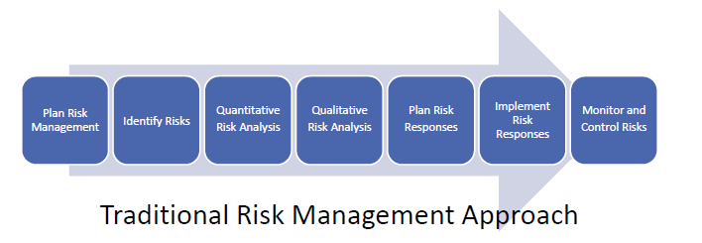

* Risk in an agile project is anything that threatens the project’s goals
* Risk is considered an anti-value
* Risk must be managed in a project
* Risk identification is an iterative activity
* Risk a recorded in a risk along

**Tools to Manage Risk**

* Risk-adjusted backlog
* Risk burndown chart

**Addressing Features with High risk**

* Features that have high levels of risk can be addressed early in project iteration
* High areas of risk need to be addressed sooner rather than
* A risk adjusted backlog brings risk features into an early portion of the project
* A risk burndown chart tracks risk as they move down in priority and elimination

**Regulatory Compliance for Agile Projects**

* Mandated requirements usually by government agencies
* Must be implement into the project work as regular development work
* Doing it after the project work is done

**How Customers Conduct Value Prioritization?**

* Valued based prioritization is the one of core practices in agile planning
* Features are prioritized on the basis of business value, risk and dependencies
* Some of prioritization techniques used: -
* Simple Scheme
* MoSCoW prioritization
* Monopoly Money
* 100-point method
* Dot Voting or Multi-voting
* Kano Analysis
* Requirements Prioritization Model
* Agile teams work on the items that yield the highest value to the customer first
* The product owner is responsible for keeping items in the backlog prioritized by business value
* When changes added to backlog, they must be prioritized for value
* The customer is the person who will declare what success looks like
* The team will discuss with the customer at the end of each iteration the priority of the remaining work items

**Prioritization Techniques**

**Simple Scheme**

* Priority 1, Priority 2, Priority 3, etc.
* Could be problematic as many items might become the first priority.

**MoSCoW Prioritization**

* Must have
* Should have
* Could have
* Would like to have, but not this time

**Dot Voting or Multi-voting**

* Each person gets a certain number of dots to distribute to the requirements

**Monopoly Money**

* Give everyone equal monopoly money
* They then distribute the funds to what they value the most

**100-point method**

* Each person is given 100 points
* They then use that to distribute to individual requirements

**Kano Analysis**

Helps to understand the customers satisfaction

* Delighters/Exciters
* Satisfiers
* Dissatisfiers
* Indifferent

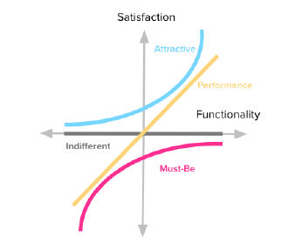

https://foldingburritos.com/kano-model/

**Prioritization / Ranking is Relative**

Doesn’t matter what techniques the customers use priority; the end results should be a list of prioritized features.

**Delivering Value Incrementally**

* Incremental delivery is about deploying working parts of a product over the life of the project
* The team regularly deploys working increments
* In software development, its first delivered to a testing environment then to production
* This will reduce the amount of rework by discovering issues early and fixing them
* This is an opportunity for an early return on investment

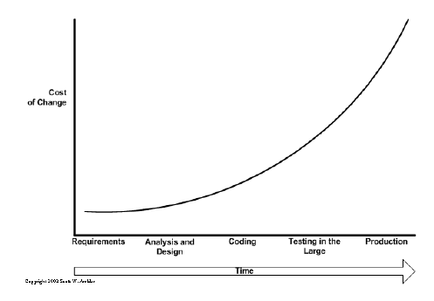

http://www.agilemodeling.com/essays/costOfChange.htm

**Minimal Marketable Feature | Minimum Valuable Product**

* A minimum marketable feature is the smallest possible set of functionality that by itself, has value in the market place is called Minimum Marketable Feature
* It refers to a set of functionalities that is complete to be useful, but small enough not to be an entire project i.e., Usually, a module in a software
* Barebones essentials of a product

**Tools for Agile Projects**

* Agile teams prefer low tech high touch tools over sophisticated computerized models
* Technical tools can exclude team members from interacting
* Consider high tech tools for scheduling: -
* Data accuracy perception increases
* A bad estimate is a bad estimate
* Barriers for stakeholder interaction are created

**Low-Tech, High-Touch Tools**

* Use card, charts, Information radiator, whiteboards, and walls
* Promotes communication and collaboration
* Skip using a computer Gantt chart to a Kanban board

**Kanban/Task Board**

* An "information radiator" -ensures efficient diffusion of information
* Can be drawn on a whiteboard or even a section of wall
* Makes iteration backlog visible
* Serves as a focal point for the daily meeting

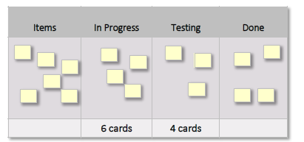

* Also known as a task board
* Help teams monitor the work in progress

**Limit WIP (Work in Progress)**

* Includes work that has been started but not completed yet
* Represents money spent with no return
* Hides process bottlenecks that slow the processes
* Represents risk in form of potential risk
* Agile processes aim to Limit and optimize WIP
* Optimal WIP makes processes efficient

**Cumulative Flow Diagrams (CFD’s)**

**Stack graphs that show how work is progressing**

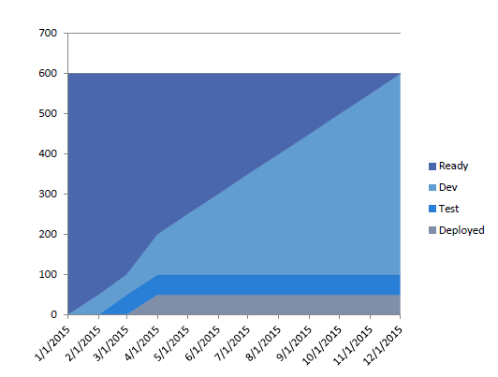

**Bottlenecks and Theory of Constraints**

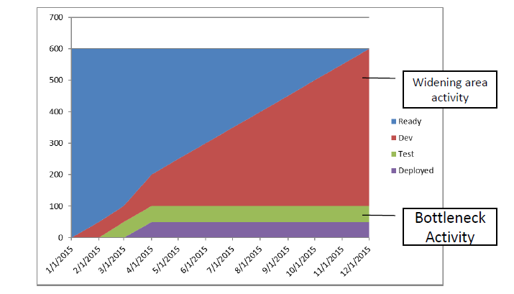

**What is Request for Proposal?**

* A request for proposal is from the buyer to the seller
* If the seller is to use a agile practices it must be defined in the request for proposal
* The buyer may need to educate the vendor about agile practices
* Agile project welcome change so this may be hard to do with contracts

**Agile Contracting**

* Agile’ s flexibility creates difficulty in outlining contract acceptance criteria
* Agile attempts to fix resources and time (cost) and vary functionality
* “Customer collaboration over contract negotiation”
* Close cooperation
* Active participation
* Timely and often feedback
* Money for nothing and change for free
* Graduated Fixed Price Contract
* Buyer / Seller share in risks and rewards
* Different hourly rates based on:
  + Finish early, Finish on time, Finish late
* Fixed Price Work Packages
* Mitigate risks of under/over estimating

**Verifying and Validating**

* “Gulf of Evaluation”

What one person describes is often different from how another interprets

* Resolve problems as soon as possible
* Don’t let little problems grow over time

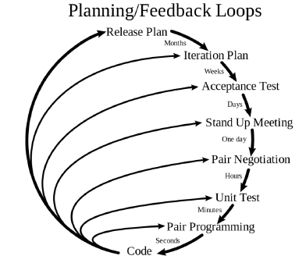

# Domain 3. Stakeholder Engagement

**Who are Project Stakeholders?**

* Those who are impacted by the project: -
* Customers
* Project sponsor
* Project leaders
* Development team
* Vendors
* End users

**How to Identify Stakeholders?**

* Stakeholder analysis
* Expert judgment
* Meetings
* Create the stakeholder register

**How to Incorporate Stakeholder Values?**

* Work is based on what the stakeholders value
* Engage the product owner to prioritize the backlog
* Work is executed by priorities
* The development team creates the highest priority items
* The development team delivers early value to the business
* Stakeholders are invited to planning meetings and retrospective

**How to Incorporate Community Values?**

* Agile teams must share the values of their broader community
* Respect
* Agile works for consensus
* Don’t judge suggestions
* Respect differing opinions
* Courage
* Agile teams display courage through demonstrations
* Pair programming
* Product owner prioritizing requirements
* Retrospective

**What are the principles of Stakeholder Engagement?**

* Get the right stakeholders
* Insure a stakeholder participation
* Manage stakeholder interest
* Frequently discussed what done looks like
* Show progress to project stakeholders
* Openly discuss project estimates and projections

**What is Stakeholder Stewardship?**

* Looking after everyone involved on the project
* Ensuring everyone has everything they need to compete the project successfully
* Starts with identifying the stakeholders

**Educating People about Agile?**

* Teach all the stakeholders about the benefits of agile
* Concerns about agile can Includes: -
* Senior management and sponsor: They are worried about the risk of failing
* Managers: fear the loss of control
* Project team: resist agile methods
* Users: will not get all features

**Engaging Stakeholders**

* Short iterations and release keep them engage
* Keeping then engage can lead to stakeholders being more involved and getting more change request
* This helps us to identify risk and issues early
* If some stakeholders are causing problems, the agile PM will need to use their interpersonal skills to resolve issues
* Need to have a process for escalating stakeholders’ issues
* Why such a big focus on stakeholders?
* Projects and done by people for people

**Methods of Stakeholder Engagement**

* Get the right stakeholders Cement stakeholder involvement
* Actively manage stakeholder interest
* Frequently discuss what done looks like
* Show progress and capabilities
* Candidly discuss estimates and projections

**What is Failing Fast?**

* Failing fast means failing early and cheaply, without making huge loss
* Good way to discover misunderstandings
* Ensures the project team understands what stakeholders want

**Set a Shared Vision**

Important to ensure customers and agile project team has the same vision Methods includes: -

* Agile Charter
* Definition of “Done”
* Agile Modeling
  + Use case diagram
  + Data models
  + Screen design
* Wireframes
* Personas

**Agile Chartering**

* High -level (uses the W5H)
* Agreement
* Authority to proceed
* Focuses on how project will be conducted
* Allows for flexibility and ability to deal with change
* Project specific processes outlined
* May use project Tweet –Describes project goal in 140 Characters or less.
* Agile charters define: -
* Who will be engaged
* What is the project about
* Where will the project take place
* When will the project start and end
* Why this project being chartered
* How the goals of the project be achieved

**What is Definition of “Done”?**

* Creating a shared vision of what done looks like
* Should be done for:
* User stories
* Releases
* Final project deliverables

**What is Agile Modeling?**

* Different modeling techniques that are used to help establish the shared vision
* Should be lightweight or “barely sufficient”

**Use case diagrams**

- Visually shows how users would use an application

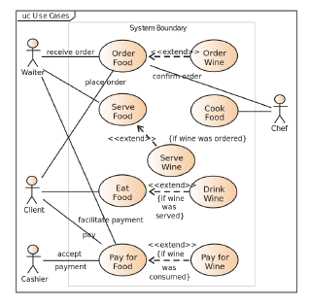

https://en.wikipedia.org/wiki/Use_case_diagram

**Data models**

- How the data are structured in tables and their relationships

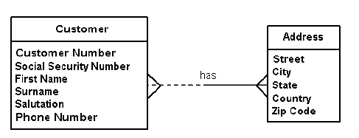

http://www.agiledata.org/essays/dataModeling101.html

**Screen designs**

Simple screen shots

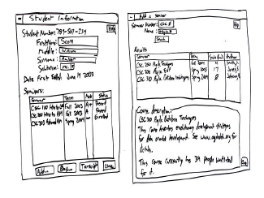

http://agilemodeling.com/artifacts/uiPrototype.htm

**Wireframes**

* A Quick mock-up of product
* Could be screens and data flows between screens
* Ensures that everyone has the same understanding of the product
* A form of low fidelity prototyping
* Quick way to get feedback
* Clarify what “done” looks like
* Validate approach prior to execution

**Personas**

* Biographical sketches of key stakeholders
* Quick guides or reminders of key stakeholders and interests
* Provide description of users
* Be grounded in reality
* Be goal-oriented, specific, and relevant
* Be tangible and actionable
* Generate focus
* Help team focus on valuable features to users

**Collaboration is Key in Agile Projects**

* Customer collaboration over contract negotiation
* Business people and developers must work together daily throughout the project

**Benefits of Collaboration**

* Generates wiser decisions
* Promotes problem solving
* Promotes action
* Build social capital
* Ownership of collective problems

**Engaging People in Agile Projects**

* Engagement creates better ideas and put some conversations
* Active problem solving instead of command and control
* Taking action rather than being passive
* Collective ownership of ideas
* Motivates and engages the project team
* Shifts the power downward

**Green Zone/Red Zone**

|  |  |
| --- | --- |
| **Red Zone** | **Green Zone** |
| * Blames others for everything * Responds defensively * Feels threatened * Triggers defensiveness * Doesn’t let go or forgive * Uses shame and blame * Focus on short-term advantage * Doesn’t seek or value feedback * Sees conflict as a battle and only seeks to win * Communicates high level of disapproval * Sees others as the problem or enemy * Does not listen effectively | * Take responsibility * Seeks to respond nondefensively * Is not easily threatened psychologically * Attempts to build success * Uses persuasion rather than force * Thinks both short and long term * Welcomes feedback * Sees conflict as a natural part of life * Seeks excellence rather than victory * Listens well |

**Hosting Workshops**

* Meeting when work gets done
* Retrospectives are a type of workshops
* Ways to make them more effective: -
* Diverse groups have a larger perspective
* Use methods such as round-robin to ensure no one dominates
* Try to get everyone to participate in the first few minutes
* User story workshops are where we write the user stories and keep stakeholders engage

**Brainstorming**

* Collaborative technique too rapidly generates lots of ideas
* Maximize number of suggestions allowed
* No stupid ideas entertained
* Will sort through the ideas later

**Brainstorming Methods**

* Quite Writing
  + Give people about 5 minutes to write down their ideas
* Round-Robin
  + Pass a token around to ensure everyone will speak
* Free-for-all
  + People shout out their taught. May only work in a supportive environment

**Collaboration Games**

Also know as Innovation Games

* Remember the future
* Prune the product tree
* Speed-boat (Sailboat)

**Remember the future**

* Ask stakeholders to imagine that an upcoming release was successfully and to look back
* Gets a better understanding of how a stakeholder would define success
* Outlines how we can accomplish that success for them

**Prune the Product Tree**

* Draw a tree and ask stakeholders to add their features to it
* Use stick notes to have them place new features on the tree
* Group the features on the trunk
* Features that are depending on other features would be higher up the tree
* Let’s everyone understand the priorities of development

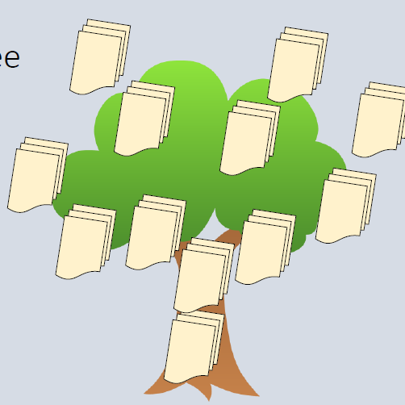

**Speedboat (Sailboat)**

* Draw a waterline and a boat moving
* Explain the boat is moving toward the goals of the project
* Ask them to use sticky notes to show what can make the boat move (wind) and what can stop it (anchors)
* Allows stakeholders to identify threats and opportunities

**Communication Model – Sender & Receiver**

* Sender
* Encoder
* Medium
* Decoder
* Receiver
* Barrier
* Noise

**Communicating with Stakeholders**

* Face to face communication
* Two-way communication
* Knowledge sharing
* Information Radiators
* Social Media

**Face to face communication**

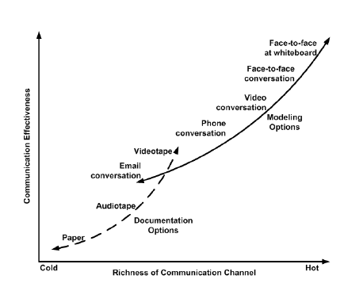

http://www.agilemodeling.com/essays/communication.htm

**Two-way communication**

Just don’t ask for confirmation or concerns, but actually listen to what they have to say.

**Knowledge sharing**

* Agile teams work closely with each other such as with pair-programming.
* Using Kanban boards or wireframes are ways to share information
* Use of low-tech tools like a whiteboard will allow all to see the work and understand
* We must encourage it

**Information Radiators**

* Things that are highly visible
* Used to display information
* Usually includes charts, graphs and boards

**Social Media**

* Use to communicate
* Can include twitter or Instagram

**Using Critical Soft Skills**

* Emotional intelligence
* Negotiation
* Active Listening
* Facilitation
* Conflict Resolution
* Participatory Decision Models

**Emotional intelligence**

* Our skill to identify, assess, and influence the emotions of ourselves and others around us
* We need to recognize our own feeling
* Then we can learn how to response to others and how they feel
* Understand how we take care of ourselves will impact other around us
* As an agile PM we have to know when team members are stuck, angry, or frustrated

**Negotiation**

* This happens all throughout the project
* Good negotiation will allow everyone to investigate the options and trade-offs
* Most effective when interactions between people are positive and there are room for give and take

**Active Listening**

* Level 1: Internal –how is it going to affect me
* Level 2: Focused –put ourselves in the mind of the speaker
* Level 3: Global –builds on level with body language

**Facilitation**

* Run effective meeting and workshops.
* Have the following:
* Goals
* Rules
* Timing
* Assisting

**Conflict Resolution**

* All projects will have conflicts
* While some levels of conflicts are good, we need to ensure they don’t become a “world war” where people are trying to destroy each other
* Levels of conflict (1-5):
* Level 1: Problem to solve –sharing info
* Level 2: Disagreement –Personal Protection
* Level 3: Contest –Must win
* Level 4: Crusade –Protecting one’s group
* Level 5: World War –Must destroy the other

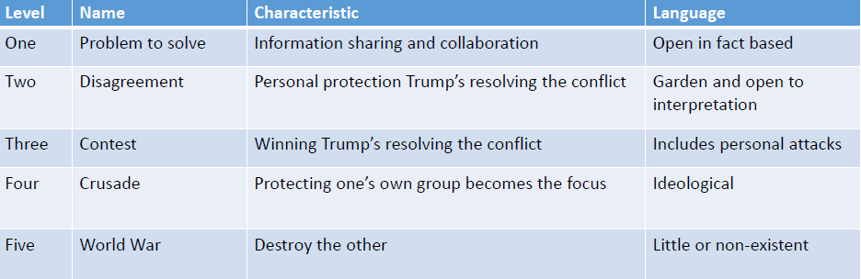

**Participatory Decision Models**

Engage stakeholder in decision making process

* Simple voting
* Vote “for” or “against” it
* Thumps up/down/sideways
* People hold their thumps in a way of if the support it or not. Sideway is if they cannot make up their mind
* Fist of five
* People how up finger based on they support the idea
* 1 finger: total support –5 finger: Stop against it



# Domain 4. Team Performance

**People Over Processes**

* Projects are done by people, not tools
  + Agile manifesto: “Individuals and Interactions over processes and tools”
* Focus on the people side of the project
* Projects are more about people management than tools management

**COCOMO**

* Constructive Cost Model
* To determine correlation between project input variables and final cost to use to estimate future projects
* People factors has a score of 33…11 times more significant than tools and processes

**COCOMO II**

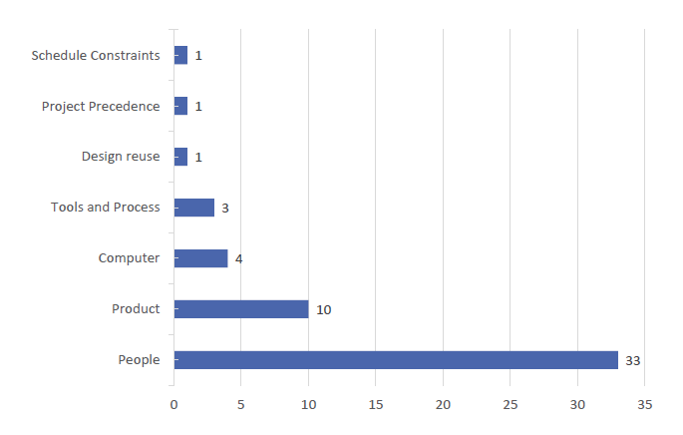

**Development Team / Delivery Team**

* Coders
* Writers
* Analyst
* Testers
* People can perform multiple jobs in switch from role to role

**Development/Delivery Team**

Group that builds and test the increments of the product: -

* Build product in increments
* Update information radiators
* Self-organize and directing
* Share progress by doing daily stand-up meetings
* Write acceptance tests
* Demo the completed product increments
* Holds retrospectives at the end of sprints
* Does release and sprint planning and estimations

**Product Owner/Customer**

* Prioritizing the product features
* Manage the product backlog ensuing its accurate and up to date
* Ensures the team has a shared understanding of the backlog items
* Defines the acceptance criteria
* Provides the due dates for the releases
* Attends planning meeting, reviews, and the retrospective

**Agile Project Manager (ScrumMaster/Coach)**

* Act as a servant leader
* Help the team self-organize and direct themselves
* Be a facilitator
* Ensure the team plan is visible and the progress is known to the stakeholders
* Act as a mentor and coach
* Work with the product owner to manage the product backlog
* Facilitates meeting
* Ensure issues are solved

**Building Teams**

* Self-Organizing
* Self-Directing
* Small teams with fewer than 12 members

**Generalizing Specialists**

* Have members that can do different tasks
* Members skilled in more than one area
* Share work reduce bottleneck

**High-Performance Agile Teams**

* Have a shared vision
* Realist goals
* Fewer than 12 members
* Have a sense of team identity
* Provide strong leadership

**Eight Characteristics of High-Performance Teams**

* Self-organizing
* Empowered
* Believe that as a team they can solve any problem
* Committed to team success
* Owns its decisions and commitments
* Motivated by trust
* Consensus driven
* Participate in constructive disagreement

**Experiments (Have a safe place)**

* Establish safe environment for disagreement
* Allows team members to build strong commitment to decisions
* Encourage people to experiments with new methods
* Leads to more engagement

**Welcome Constructive Disagreement**

* Leads to better buy -in and decisions
* Avoiding conflicts can lead to conflicts escalating
* A safe place for disagreement leads to successful problem solving

**Models of team development**

* Shu-Ha-RiModel of Skill Mastery

- Shu-Obey,

- Ha –Moving away,

- Ri–finding individual paths

* Dreyfus Model of Adult Skill Acquisition

- Novice, Advanced Beginner, Competent, Proficient, Expert

**Tuckman’s Five Stages of Team Development**

**1.Forming:** team comes together and starts to get to know each other. There is not much conflict or communication.

**2.Storming:** team members start to have conflicts with each other. They start to learn of each other’s ideas and may not agree with them. Most conflicts takes place in this stage.

**3.Norming:** the team members begin to agree with each other on the best methods to build the deliverables. Generally, everyone is coming to a consensus.

**4.Performing:** the team is performing well and is working without conflict.

**5.Adjourning:** In this stage, the project is completed and the team is reassigned.

**Adaptive Leadership**

* Forming -> Directing
* Storming -> Coaching
* Norming ->Supporting
* Performing -> Delegating
* Adjourning

**Training, Coaching, and Mentoring**

* Training: Teaching of skills or knowledge
* Coaching: Process that helps a person develop and improve their skills
* Mentoring: More of a professional relationship that can fix issues on an as-needed basis
* Help team stay on track, overcome issues, and continually improve skills
* Individual level
* Whole-team level

**Team Spaces**

* Co-located Teams
* Team Spaces
* Osmotic Communication
* Global and Cultural Diversity
* Distributed teams

**Co-Located Teams**

* All team member work together in the same location
* Allows for face-to-face time and interaction
* Should be within 33 feet of each other
* No physical barriers
* Sometimes a virtual co-location

**Team Space**

* **Lots of low-tech, high touch**
* Whiteboards and task boards
* Sticky notes, flip charts
* Round table
* No barriers to face-to-face communication
* **Caves and Common**
* Caves →space team members can retreat to individually
* Common →space team members can work as group
* **Osmotic Communication**
* Information flows that occur as part of everyday conversations and questions
* 33 feet or 10 meters
* **Tacit Knowledge**
* Information that is not written down; supported through collective group knowledge

**Global and Cultural Diversity**

* Time Zones
* Cultures
* Native Languages
* Styles of communications

**Distributed Teams**

* At least one team member working off-site
* Need to find ways to replicate co-location team benefits
* Agile Tools
* Low-Tech, High-Touch Tools
* Digital Tools for distribute teams
* Video conferencing
* Interactive whiteboards
* IM / VoIP
* Virtual card walls
* Web cams
* Digital cams

**Tracking Team Performance**

* Burn Charts
* Burnup
* Burndown
* Velocity Charts

**Burnup Chart**

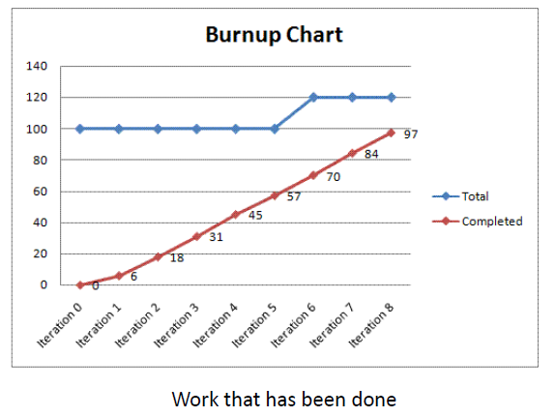

**Burndown Chart**

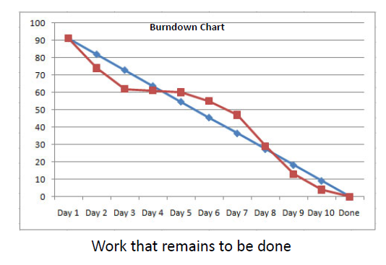

**Velocity Charts**

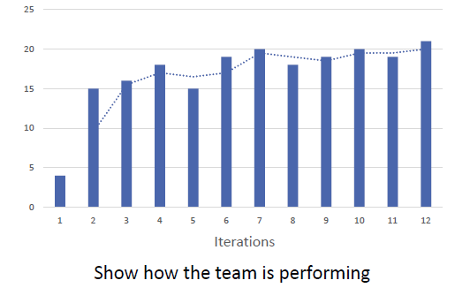

**If a team has to complete 3 iterations with the average velocity of 18 points per iteration, how many iterations would it take to complete 250 points of work?**

250/18 = About 14 more iterations.

# Domain 5. Adaptive Planning

**What is Adaptive Planning?**

* Planning is ongoing process
* Multiple mechanisms to proactively update plan
* Focus on value delivery and minimize nonvalue-adding work
* Uncertainty drives need to replan
* Frequently discover issues and experience high rates of change

**Agile Plans**

Agile planning varies from traditional planning

1.Trial and demonstration uncover true requirements, which then require replanning

2.Agile planning is less of an upfront effort, and instead is done more throughout the project

3.Midcourse adjustments are the norm

**Principles of Agile Planning**

1. Plan at multiple levels

2. Engage the team and the customer in planning

3. Manage expectations by frequently demonstrating progress

4. Tailor processes to the project’s characteristics

5. Update the plan based on the project priorities

6. Ensure encompassing estimates that account for risk, distractions, and team availability

7. Use appropriate estimate ranges to reflect the level of uncertainty in the estimate

8. Base projections on completion rates

9. Factor in diversion and outside work

**Progressive Elaboration**

* Adding more detail as information emerges Includes:
* Plans
* Estimates
* Designs
* Test scenarios
* Rolling wave planning: Planning at multiple points in time as data becomes available

**Value-Base Analysis and Decomposition**

* Assessing and prioritizing the business value of work items, and then plan accordingly.
* Consider payback frequency and dependencies
* Value-Based Decomposition
* Breaks down requirements and prioritized them
* Design the product box

**Design the Product Box**

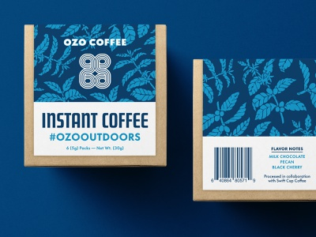

**Coarse-Grained Requirements**

* Keep Requirements “coarse” then progressively refine them
* Helps keeps the overall design balanced
* Delays decision on implementation until the “last responsible moment”

**Timeboxing**

* Short, fixed -duration periods of time in which activities or work are undertaken
* If work is not completed within time period, move it to another timebox
* Daily Stand-up –15 minutes
* Retrospectives–2 hours
* Sprints–1-4 weeks
* Beware of Parkinson’s Law
* Work tends to expand to fill the time given

**Agile Estimation**

Knowledge of agile estimation theory & ability to perform simple agile estimating techniques

**Why do we estimate?**

Determining which pieces of work can be done within a release or iteration

**How are estimates created?**

By progressing through the stages planning.

**How should estimates be stated?**

Should be started in ranges

**When do we estimate?**

Throughout the project. More detail in the later parts of the project

**Who estimates?**

Team members will do their own estimates

**Ideal Time**

Refers to the time it would take to complete a given task assuming zero interruptions or unplanned problems

**Decomposing Requirements**

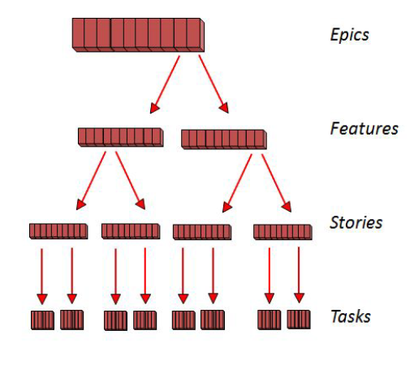

**User Stories**

User Stories / Backlogs

* Business functionality within a feature that involves 1-3 days of work.
* Acts as agreement between customers and development team
* Every requirement is user story
* Every story, including technical stories, has value
* Common structure of a user story

As a <**user type**>

I <**want to/need, etc**.> goal

So that <**value**>

**Example**

* “As a payroll clerk, I want to be able to view a report of all payroll taxes, so that I can pay them on time”
* “As a sales person, I want to be able to see a current list of leads, so that I can call them back quickly”
* “As student of this course, I want to be able to understand the requirements of the exam, so that I know if I qualify for it or not”

**Three C’s of Stories**

* Have users write the stories on index cards
* No details, it’s used to help conversate
* 3 Cs:
* Card
* Conversation
* Confirmation

**User Stories -INVEST**

Effective user stories should be “**INVEST**”

**Independent**

◦Should be independent so it can reprioritize

**Negotiable**

◦Should allow for trade-off’s based on cost and function

**Valuable**

◦Should clearly state the value of it

**Estimatable**

◦Should be able to estimate how long to complete

**Small**

◦Stories should be between 4-40 hours of work

**Testable**

◦Should be testable to ensure it will be accepted once competed

**User Story Backlog (Product Backlog)**

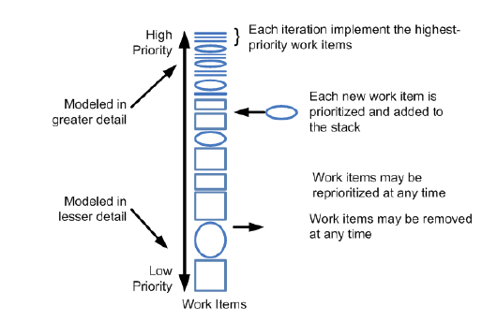

* Prioritize Requirements
* Refining (Grooming) Backlog
* Keeping the backlog updated and accurately prioritized

**Relative Sizing and Story Points**

* Absolute estimates are difficult for humans to make
* Estimates should be relative
* Assign points to each story using a relative number

**Fibonacci Sequence**

Fibonacci Sequence: 1, 2, 3, 5, 8, 13, 21

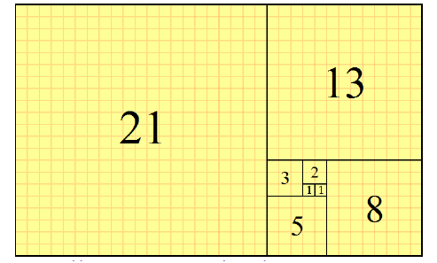

https://en.wikipedia.org/wiki/Fibonacci_number

**Guidelines for Using Story Points**

* Team should own the definition of their story points
* Story point estimates should be all-inclusive
* Point sizes should be relative
* Complexity, work effort, and risk should all be included in the estimate

**Affinity Estimating and T-Shirt Sizing**

* Affinity Estimating
* Group estimates into categories or collections
* T-Shirt Sizing
* Place stories in sizes of t-shirts

**Wideband Delphi**

* Group-based estimation approach
* Panel of experts, anonymously
* It’s used to prevent:
* Bandwagon effect
* HIPPO decision making (HIghest-Paid Person's Opinion)
* Groupthink

**Story Maps**

* High-level planning tool
* Stakeholders map out what the project priorities early in the planning
* Serves as the “product roadmap”
* Shows when features will be delivered and what is included in each release

**Product Roadmap**

* Shows when features will be delivered and what is included in each release
* Can convert the story map into a product roadmap

**Types of Iterations**

**Iteration 0**

* Set the stage for development efforts
* Doesn’t build anything

**Development Iteration**

* Build the product increment

**Iteration H (hardening sprint or release)**

* Done at the end to clean up codes or producing documentation

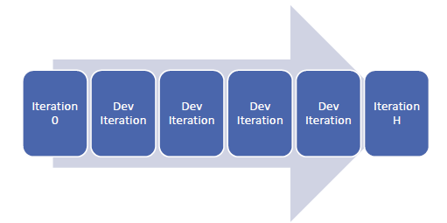

**Spikes**

* **Architectural spike**
  + Period of time dedicated to proof of concept
* **Risk-Based Spike**
  + Team investigates to reduce or eliminate risk

**Iteration Planning**

* Meeting run by the delivery team.
* Discuss the user stories in the backlog
* Select the user stories for the iteration
* Define the acceptance criteria
* Break down the user stories into task
* Estimate the task

**Release Planning**

* Meeting with all stakeholders to determined which stories will be done in which iterations for the upcoming release.
* Selecting the user stories for the release

Using Velocity –points per iteration

* Slicing the stories

Breaking down stories that are too large to be completed in 1 iteration

# Domain 6. Problem Detection and Resolution

**Understand How Problems Happen**

* All projects will have problems
* As a project is progressing the agile PM should expect issues to happen
* Over time issues can delay or change a project objective

**Cost of Change**

* Over time the cost of change will increase

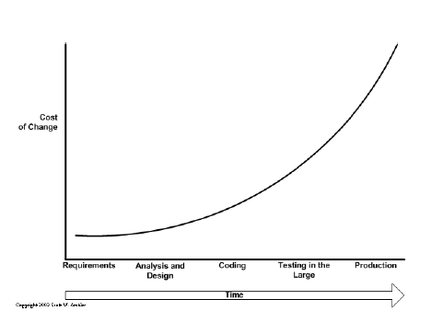

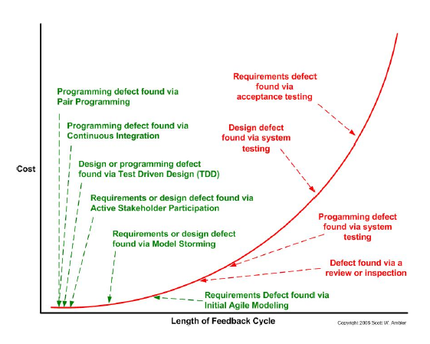

**Technical Debt**

* Backlog of work caused by not doing regular cleanup
* If not done will lead the increase cost of development and make it harder to implement changes
* Refactoring is the solution

**Failure Modes**

Why do people Fail:

* Making mistakes
* Preferring to fail conservatively
* Inventing rather than researching
* Being creatures of habit
* Being inconsistent

**Success Modes**

Why do we succeed: -

* Being good at looking around
* Being able to learn
* Being malleable
* Taking pride in work

**Success Strategies**

* Balance discipline with tolerance
* Start with something concrete and tangible
* Copy and alter
* Watch and listen
* Support both concentration and communication
* Match work assignment with the person
* Retain the best talent
* Use rewards that preserve joy and combine rewards
* Get feedback

**Lead Time and Cycle Time**

**Lead/Cycle time**

* Lead time: how long something takes to go through the entire process
* Cycle time: how long something takes to go through a part of the process. Part of lead time.

**Cycle Time**

* Measure of how long it takes to get things done
* Closely related to work in progress (WIP)
* Excessive WIP is associated with several problems
  + - Represents money invested with no return on investment yet
    - Hides bottlenecks in processes & masks efficiency issues
    - Represents risk in form of potential rework
* Long cycle times lead to increased amounts of WIP

Cycle Time =𝑊IP /Throughput

Where Throughput: Amount of work that can done in a time period

**What would be the cycle time of feature A, if it requires 60 points of work and the team can complete 5 points per day?**

=60/5 points per day = 12 days.

**Defects**

* Longer defects are left, more expensive to fix
* More work may have been built on top of bad design, resulting in more work to be undone
* Later in development cycle, more stakeholders impacted by defect and more expensive to fix
* Escaped Defects
  + Defects that make it to the customer

**Variance and Trend Analysis**

* Variance measure of how far apart things are (or vary)
* Trend Analysis measure that provides insight into future issues
* Lagging Metrics provides information on something that has already happened
* Leading Metrics provides information on is or is about to occur

**Control Limits**

Help diagnose issues before issue occurs

Provide guidelines to operate within

**Risk**

* Risk Adjusted Backlog
* Adjusting the backlog for risk
* Done after risk response
* Expected Monetary Value = Impact($) x Probability (%)
* Risk Severity
* Risk Probability x Risk Impact
* Uses a scale of numbers (E.g1-5)

**Risk Burndown Graphs**

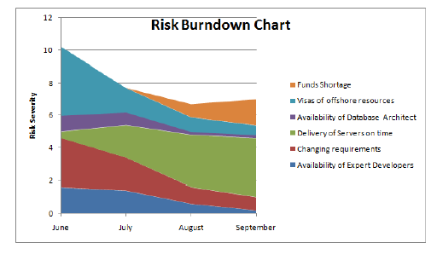

**Solving Problems**

* Problem Solving as continuous improvement
* Engage the team
* Some problems can’t be solved

**Why Engaging the Team?**

* Team usually produces the best practical solutions
* Benefits
* Get consensus from all members
* Gets a broad knowledge base
* Solutions are practical
* When ask people work hard to produce good ideas
* Asking someone for help shows confidence
* Usage and Cautions
* Solve real problems
* Poor team cohesion
* Team and project changes
* Follow-Through

# Domain 7. Continuous Improvement

**What is Kaizen?**

* Kaizen is a process for continuous improvement name after the Japanese word
* Focus on the team to implement small incremental improvement
* Usually follows the Plan-Do-Check-Act (PDCA) cycle by Edwards Deming

**PDCA**

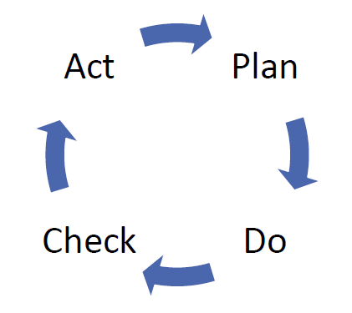

**Agile Cycle**

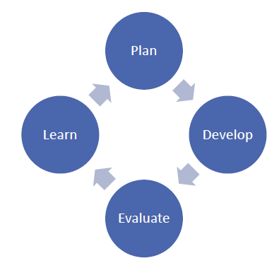

**Process Analysis**

* Review and diagnose issues
* Look for tailoring possibilities

**Process Tailoring**

* Amend methodology to better fit project environment
* Change things for good reason, not just for sake of change
* Develop a hybrid

**Value Stream Map**

* Optimize the flow of information or materials to complete a process
* Reduce waste (waiting times) or unnecessary work
* Steps to creating: -
* Identify the product or service
* Create a value stream map
* Review to find waste
* Create a new map with the desire improvement
* Develop a roadmap to implement the fixes
* Plan to revisit it again

**Value Stream Map Example**

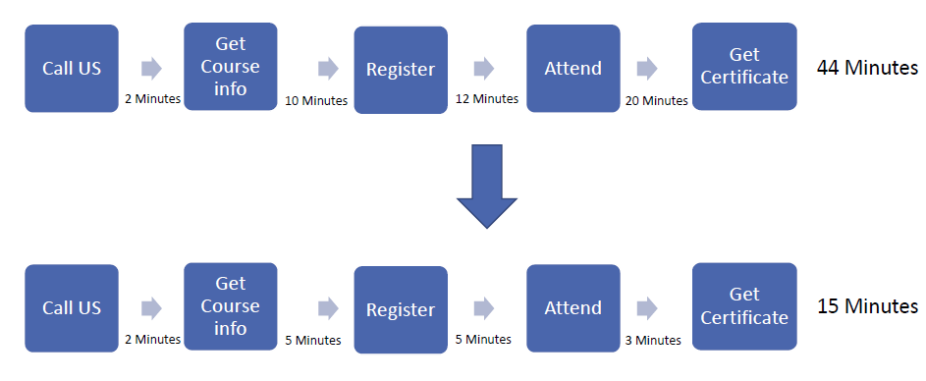

**Pre-Mortems**

* Team meeting that looks at possible
* things that can cause failure during a project before they take place
* Steps includes: -
* Think what the failures might be
* Create a list of reasons that can cause the failures
* Review the project plan to determine what can be done to reduce or remove the reasons for failure

**Retrospectives**

* Special meeting that takes place after each iteration
* Inspect and improve methods and team work
* Offers immediate value
* Should have a 2-hour time limit

**Retrospectives Stages**

About 2 Hours for a typical retrospective

1. Set Stage –6 Minutes

2. Gather Data –40 Minutes

3. Generate Insights –25 Minutes

4. Decide What to Do –20 Minutes

5. Close Retrospective –20 Minutes

**1. Set the Stage**

* Start of the retrospective
* Help people to get focus
* Encourage participation to ensure everyone start talking early
* Outlining the approach and topics for discussion
* Get people in mood for contributing information
* Activities includes: -
* Check-In
* Focus On/Focus Off
* ESVP
* People identify if they are an explorer, shopper, vacationer, or Prisoner

**2. Gather Data**

* Create a picture of what happened during the sprint
* Start to collect information to be used for improvement
* Activities: -
* Timeline
* Triple Nickels: break the team into 5 groups to spend 5 minutes collecting 5 ideas, 5 time
* Mad, Sad, Glad: what where the team emotion as the sprint was taking place

**3. Generate Insights**

* Analyze the data
* Helps to understand what was found
* Activities Include:
* Brainstorming
* Five Whys: asking why five times
* Fishbone analysis
* Prioritize with dots: use a dot voting technique

**Fishbone Analysis**

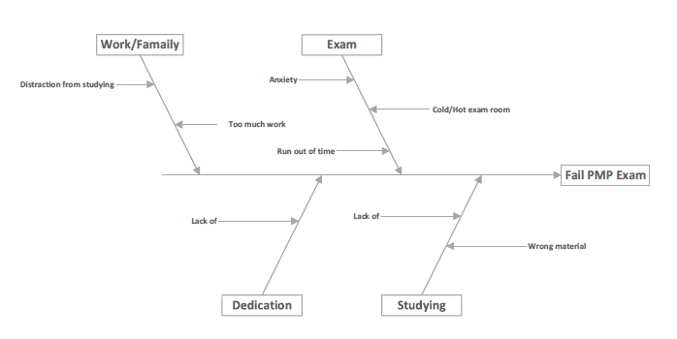

**4. Decide what to do**

* Decide what to do about the problems that was found
* How can we improve for the next iteration
* Activates include: -
* Short Subjects
* Smart Goals

**Short Subjects**

Team decides what actions to take in the next iteration:

* Start doing
* Stop doing
* Do more of
* Do less of

**SMART Goals**

Team sets goals that are SMART: -

* Specific
* Measurable
* Attainable
* Relevant
* Timely

**5. Close the Retrospective**

* Opportunity to reflect on what
* happened during the retrospective
* Activities include: -
* Plus/Delta: make two columns of what the team will do more of and what to do less of

**Team Self-Assessments**

* Uses to evaluate the team as a hold
* Things to evaluate can include:
* Self-organization
* Empowered to make decisions
* Belief in vision and success
* Committed team
* Trust each other
* Constructive disagreement

**PMI Code Ethics and Professional Conduct**

Four areas of professional behavior:

* Responsibility
* Respect
* Fairness
* Honesty

# Agile Project Management Glossary 1

**Acceptance Test-Driven Development (ATDD).** A method of collaboratively creating acceptance test criteria that are used to create acceptance tests before delivery begins.

**Agile.** A term used to describe a mindset of values and principles as set forth in the Agile Manifesto.

**Agile Coach.** An individual with knowledge and experience in agile who can train, mentor, and guide organizations and teams through their transformation.

**Agile Life Cycle.** An approach that is both iterative and incremental to refine work items and deliver frequently.

**Agile Manifesto.** The original and official definition of agile values and principles.

**Agile Mindset.** A way of thinking and behaving underpinned by the four values and twelve principles of the Agile Manifesto.

**Agile Practitioner.** A person embracing the agile mindset who collaborates with like-minded colleagues in cross-functional teams. Also referred to as agilist.

**Agile Principles.** The twelve principles of agile project delivery as embodied in the Agile Manifesto.

**Agile Unified Process.** A simplistic and understandable approach to developing business application software using agile techniques and concepts. It is a simplified version of the Rational Unified Process (RUP).

**Agilist.** See *Agile Practitioner*.

**Anti-Pattern.** A known, flawed pattern of work that is not advisable.

**Automated Code Quality Analysis.** The scripted testing of code base for bugs and vulnerabilities.

**Backlog.** See *Product Backlog*.

**Backlog Refinement.** The progressive elaboration of project requirements and/or the ongoing activity in which the team collaboratively reviews, updates, and writes requirements to satisfy the need of the customer request.

**Behavior-Driven Development (BDD).** A system design and validation practice that uses test-first principles and English-like scripts.

**Blended Agile.** Two or more agile frameworks, methods, elements, or practices used together such as Scrum practiced in combination with XP and Kanban Method.

**Blocker.** See *Impediment*.

**Broken Comb.** Refers to a person with various depths of specialization in multiple skills required by the team. Also known as Paint Drip. See also *Tshaped* and *I-shaped*.

**Burndown Chart.** A graphical representation of the work remaining versus the time left in a timebox.

**Burnup Chart.** A graphical representation of the work completed toward the release of a product.

**Business Requirement Documents (BRD).** Listing of all requirements for a specific project.

**Cadence. A rhythm of execution.** See also *Timebox*.

**Collective Code Ownership.** A project acceleration and collaboration technique whereby any team member is authorized to modify any project work product or deliverable, thus emphasizing team-wide ownership and accountability.

**Continuous Delivery.** The practice of delivering feature increments immediately to customers, often through the use of small batches of work and automation technology.

**Continuous Integration.** A practice in which each team member's work products are frequently integrated and validated with one another.

**Cross-Functional Team.** A team that includes practitioners with all the skills necessary to deliver valuable product increments.

**Crystal Family of Methodologies.** A collection of lightweight agile software development methods focused on adaptability to a particular circumstance.

**Daily Scrum.** A brief, daily collaboration meeting in which the team reviews progress from the previous day, declares intentions for the current day, and highlights any obstacles encountered or anticipated. Also known as daily stand-up.

**Definition of Done (DoD).** A team's checklist of all the criteria required to be met so that a deliverable can be considered ready for customer use.

**Definition of Ready (DoR).** A team's checklist for a user-centric requirement that has all the information the team needs to be able to begin working on it.

**DevOps.** A collection of practices for creating a smooth flow of delivery by improving collaboration between development and operations staff.

**Disciplined Agile (DA).** A process decision framework that enables simplified process decisions around incremental and iterative solution delivery.

**Double Loop Learning.** A process that challenges underlying values and assumptions in order to better elaborate root causes and devise improved countermeasures rather than focusing only on symptoms.

**Dynamic Systems Development Method (DSDM).** An agile project delivery framework.

**Evolutionary Value Delivery (EVO).** Openly credited as the first agile method that contains a specific component no other methods have: the focus on delivering multiple measurable value requirements to stakeholders.

**eXtreme Programming.** An agile software development method that leads to higher quality software, a greater responsiveness to changing customer requirements, and more frequent releases in shorter cycles.

F**eature-Driven Development.** A lightweight agile software development method driven from the perspective of features valued by clients.

**Fit for Purpose.** A product that is suitable for its intended purpose.

**Fit for Use.** A product that is usable in its current form to achieve its intended purpose.

**Flow Master.** The coach for a team and service request manager working in a continuous flow or Kanban context. Equivalent to *Scrum Master*.

**Framework.** A basic system or structure of ideas or facts that support an approach.

**Functional Requirement.** A specific behavior that a product or service should perform.

**Functional Specification.** A specific function that a system or application is required to perform. Typically represented in a functional specifications document.

**Hoshin Kanri.** A strategy or policy deployment method.

**Hybrid Approach.** A combination of two or more agile and non-agile elements, having a non-agile end result.

**IDEAL.** An organizational improvement model that is named for the five phases it describes: initiating, diagnosing, establishing, acting, and learning.

**Impact Mapping.** A strategic planning technique that acts as a roadmap to the organization while building new products.

**Impediment.** An obstacle that prevents the team from achieving its objectives. Also known as a blocker.

**Increment.** A functional, tested, and accepted deliverable that is a subset of the overall project outcome.

**Incremental Life Cycle.** An approach that provides finished deliverables that the customer may be able to use immediately.

**Information Radiator.** A visible, physical display that provides information to the rest of the organization enabling up-to-the-minute knowledge sharing without having to disturb the team.

**I-shaped.** Refers to a person with a single deep area of specialization and no interest or skill in the rest of the skills required by the team. See also *T-Shaped* and *Broken Comb*.

**Iteration.** A timeboxed cycle of development on a product or deliverable in which all of the work that is needed to deliver value is performed.

**Iterative Life Cycle.** An approach that allows feedback for unfinished work to improve and modify that work.

**Kaizen Events.** Events aimed at improvement of the system.

**Kanban Board.** A visualization tool that enables improvements to the flow of work by making bottlenecks and work quantities visible.

**Kanban Method.** An agile method inspired by the original Kanban inventory control system and used specifically for knowledge work.

**Large Scale Scrum (LeSS).** Large-Scale Scrum is a product development framework that extends Scrum with scaling guidelines while preserving the original purposes of Scrum.

**Lean Software Development (LSD).** Lean software development is an adaptation of lean manufacturing principles and practices to the software development domain and is based on a set of principles and practices for achieving quality, speed, and customer alignment.

**Life Cycle.** The process through which a product is imagined, created, and put into use.

**Mobbing.** A technique in which multiple team members focus simultaneously and coordinate their contributions on a particular work item.

**Organizational Bias.** The preferences of an organization on a set of scales characterized by the following core values: exploration versus execution, speed versus stability, quantity versus quality, and flexibility versus predictability.

**Organizational Change Management.** A comprehensive, cyclic, and structured approach for transitioning individuals, groups, and organizations from the current state to a future state with intended business benefits.

**Paint-Drip.** See *Broken Comb*.

**Pairing.** See *Pair Work*.

**Pair Programming.** Pair work that is focused on programming.

**Pair Work.** A technique of pairing two team members to work simultaneously on the same work item.

**Personas.** An archetype user representing a set of similar end users described with their goals, motivations, and representative personal characteristics.

**Pivot.** A planned course correction designed to test a new hypothesis about the product or strategy.

**Plan-Do-Check-Act (PDCA).** An iterative management method used in organizations to facilitate the control and continual improvement of processes and products.

**Plan-Driven Approach.** See *Predictive Approach*.

**Predictive Approach.** An approach to work management that utilizes a work plan and management of that work plan throughout the life cycle of a project.

**Predictive Life Cycle.** A more traditional approach, with the bulk of planning occurring up-front, then executing in a single pass; a sequential process.

**Project Management Office (PMO).** A management structure that standardizes the project-related governance processes and facilitates the sharing of resources, methodologies, tools, and techniques.

**Product Backlog.** An ordered list of user-centric requirements that a team maintains for a product.

**Product Owner.** A person responsible for maximizing the value of the product and who is ultimately responsible and accountable for the end product that is built. See also *Service Request Manager*.

**Progressive Elaboration.** The iterative process of increasing the level of detail in a project management plan as greater amounts of information and more accurate estimates become available.

**Refactoring.** A product quality technique whereby the design of a product is improved by enhancing its maintainability and other desired attributes without altering its expected behavior.

**Retrospective.** A regularly occurring workshop in which participants explore their work and results in order to improve both process and product.

**Rolling Wave Planning.** An iterative planning technique in which the work to be accomplished in the near term is planned in detail, while the work in the future is planned at a higher level.

**Scaled Agile Framework (SAFe®).** A knowledge base of integrated patterns for enterprise-scale lean–agile development.

**Scrum.** An agile framework for developing and sustaining complex products, with specific roles, events, and artifacts.

**Scrumban.** A management framework that emerges when teams employ Scrum as the chosen way of working and use the Kanban Method as a lens through which to view, understand, and continuously improve how they work.

**Scrum Board.** An information radiator that is utilized to manage the product and sprint backlogs and show the flow of work and its bottlenecks.

**Scrum Master.** The coach of the development team and process owner in the Scrum framework. Removes obstacles, facilitates productive events and defends the team from disruptions. See also *Flow Master*.

**Scrum of Scrums.** A technique to operate Scrum at scale for multiple teams working on the same product, coordinating discussions of progress on their interdependencies, and focusing on how to integrate the delivery of software, especially in areas of overlap.

**Scrum Team.** Describes the combination of development team, scrum master, and process owner used in Scrum.

**Self-Organizing Team.** A cross-functional team in which people fluidly assume leadership as needed to achieve the team's objectives.

**Servant Leadership.** The practice of leading through service to the team, by focusing on understanding and addressing the needs and development of team members in order to enable the highest possible team performance.

**Service Request Manager.** The person responsible for ordering service requests to maximize value in a continuous flow or Kanban environment. Equivalent to product owner.

**Siloed Organization.** An organization structured in such a way that it only manages to contribute a subset of the aspects required for delivering value to customers. For contrast, see *Value Stream*.

**Single Loop Learning.** The practice of attempting to solve problems by just using specific predefined methods, without challenging the methods in light of experience.

**Smoke Testing.** The practice of using a lightweight set of tests to ensure that the most important functions of the system under development work as intended.

**Specification by Example (SBE).** A collaborative approach to defining requirements and business-oriented functional tests for software products based

on capturing and illustrating requirements using realistic examples instead of abstract statements.

**Spike.** A short time interval within a project, usually of fixed length, during which a team conducts research or prototypes an aspect of a solution to prove its viability.

**Sprint.** Describes a timeboxed iteration in Scrum.

**Sprint Backlog.** A list of work items identified by the Scrum team to be completed during the Scrum sprint.

**Sprint Planning.** A collaborative event in Scrum in which the Scrum team plans the work for the current sprint.

**Story Point.** A unit-less measure used in relative user story estimation techniques.

**Swarming.** A technique in which multiple team members focus collectively on resolving a specific impediment.

**Technical Debt.** The deferred cost of work not done at an earlier point in the product life cycle.

**Test-Driven Development.** A technique where tests are defined before work is begun, so that work in progress is validated continuously, enabling work with a zero defect mindset.

**Timebox.** A fixed period of time, for example, 1 week, 1 fortnight, 3 weeks, or 1 month. See also *Iteration*.

**T-shaped.** Refers to a person with one deep area of specialization and broad ability in the rest of the skills required by the team. See also *I-Shaped* and *Broken Comb*.

**User Story.** A brief description of deliverable value for a specific user. It is a promise for a conversation to clarify details.

**User Story Mapping.** A visual practice for organizing work into a useful model to help understand the sets of high-value features to be created over time, identify omissions in the backlog, and effectively plan releases that deliver value to users.

**UX Design.** The process of enhancing the user experience by focusing on improving the usability and accessibility to be found in the interaction between the user and the product.

**Value Stream.** An organizational construct that focuses on the flow of value to

customers through the delivery of specific products or services.

**Value Stream Mapping.** A lean enterprise technique used to document,

analyse, and improve the flow of information or materials required to produce a product or service for a customer.

# Agile Project Management Glossary 2

**ACP**

Agile Certified Practitioner

**Acceptance Test Driven Development**

A method used to communicate with business customers, developers, and testers before coding begins.

**Active Listening**

To focus on what is said and provide feedback to communicate understanding

**Adaptive Leadership**

A leadership style that helps teams to thrive and overcome challenges throughout a project.

**Affinity Estimation**

A method used to quickly place user stories into a comparable-sized group.

**Agile**

To develop a goal through periodic experimentation in order to fulfill the need of a complex decision.

**Agile Adaption**

To adapt the project plan continuously through retrospectives in order to maximize value creation during the planning process.

**Agile Coaching**

To help achieve goals that is either personal or organizational.

**Agile Experimentation**

To use the empirical process, observation, and spike introduction while executing a project to influence planning.

**Agile Manifesto**

A statement that reflects Agile Philosophy that includes: individuals and interactions over processes and tools, working software over comprehensive documentation, customer collaboration over contract negotiation, and responding to changes over following a plan.

**Agile Manifesto Principles**

A document that describes the twelve principles of the Agile Manifesto

**Agile Manifesto: Customer Satisfaction**

To satisfy customers through early and continuous delivery of products, to test and receive feedback, to inform customers on progress, and to fulfil the customer’s value by completing priority requirements.

**Agile Manifesto: Welcome Changes**

To allow quick responses to changes in the external environment, and late in development to maximize the customer’s competitive advantage.

**Agile Manifesto: Frequent Delivery**

To deliver software frequently to the customer, allowing for a quicker product release, faster provision of value to the customer and shorter delivery timeframe.

**Agile Manifesto: Collocated Team**

To have individuals work together daily on a project to implement osmotic communication, focus, and receive instant feedback to achieve a common goal.

**Agile Manifesto: Motivated Individuals**

To give individuals the empowerment, environment, support, and trust needed to complete a task successfully.

**Agile Manifesto: Face-to-Face Conversation**

The most efficient and effective way to communicate in order to receive direct feedback and influence osmotic communication.

**Agile Manifesto: Working Software**

Working software enables the measurement of progress, enhance customer satisfaction, and maintain and improve the quality of the software to help support project goals.

**Agile Manifesto: Constant Pace**

To help team members establish a healthy work-life balance, remain productive, and respond to changes swiftly for progress during a project.

**Agile Manifesto: Continuous Attention**

To enhance agility and time spent on work requirements in order to retain a well-balanced work environment.

**Agile Manifesto: Simplicity**

Allows team members to focus on what is necessary to achieve the requirements needed to create and deliver value to the project and customer.

**Agile Manifesto: Self-Organization**

A team that knows how to complete tasks effectively, has dedication to the project, and is expert on the process and project.

**Agile Manifesto: Regular Reflection**

This allows a team to learn how to become more effective, what changes need immediate implementation, and behaviour that needs adjustment.

**Agile Mentoring**

To pass on and teach based on experience, knowledge, and skills to other individuals in the team or that work for the organization.

**Agile Methodologies**

A way to complete a goal effectively and efficiently. Examples of Agile Methodologies include XP, Scrum, and Lean.

**Agile Modelling**

A workflow depiction of a process or system a team can review before it is turned into code. Stakeholders should understand the model.

**Agile Planning**

The most important aspect of the Agile project. Planning happens at multiple levels such as strategic, release, iteration, and daily. Planning must happen up-front and can change throughout the project.

**Agile Practices**

To make use of the Agile principles through activities.

**Agile Projects**

A project that occurs based on the Agile Manifesto and Agile Principles.

**Agile Smells**

Symptoms of problems that affect Agile teams and projects.

**Agile Space**

A space that allows team members to establish collaboration, communication, transparency, and visibility.

**Agile Themes**

Themes used to help the team focus on the functions of iteration.

**Agile Tooling**

To increase team morale with software or artifacts.

**Analysis**

To develop possible solutions by studying the problem and its underlying need and to understand the information provided.

**Approved Iterations**

After the deadline of iteration is reached, the team and stakeholders conduct a meeting for approval. Stakeholders approve the iteration if the backlog used supports the product increment.

**Architectural Spikes**

Spikes that relate to any area of a system, technology, or application domain that is unknown.

**Artifact**

A process or work output Ex. Document, Code

**ASD**

Exhibits continuous adaptation to the project and its processes with characteristics that include: mission focused, feature based, iterative, time-boxed, risk driven, and change tolerant.

**Automated Testing Tools**

These tools allow for efficient and strong testing. Examples: Peer Reviews, Periodical Code-Reviews, Refactoring, Unit Tests, Automatic and Manual Testing.

**Being Agile**

To work in a responsive way to deliver the products or services a customer needs and when they want the products or services.

**Brainstorming**

An effective and efficient way of gathering ideas within a short period of time from a group.

**Burn-Down Chart**

A chart used to display progress during and at the end of iteration. “Burning down” means the backlog will lessen throughout the iteration.

**Burn Rate**

The rate of resources consumed by the team; also cost per iteration.

**Burn-Up Chart**

A chart that displays completed functionality. Progress will trend upwards, as stories are completed. Only shows complete functions, it is not accurate at predicting or showing work-in-progress.

**CARVER**

An acronym to measure the goals and mission of the project with each letter meaning: Criticality, Accessibility, Return, Vulnerability, Effect, and Recognizability.

**Ceremony**

A meeting conducted during an Agile project that consists of daily stand-up, iteration planning, iteration review, and iteration retrospective.

**Change**

To change requirements that increase value to the customer.

**Charter**

A document created during initiation that formally begins the project. The document includes the project’s justification, a summary level budget, major milestones, critical success factors, constraints, assumptions, and authorization to do it.

**Chicken**

An individual involved but not committed to an Agile project.

**Coach**

A team role that keeps the team focused on learning and the process.

**Collaboration**

A method of cooperation among individuals to achieve a common goal.

**Collective Code Ownership**

The entire team together is responsible for 100% of the code.

**Collocation**

The entire team is physically present, working in one room.

**Common Cause**

An issue solved through trend analysis because the issue is systematic.

**Communication**

To share smooth and transparent information of needs.

**Command & Control**

Decisions created by higher up individuals in the organization and handed over to the team.

**Compliance**

To meet regulations, rules, and standards.

**Cone of Silence**

An environment for the team that is free of distractions and interruptions.

**Conflict**

Disagreements in certain areas between individuals.

**Conflict Resolution**

An agreement made after a conflict.

**Continuous Improvement**

To ensure that self-assessment and process improvement occurs frequently to improve the product. **Continuous Integration**

To consistently examine a team member’s work. To build, and test the entire system.

**Coordination**

To organize work with the goal of higher productivity and teamwork.

**Cost Performance Index (CPI)**

To measure the cost spent on a project and its efficiency. Earned Value / Actual Cost = CPI

**Cross-Functional Team**

Teams that consist of members who can multi-task well and complete various functions to achieve a common goal.

**Crystal Family**

An adaptable approach that focuses on interaction between people and processes that consists of families that vary based on team size, system criticality, and project priorities.

**Cumulative Flow Diagram**

A chart that displays feature backlog, work-in-progress, and completed features.

**Customer**

The end-user who determines and emphasizes business values.

**Customer-Valued Prioritization**

To deliver the maximum customer value early in order to win customer loyalty and support.

**Cycle Time**

The time needed to complete a feature (user story).

**Daily Stand Up**

A brief meeting where the team shares the previous day’s achievements, plans to make achievements, obstacles, and how to overcome the obstacles.

**Decide As Late As Possible**

To postpone decisions to determine possibilities and make the decision when the most amount of knowledge is available.

**DEEP**

The qualities of a product backlog which include: detailed, estimate-able, emergent, and prioritized.

**Deliverables**

A tangible or intangible object delivered to the customer. Ex. Document, Pamphlet, Report **Disaggregation**

To separate epics or large stories into smaller stories.

**Dissatisfaction**

The lack of satisfaction among workers such as, work conditions, salary, and management-employee relationships. Factors known as demotivators.

**Distributive Negotiation**

To reach a deal through tactics so both parties receive the highest amount of value possible.

**Done**

When work is complete, and meets the following criteria: complies, runs without errors, and passes predefined acceptance and regression tests.

**Dot Voting**

A system of voting where people receive a certain number of dots to vote on the options provided.

**Dynamic Systems Development Model (DSDM)**

A model that provides a comprehensive foundation for planning, managing, executing, and scaling agile and iterative software development projects based on nine principles that involve business needs/value, active user involvement, empowered teams, frequent delivery, integrated testing, and stakeholder collaboration.

**Earned Value Management (EVM)**

Earned Value Management, works well at iteration. It is a method to measure and communicate progress and trends at the current stage of the project.

**Emergent**

Stories that grow and change overtime as other stories reach completion in the backlog.

**Emotional Intelligence**

An individual’s skill to lead and relate to other team members.

**Epic Story**

A large story that spans iterations, then disaggregated into smaller stories.

**Escaped Defects**

Defects reported after the delivery by the customer.

**Expectancy Theory**

An individual chooses to behave in a particular way over other behaviours because of the expected results of the chosen behaviour.

**Exploratory Testing**

To inquire how software works with the use of test subjects using the software and asking questions about the software.

**Extreme Persona**

A team-manufactured persona that exaggerates to induce requirements a standard persona may miss.

**eXtreme Programming (XP)**

A methodology in Agile with one-week iterations and paired development.

**Feature-Driven Development (FDD)**

A comprehensive model and list of features included in the system before the design work begins.

**Feature**

A group of stories that deliver value to the customers.

**Feedback**

Information or responses towards a product or project used to make improvements.

**Fibonacci Sequence**

A sequence of numbers used in Agile estimating, 0, 1, 2, 3, 5, 8, 13, 20, 40, 100.

**Finish Tasks One by One**

Tasks must be finished in all iterations to meet the “Definition of Done” requirements as a way to track progress and allow frequent delivery.

**Fishbone Diagram**

A root cause diagram.

**Five Whys**

The root causes analysis technique that asks WHY five times. The problem is looked into deeper each time WHY is asked. Toyota developed this technique.

**Fixed Time Box**

Assigned tasks prioritized for completion based on an estimated number of days. Top priorities are usually completed first.

**Focus**

To stay on task, and is facilitated by the scrum master or coach.

**Force Field Analysis**

To analyze forces that encourages or resists change.

**Functionality**

An action the customer must see and experience from a system, which will add value to the customer.

**Grooming**

To clean up the product backlog by removal of items, disaggregation of items, or estimation of items.

**Ground Rules**

Unwritten rules decided and followed by team members.

**Herzberg’s Hygiene Theory**

A theory that states factors in the workplace create satisfaction and dissatisfaction in relation to the job.

**High-Bandwidth Communication**

Face-to-face communication that also includes non-verbal communication.

**High Performing Team**

This team reaches maximum performance by creation of clear, detailed goals, open communication, accountability, empowerment, use of the participatory decision model, and the team consists of twelve dedicated members or less.

**Ideal Time**

The amount of time needed to complete an assignment without distractions or interruptions.

**Incremental Delivery**

Functionality conveyed in small phases.

**Incremental Project Releases**

To build upon the prior release of a goal, outcome, or product, not all requirements are met, but after all releases, the requirements will be met.

**Information Radiator**

Artifacts used to help maintain transparency of a project status to team members and stakeholders.

**Information Refrigerator**

Information that is not transparent or useful to the team and stakeholders.

**Innovation Games**

Practice used to induce requirements from product, owners, users, and stakeholders.

**Integrative Negotiation**

To reach an agreement collaboratively that creates more value for both parties by a win-win solution.

**Interaction**

Face-to-Face communication

**IRR**

Internal Rate of Return- a discount rate that makes the net present value of all cash flows from a project equal to zero. Used to determine potential profitability of project or investment.

**Introspective**

To inspect within, during a meeting with the Agile team to review practices, usually when a problem or issue occurs.

**Intrinsic Schedule Flaw**

Poor estimation that occurs at the beginning of iteration.

**INVEST**

The benefits of good user stories, which include: Independent, Negotiable, Valuable, Estimate-able, Small, and Testable.

**Iteration**

Work cycle, Scrum uses 2-4 weeks, XP uses 1 week.

**Iteration Backlog**

Work to complete in a particular iteration.

**Iteration H**

Iteration used to prepare the launch of software, and to test software.

**Iteration 0**

Iteration to complete tasks before the development work occurs, for technical and architectural spikes and to gather requirements into the backlog.

**Iteration Retrospective**

A meeting used in Scrum; the team discusses ways to improve after work is completed.

**Just-In-Time**

Used to minimize inventory cost by materials delivered before they are required.

**Kaizen**

Based on Japanese management philosophy, to continue improvement through small releases.

**Kanban**

A signal used to advance transparency of work-in-progress; a new task can begin once a previous one is complete.

**Kanban Board**

A chart that shows workflow stages to locate work-in-progress.

**Kano Analysis**

An analysis of product development and customer satisfaction based on needs fulfilled/not fulfilled vs. satisfaction/dissatisfaction.

**Last Responsible Moment**

To make decisions as late as possible in order to preserve all possible options.

**Lean Methodology**

To eliminate waste, an Agile method derived from manufacturing.

**Little’s Law**

The law that limits work-in-progress efficiently with development of an appropriate cycle time.

**Low Performing Team**

This team has a lack of trust, no accountability, fear of conflict, less commitment, and less attention to details and results.

**Lean Software Development (LSD)**

This methodology focuses on the “Value Stream” to deliver value to customers. The goal is to eliminate waste by focusing on valuable features of a system and to deliver the value in small batches. Principles of Lean include: elimination of waste, amplify learning, to decide late as possible, deliver as fast as possible, empowerment of the team, to build in integrity, and to see the whole.

**Maslow’s Hierarchy of Needs**

This theory suggests the interdependent needs (motivators) of people based on five levels in this order: Physiological, Safety & Security, Social, Esteem, and Self-Actualization.

**Metaphor**

To explain how a project will be completed successfully to stakeholders by use of real-world examples of systems and components.

**Minimal Viable Product (MVP)**

A product with only the essential features delivered to early adopters to receive feedback.

**Minimal Marketing Feature (MMF)**

The smallest feature of a product that provides value to the end-user.

**Monopoly Money**

To give fake money to business features in order to compare the relative priority of those features.

**MoSCoW Analysis**

An analysis used to help stakeholders understand the importance of each requirement delivered. MoSCoW is the acronym for Must have, should have, Could have, and Would like to have.

**Negotiation**

To reach an agreement between two or more parties to resolve a conflict.

**Negotiable**

Anything opened to discussion.

**NPV**

Net Present Value- A value that compares the amount invested today to the present value of future cash receipts from the investment.

**Osmotic Communication**

To communicate by sharing an environment.

**Pair Programming**

When developers work together in XP Practice

**Pareto Principle**

Known as the 80/20 rule. For Agile projects, it means that 80% of all development should be spent on the top 20% of the features the customers need.

**Parking Lot**

A storage place for ideas that distract from the main goal during a meeting.

**Participatory Decision Models**

To have stakeholder’s involvement in decision making with techniques such as a simple vote.

**Persona**

A depiction of the customer of system with applicable details about usage.

**Personnel Loss**

When an employer faces the loss of a human resource through death, injury, or disability of an employee.

**Pig**

A committed individual impacted by the outcome.

**Plan-Do-Check-Act**

Work cycle in smaller, quick iterations than traditional.

**Planning Game**

To prioritize work and estimate effort required by creation of a release plan in XP.

**Planning Poker**

A tool used to estimate team effort on user stories.

**PMBOK Guide**

A Guide to the Project Management Body of Knowledge

**PMI**

Project Management Institute

**Positive Value**

To maximize value through incremental work in order to gain competitive advantage.

**Pre-Mortem**

Team members asked to define reasons of a project’s failure and to identify causes of failure missed in previous analyses.

**Present Value**

A way to calculate the time value of money.

**Process Tailoring**

To perfect agile processes for a particular project and environment.

**Productivity**

The effectiveness of production, usually measured with output per unit of input.

**Productivity Variation**

The difference between the planned and actual performance.

**Product Backlog**

The known features for a project.

**Product Road Map**

An artifact that displays planned project functionality.

**Product Vision**

A document that describes what the product is, who will use the product, why the product will be used, and how the product supports the strategy of a company.

**Product Vision Statement**

A statement that defines the purpose and value of the product.

**Programmer**

The role of a team member that writes the code, a role used in XP.

**Progressive Elaboration**

An approach for planning that occurs in cycles instead of upfront, which happens frequently.

**Project**

An enterprise planned and designed to create a product, service, or result.

**PMP**

Project Management Professional credential.

**Prototyping**

A model used to perfect requirements.

**Qualitative**

Descriptive data used for analysis.

**Quality**

The specifications and requirements of product or service measured against the standard product or service in the industry.

**Quantitative**

Numerical data used for analysis.

**Refactoring**

To adjust working code to improve functionality and conservation.

**Relative Prioritization**

A list of all user stories and features ordered by highest priority to the lowest priority.

**Relative Sizing**

To estimate the size of a story in comparison with another story.

**Release**

Iteration outcomes delivered to customers (end-users).

**Release Plan**

A document that describes the timeline of a product release.

**Requirements at a High Level**

Requirements are in the form of user stories, and collected at a high level to estimate a budget.

**Requirements Prioritization Model**

A model to rate each feature with the calculation of weighted formula defined by the team.

**Requirements Review**

To review the requirements so they fulfil the needs and priorities of stakeholders.

**ROI**

Return on Investment- The return an organization makes on an investment expressed by a percentage.

**Risk**

The uncertainty of an unwanted outcome related to the project.

**Risk-Adjusted Backlog**

A product backlog adjusted to help balance the risk and value factors of product.

**Risk-Based Spike**

This spike helps the team remove major risks, and if the spike fails every approach possible, the project is defined as “fast failure”.

**Risk Burn Down**

A chart that displays risk and success with feature vs. time.

**Risk Impact**

To analyze the consequences of the risk if they occur based on their probability.

**Risk Probability**

The likelihood that the risk will occur.

**Risk Severity**

How much the risk’s consequences will influence the success or failure of a project. Risk Probability (%) x Risk Impact ($) = Risk Severity

**Role**

A person’s description that includes their function in an Agile project.

**Rolling Wave Planning**

To divide the planning phase into stages.

**Root Cause Analysis**

To investigate beyond the symptoms of the problem and to understand the root cause of the problem.

**Root Cause Diagram**

A diagram that correlates different factors and the symptom.

**Satisfaction**

The feeling of workers when their needs are fulfilled. Known as motivators.

**Schedule Performance Index**

The ratio of earned value to planned value. EV/PV=SPI.

**Scope Creep**

The uncontrolled changes or growth in a project’s scope which goes beyond the initial agreement.

**Scrum**

A popular Agile methodology.

**Scrum of Scrums**

Meetings used to organize large projects with scrum masters from different teams.

**Scum Master**

The leader that helps the team to follow Scrum methodology.

**Software Development Life Cycle (SDLC)**

This cycle tends to be long and requires a lot of advanced planning.

**Self-Directing Team**

This team has the capability to make their own decisions, empowerment, mutual accountability, and collective ownership of a project, which leads them to be more productive and efficient.

**Self-Organizing Team**

Naturally formed teams that interact with minimal management supervision.

**Servant Leadership**

Leaders collaborate with the team and do anything the team does when needed.

**Shu-Ha-Ri Model**

Originated in Japan as a way to understand learning and mastery, Shu – obeying the rules, Ha - consciously moving away from the rules, and Ri – consciously finding an individual path.

**Silo**

Work that is isolated.

**Social Media-Based Communication**

Communication used conveniently to receive instant feedback, ideas, and requirements from a particular community.

**Special Cause**

A cause that occurs once because of special reasons.

**Specification Breakdown**

This occurs when requirements for the specification are incomplete or conflicting.

**Spike**

An experiment that helps a team answer, a particular question and determine future actions.

**Sprint**

A consistent iteration that lasts from one week to one month in order to measure velocity in Scrum.

**Sprint Plan**

A document that explains sprint goals, tasks, and requirements and how the tasks will reach completion.

**Sprint Retrospective**

A team-member meeting that occurs after each sprint to evaluate the product and process to improve efficiency and effectiveness.

**Sprint Review**

A meeting that occurs after each sprint to show the product or process to stakeholders for approval and to receive feedback.

**Stakeholder**

An individual with an interest in the outcome.

**Stakeholder Management**

To ensure stakeholders remain informed and that the achievement of their needs are met.

**Standardized Test**

A curved test used to measure knowledge and understanding, but constructed so the same test-taker will perform similarly each time.

**Story Card**

An index card that displays the user story.

**Story Map**

A prioritization tool that backlogged stories made smaller and organized by user functionality.

**Story Point**

A unit of measurement to estimate the difficulty of a user story.

**Sustainability**

A maintainable pace of work that is intense yet steady.

**Swarming**

When the team collaborates to focus on a single user story.

**Tabaka’s Model**

A model originated in Japan to describe a team with values that include self-organization, empowered to make decisions, belief in vision and success, a committed team, trust, participatory decision making, consensus-driven, and construction disagreement.

**Tasks**

The smaller jobs to fulfil a user story, usually divided among team members.

**Team**

A group of individuals charged with the responsibility of delivery and value of a project.

**Teamwork**

Team members function in a way that is collaborative to complete tasks and reach a common goal, mostly achieved with strong communication.

**Team Empowerment**

A team that is empowered has collaboration, responsibility, and self-sufficiency.

**Team Formation**

Formation happens when a team creates ground rules and processes to build bonds and shared goals.

**Team Participation**

When the team discusses the requirements that will fulfill the customer’s needs.

**Team Space**

An area for team members to collocate, usually a physical location, in some cases a virtual location is created.

**Team Velocity**

The number of story points completed during iteration, and used to determine the planned capacity.

**Technical Debt**

Technical decisions a team chooses to not implement currently, but must do so or face difficulty in the future.

**Test-Driven Development (TDD)**

A written acceptance test for a module with the code built to pass the tests in order to ensure correct performance.

**Tester**

Explains acceptance test to the customers then consistently measures the product against the test and records results for the team. (XP Role)

**Theme**

A group of stories, iteration, or release’s idea determined by the customer and the team agrees with the idea.

**Time-boxing**

To set a fixed delivery date for a project or release.

**Tracker**

A role in XP that measures the team’s progress, and communicates the measurements to the team.

**Traditional Management**

A top-down approach that consists of long cycles, heavy planning, and minimal customer involvement.

**Transparency**

To show everyone’s involvement and progress to the entire team.

**Trend Analysis**

This analysis provides trends that will occur in the future to help control and implement continuous improvement.

**Two-Way Communication**

To allow communication between parties so their concerns and perspectives are given for effective feedback.

**Unit Testing**

These tests are used for continuous feedback to achieve quality improvement and assurance.

**Usability Testing**

An exploratory test which uses a test subject to understand the usability of software.

**Users Involvement**

The active involvement of users in the development cycle of a project so team members can receive feedback about the user’s requirements.

**User Story**

At least one business requirement that increases the value for the user.

**Validation**

The way to make sure that the product is acceptable to the customer.

**Value**

The worth of a product, project, or service.

**Value-Based Prioritization**

To allow the PO or customer determine which function to implement first based on the value it delivers.

**Value-Driven Delivery**

To realize the values needed to deliver a project.

**Value Stream Mapping**

A tool used to analyze a chain of processes with the desired outcome of eliminating waste.

**Variance**

The measurement of how far apart data is from each other.

**Velocity**

The total number of features that a team delivers in iteration.

**Verification**

To ensure the product meets requirements and specifications.

**Virtual Team**

A geographically distributed group that does not meet physically.

**Visibility**

The team’s work and progress must be transparent to all stakeholders.

**War Room**

A space where the team can work and collaborate effectively.

**Waterfall**

Resistant to change that requires heavy planning and sequential, traditional approach.

**Wide-Band Delphi Estimating**

An estimation technique for user stories. The PO presents user stories & discusses challenges. Each story’s estimates plotted, and then the team comes to an agreement on the range of points.

**WIP Limits**

To limit work-in-progress so a team can do the following: maintain focus on completing work, maintaining quality, and delivering value.

**Wireframe**

A lightweight non-functional UI design that shows the customer the vital elements and how they will interact before coding.

**WIP**

Work-In-Progress- Stories that have started, which are displayed in workflows to show progress and what still needs to be completed.

**Workflow**

A series of phases or stages the team has agreed to execute for a project.

**100-Point Method**

A method that allows customers to score (total 100 points) different features of a product.